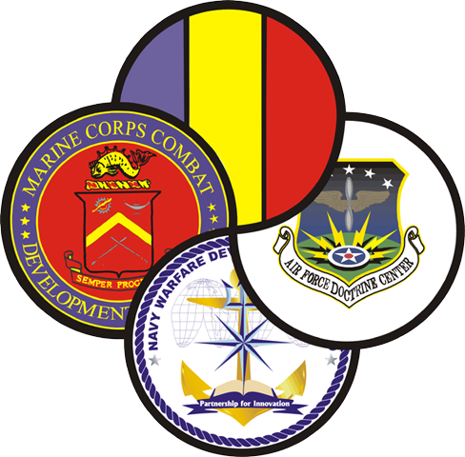

STANDARD
Detainee Operations in a Joint Environment
Detainee Ops
Multi-Service Tactics, Techniques, and Procedures (MTTP) Package
Suspense:
MEETING THE IMMEDIATE NEEDS OF THE WARFIGHTER

STANDARD

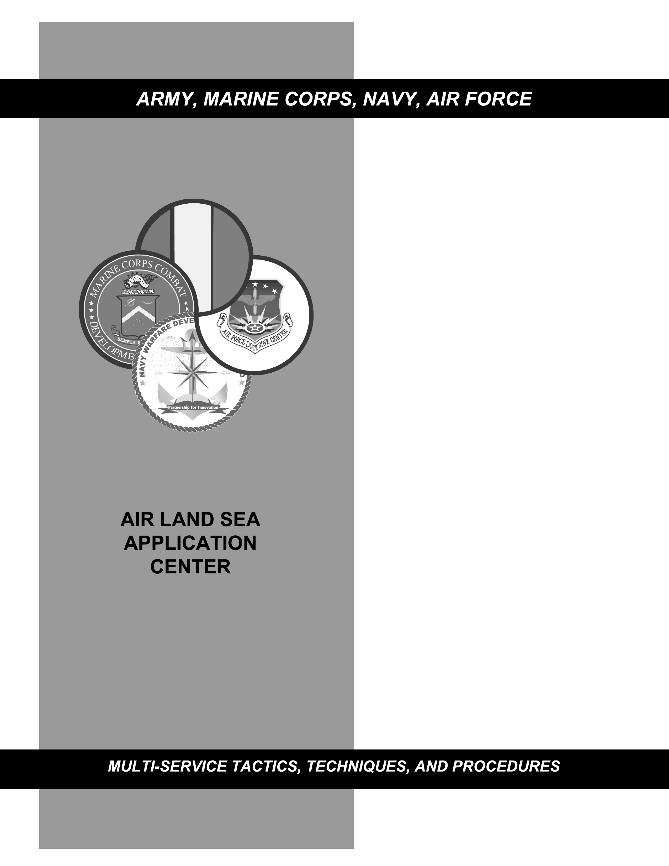
Detainee Ops
multi-service TACTICS, TECHNIQUES, AND procedures for Detainee operations in a joint environment
FM xx-z.x (FM xx-xx.x)
MCRP x-xx
NTTP x-xx-x
AFTTP(I) x-xx-x
MArch 2004
DISTRIBUTION RESTRICTION: Distribution authorized to DOD and DOD contractors only to protect technical or operational information from automatic dissemination under the International Exchange Program or by other means. This determination was made on 4 February 2003. Other requests for this document will be referred to HQ TRADOC, ATTN: ATDO-A, Fort Monroe, VA 23651; HQ AFDC/DJ, Langley AFB, VA 23665; HQ MCCDC, C427, Quantico, VA 22134; or NWCD, ATTN: N5, Newport, RI 02841.
DESTRUCTON NOTICE: Destroy by any means that will prevent disclosure of the document.
FOREWORD
This publication has been prepared under our direction for use by our respective commands and other commands as appropriate.
DAVID A. FASTABEND EDWARD HANLON, JR.
Brigadier General, U.S. Army Lieutenant General, USMC
Deputy Chief of Staff for Commanding General
Doctrine, Concepts and Strategy Marine Corps Combat
U.S. Army Training and Doctrine Development Command
Command
R. A. ROUTE DAVID MacGHEE, JR.
Rear Admiral, USN Major General, USAF
Commander Commander
Navy Warfare Development Headquarters Air Force
Command Doctrine Center

This publication is available at Army
Knowledge Online (www.us.army.mil)
and at the General Dennis J. Reimer
Training and Doctrine Digital Library at
(www.adtdl.army.mil).
PREFACE (ForewordTitle)
- Purpose (PrefPara1)
Normal
- Scope
Normal
- Applicability
Normal
- Implementation Plan
Normal
Army (PrefServiceP4--text). (Normal—Para) Upon approval and authentication, this publication incorporates the procedures contained herein into the U.S. Army Doctrine and Training Literature Program as directed by the Commander, U.S. Army Training and Doctrine Command (TRADOC). Distribution is in accordance with Initial Distribution Number (IDN) XXXXXXX.
Marine Corps. The Marine Corps will incorporate the procedures in this publication in U.S. Marine Corps training and doctrine publications as directed by the Commanding General, U.S. Marine Corps Combat Development Command (MCCDC). Distribution is in accordance with the Marine Corps Publication Distribution System (MCPDS).
Navy. The Navy will incorporate these procedures in U.S. Navy training and doctrine publications as directed by the Commander, Navy Warfare Development Command (NWDC)[I5]. Distribution is in accordance with Military Standard Requisition and Issue Procedure Desk Guide (MILSTRIP Desk Guide) and Navy Standing Operating Procedure Publication 409 (NAV SOP Pub 409).
Air Force. The Air Force will incorporate the procedures in this publication in accordance with applicable governing directives. Distribution is in accordance with Air Force Instruction (AFI) 33-360.
- User Information
- (ParaA) TRADOC, MCCDC, NWDC, Headquarters AFDC, and the Air Land Sea Application (ALSA) Center developed this publication with the joint participation of the approving Service commands. ALSA will review and update this publication as necessary.
- This publication reflects current joint and Service doctrine, command and control organizations, facilities, personnel, responsibilities, and procedures. Changes in Service protocol, appropriately reflected in joint and Service publications, will likewise be incorporated in revisions to this document.
- We encourage recommended changes for improving this publication. Key your comments to the specific page and paragraph and provide a rationale for each recommendation. Send comments and recommendations directly to—
Army (Lead Agent)
Commander
U.S. Army Training and Doctrine Command
ATTN: ATDO-A
Fort Monroe, VA 23651-5000
DSN 680-3951 COMM (757) 788-3951
E-mail: doctrine@monroe.army.mil
Marine Corps
Commanding General
U.S. Marine Corps Combat Development Command
ATTN: C42
3300 Russell Road, Suite 318A
Quantico, VA 22134-5021
DSN 278-6233/6234 COMM (703) 784-6234
E-mail: deputydirectordoctrine@mccdc.usmc.mil
Navy
Commander
Navy Warfare Development Command
ATTN: N5
686 Cushing Road
Newport, RI 02841-1207
DSN 948-1164/4189 COMM (401) 841-1164/4189
E-mail: alsapubs@nwdc.navy.mil
Air Force
HQ AFDC/DJ
204 Dodd Blvd, Suite 301
Langley AFB, VA 23665-2788
DSN 574-8091 COMM (757) 764-8091
E-mail: afdc.dj@langley.af.mil
ALSA
ALSA Center
ATTN: Director
114 Andrews Street
Langley AFB, VA 23665-2785
DSN 575-0902 COMM (757) 225-0902
E-mail: alsa.director@langley.af.mil
FM XX-X.X(FM Number) (FM 100-103-2)
(MCRPNumber)MCRP XX-X.X
(MCRPNumber)NTTP X-XX.X
(MCRPNumber)AFTTP(I) X-X.XX
FM X-XX.X (FM NumberLeft) (FM X-XX-X) U.S. Army Training and Doctrine Command
(FortTitlePage) Fort Monroe, Virginia
MCRP X-X.X (MCRPNumberLeft) Marine Corps Combat Development Command
(FortTitlePage) Quantico, Virginia
NTTP X-XX.X (MCRPNumberLeft) Navy Warfare Development Command
(FortTitlePage) Newport, Rhode Island
AFTTP(I) X-X.XX (MCRPNumberLeft) Air Force Doctrine Center
(FortTitlePage) Maxwell Air Force Base, Alabama
Day/month/Year
detainee ops
MULTI-SERVICE TACTICS, TECHNIQUES AND PROCEDURES
FOR Detainee Operations in a Joint Environment
Table of Contents
Page

EXECUTIVE SUMMARY x
Chapter I I-1
Introduction I-1
1. Background I-1
2. Policy I-1
3. Purpose I-1
4. Key Definitions I-2
5. Roles and Responsibilities I-2
Chapter II II-1
Capture and Combat Operations (Initial Detainment) II-1
1. PROCESSING DETAINEES II-1
2. CAPTURING UNIT II-3
3. EVACUATING DETAINEES II-7
Chapter III III-1
Initial Internment and Screening Facility III-1
1. Definition and Overview: III-1
2. Positions Roles and Responsibility III-1
3. Facility organization and structure III-7
4. Receipt of Detainees III-10
5. Receiving procedures: (see figure 3-2) III-11
6. Preparations of Detainees for movement III-18
7. RECEIPT OF TANSFER NOTIFICATION. III-18
8. TRANSFER BETWEEN FACILITIES. III-18
9. TRANSFER TO Established Recognized National Authority (ERNA), ALLIED FACILITIES, or INTERSERVICE agency. III-19
10. RELEASE III-19
Chapter IV IV-1
TRANSPORT MISSION PROCEDURES IV-1
1. Background. IV-1
2. Planning Considerations. IV-1
3. Procedures. IV-1
4. ON-BOARD IV-2
5. IN-TRANSIT OPERATIONS FOR ESCORT MISSIONS IV-2
6. ESCORT MISSION CONVEYANCE EMBARKATION/DEBARKATION OPERATIONS IV-5
7. TEAM COMPOSITION FOR ESCORT MISSIONS IV-6
8. TRAINING IV-6
9. USE OF FORCE/WEAPONS IV-7
10. FORMS AND REPORTS IV-7
Chapter V V-1
Long Term Internment Facility V-1
1. Definition and Overview: V-1
2. Positions Roles and Responsibility V-1
3. Facility Organization and Structure V-6
4. Receipt of Detainees V-8
5. TRANSFER BETWEEN FACILITIES V-13
6. TRANSFER TO HOST NATION OR ALLIED FACILITIES AND INTERSERVICE (Not sure if paragraph relates fully to title…more info?) V-14
7. RELEASE V-15
Chapter VI A-1
TRANSFER/RELEASE FROM LONG-TERM DETENTION A-1
1. Review and Approval Process A-1
2. Definitions A-1
3. Transfer. A-1
DEFINITIONS A-1
Confinement of Enemy Combatants at DOD Military Confinement Facilities B-1
1. Background B-1
2. Military Commissions B-1
Intelligence/Interrogation C-1
1. Background. C-1
2. Collection Management and Fusion Sections C-2
Detainee Reporting System D-1
1. Introduction - D-1
2. Background - D-1
3. DRS Software D-1
4. Database Management - D-2
5. DRS Integration with Military Police Doctrine - D-2
FIELD EXPEDIENT RESTRAINTS E-1
1. Purpose. E-1
2. Guidance. E-1
Tactical Level Logistics Considerations F-1
NEEDS AND CONSIDERATIONS CHECKLIST F-1
Forms G-1
1. Purpose - G-1
DETAINEE MOVEMENT by MILAIR 1
1. Purpose - 1
2. Background - 1
1. MISSION. 2
2. ASSUMPTIONS. 2
3. REQUIREMENTS. 2
4. OPERATIONS. 2
5. COMMAND AND CONTROL. 3
1. BACKGROUND - 4
2. PROCEDURES 4
1. BACKGROUND - 5
2. TECHNICAL CONSIDERATIONS - 5
3. TACTICAL CONSIDERATIONS - 5
4. CONFIGURATIONS - 6
5. NOTE ON SCHEMATICS - 6
1. BACKGROUND - 7
2. TOTAL DETAINEE LOAD - 7
3. FRIENDLY FORCES IN BACKEND OF AIRCRAFT - 7
4. TEAM COMPOSITIONS - 7
5. RELIEF CONCEPT - 7
1. BACKGROUND - 10
2. TOTAL DETAINEE LOAD - 10
3. FRIENDLY FORCES IN BACKEND OF AIRCRAFT - 10
4. TEAM COMPOSITIONS - 10
5. RELIEF CONCEPT - 10
1. BACKGROUND - 13
2. TOTAL DETAINEE LOAD - 13
3. FRIENDLY FORCES IN BACKEND OF AIRCRAFT - 13
4. TEAM COMPOSITIONS - 13
5. RELIEF CONCEPT - 13
6. SIGNIFICANT AIRCRAFT CONFIGURATION CHANGES - 14
1. BACKGROUND - 16
2. ADDITIONAL REQUIREMENTS - Medical care 16
3. TOTAL DETAINEE LOAD - Eighteen (18) detainees set in six centerline litter positions. 16
4. FRIENDLY FORCES IN BACKEND OF AIRCRAFT - 16
5. TEAM COMPOSITIONS - 16
6. RELIEF CONCEPT - 17
7. SIGNIFICANT AIRCRAFT CONFIGURATION CHANGES - 17
8. COORDINATION REQUIREMENTS - 17
1. BACKGROUND - 19
2. TOTAL DETAINEE LOAD - 19
3. FRIENDLY FORCES IN BACKEND OF AIRCRAFT - 19
4. TEAM COMPOSITIONS - 19
5. RELIEF CONCEPT - 20
6. SIGNIFICANT AIRCRAFT CONFIGURATION CHANGES - 20
1. BACKGROUND - 22
2. TECHNICAL CONSIDERATIONS - 22
3. TACTICAL CONSIDERATIONS - 22
4. TEAM COMPOSITION - 22
5. NOTE ON SCHEMATICS - 23
1. BACKGROUND - 24
2. TOTAL DETAINEE LOAD - 24
3. FRIENDLY FORCES IN BACKEND OF AIRCRAFT - 24
4. TEAM COMPOSITION - 24
5. RELIEF CONCEPT - 24
1. BACKGROUND - 27
2. CRITICAL ASSUMPTIONS - 27
3. SECURITY DURING EMERGENCY DIVERSION OF AIRCRAFT - 27
4. SUPPORTING/REINFORCING FORCES - 29
5. 3 ATTACHMENTS: 29
BACKGROUND - 30
BACKGROUND - 31
BACKGROUND - 32
1. BACKGROUND - 33
2. PROCEDURES - 33
3. 7 ATTACHMENTS: 34
1. BACKGROUND - 35
2. PERSONNEL - 35
3. PROCEDURES - 35
4. LOGISTICS - 36
1. BACKGROUND - 37
2. PERSONNEL - 37
3. PROCEDURES - 37
4. LOGISTICS - 38
5. STAND-DOWN - 38
1. BACKGROUND - 39
2. PERSONNEL - 39
3. PROCEDURES - 39
4. LOGISTICS - 40
1. BACKGROUND - 41
2. PERSONNEL - 41
3. PROCEDURES - 41
4. LOGISTICS - 42
5. STAND-DOWN - 42
1. BACKGROUND - 43
2. PERSONNEL - 43
3. PROCEDURES - 43
4. LOGISTICS - 44
5. STAND-DOWN - 44
1. BACKGROUND - 45
2. PERSONNEL - 45
3. PROCEDURES - 45
4. LOGISTICS - 46
1. BACKGROUND - 47
2. PROCEDURES - 47
1. BACKGROUND - 48
2. PERSONNEL - 48
3. PROCEDURES - 48
4. LOGISTICS - 51
5. STAND-DOWN - 52
6. ADMINISTRATION AND REPORTS - 52
1. BACKGROUND - 53
2. USE OF FORCE - 53
3. USE OF DEADLY FORCE - 53
4. RULES OF ENGAGEMENT (ROE) - 53
5. WEAPONS - 53
1. BACKGROUND - 55
2. PROCEDURES - 55
3. ATTACHMENTS: 56
1. BACKGROUND - 57
2. PROCEDURES - 57
BACKGROUND - 58
BACKGROUND - 59
1. BACKGROUND - 63
2. USE OF FORCE - 63
3. RULES OF ENGAGEMENT (ROE) - 63
1. BACKGROUND - 64
2. SECURITY ELEMENT TRAINING - 64
3. SUPPORT ELEMENT TRAINING - 65
1. BACKGROUND - 68
2. PERSONNEL - 68
3. PROCEDURES - 68
4. MEDICAL EQUIPMENT & SUPPLIES FOR DETAINEE TRANSPORT - 69
RELIGIOUS SUPPORT 1
1. Command Support 1
2. Religious Requirements 1
3. Religious Accommodation 1
4. Religious Practices 1
5. Religious Items 2
6. Cultural Considerations 3
7. Death and Burial 3
8. U.S. Military Chaplain Involvement 3
REFERENCES 2
Chapter VII REFERENCES 2
GLOSSARY (ChapterTitle) 1
Error! No index entries found. 11

FIGURES
Figure I-1. (Graphic Caption) Error! Bookmark not defined.
Figure B-1. (Graphic Caption) Error! Bookmark not defined.

TABLES
Table II-1. TableTitle Error! Bookmark not defined.

EXECUTIVE SUMMARY
ExecSumAcronym
Multi-Service Tactics, Techniques, and
Procedures for (ExecSumSubtitle)
(ExecSumSubtitle)
Normal Text
(ExecSumSubtitle)
Normal Text
(ExecSumSubtitle)
Normal Text
PROGRAM PARTICIPANTS
The following commands and agencies participated in the development of this publication:
Joint
U.S. Joint Forces Command, Norfolk, VA
U.S. Central Command, MacDill AFB, FL
U.S. European Command, Vaihingen, GE
U.S. Pacific Command, Camp H.M. Smith, HI
U.S. Southern Command, Miami, FL
U.S. Special Operations Command, MacDill AFB, FL
U.S. Transportation Command, Scott AFB, IL
Army
U.S. Army Training and Doctrine Command, Fort Monroe, VA
U.S. Army Intelligence Center and Fort Huachuca, Fort Huachuca, AZ
ISR/C4I Directorate, Fort Monroe, VA
DTT Detachment, 360th MI BN, Melbourne, FL
93 ACW Army Group, Robins AFB, GA
Ft Sill/DCD, Fort Sill, OK
Marine Corps
Marine Corps Combat Development Command, Quantico, VA
Navy
Navy Warfare Development Command (Norfolk Detachment), Norfolk, VA
Air Force
Air Force Doctrine Center, Detachment 1, Langley AFB, VA
Air Combat Command/DOYA, Langley AFB, VA
93 Air Control Wing, Robins AFB, GA
Detachment 2, 605th Test Squadron, Melbourne, FL

Introduction
- Background
International terrorists, including members of al Qaida, have carried out attacks on United States diplomatic and military personnel and facilities abroad and on citizens and property within the United States on a scale that has created a state of armed conflict that requires the use of the United States Armed Forces. Individuals acting alone and in concert involved in international terrorism possess both the capability and the intention to undertake further terrorist attacks against the United States that, if not detected and prevented, will cause mass deaths, mass injuries, and massive destruction of property, and may place at risk the continuity of the operations of the United States Government. The ability of the United States to protect the United States and its citizens, and to help its allies and other cooperating nations protect their nations and their citizens, from such further terrorist attacks depends in significant part upon using the United States Armed Forces to identify terrorists and those who support them, to disrupt their activities, and to eliminate their ability to conduct or support such attacks. To protect the United States and its citizens, and for the effective conduct of military operations and prevention of terrorist attacks, it is necessary for individuals to be detained. (President’s Military Order of November 13, 2001.)
- Policy
It is the policy of the United States to treat all detainees humanely. Those detainees entitled to protected status under the laws and customs of war (e.g., the Geneva Conventions of 1949) will be afforded such protections. Those detainees determined not to be entitled to protected status under the laws and customs of war will, to the extent appropriate and consistent with military necessity, be treated in a manner consistent with the principles of the Geneva Conventions.
- Purpose
The intent of this publication is to support planners and warfighters, by providing consolidated, current information on planning for handling, transferring, transporting and releasing detainees. Recent lessons learned from operations in Afghanistan, Cuba, and Iraq has identified areas dealing with detainees that lack current information. This MTTP serves as a planning, coordination, and reference guide for the Services and will provide a framework for the warfighters dealing with detainees that is consistent with joint doctrine, multi-Service instructions and applicable law. This publication provides combatant commanders, JTFs, Services, and components with a single, consolidated source of tactics, techniques and procedures (TTP) for the handling and processing of unprivileged enemy combatants. TTP for the handling and processing of enemy prisoners of war, civilian internees, battlefield confinement of U.S. military prisoners, and other detainees are contained within FM 3-19.40.
- Key Definitions
The following key terms have specific meanings and are used regularly throughout this document. Other definitions can be found in Appendix A.
- DETAINEE. Any person captured or otherwise detained by an Armed Force (JP 1-02). Detainees include, but are not limited to, those persons held during operations other than war (DODD 2310.1).
- ENEMY COMBATANT (EC). Any person that US or allied forces could properly detain under laws and customs of war.
- UNPRIVILEGED ENEMY COMBATANT (UEC). An enemy combatant who is not entitled to protected status under the laws and customs of war, (e.g., the Geneva Conventions of 1949) such as a member or agent of al Qaeda, the Taliban, or another international terrorist organization against which the United States is engaged in an armed conflict.
- CIVILIAN INTERNEE (CI). A Civilian Internee is a person who is interned during armed conflict or occupation for security reasons or for protection or because he committed an offense (insurgent, criminal) against the detaining power (JP 1-02). A CI is protected according to the Geneva Convention Relative to the Protection of Civilian Persons in Time of War (GC), 12 August 1949.
- PRISONER OF WAR (POW). A Prisoner of War is a detained person as defined in Articles 4 and 5 of the Geneva Convention Relative to the Treatment of Prisoners of War of August 12, 1949. In particular, one who, while engaged in combat under orders of his or her government, is captured by the armed forces of the enemy. As such, he or she is entitled to the combatant''s privilege of immunity from the municipal law of the capturing state for warlike acts which do not amount to breaches of the law of armed conflict. For example, a prisoner of war may be, but is not limited to, any person belonging to one of the following categories who has fallen into the power of the enemy: a member of the armed forces, organized militia or volunteer corps; a person who accompanies the armed forces without actually being a member thereof; a member of a merchant marine or civilian aircraft crew not qualifying for more favorable treatment; or individuals who, on the approach of the enemy, spontaneously take up arms to resist the invading forces. Also called POW or PW (JP 1-02). NOTE: US personnel are generally referred to as POWs when held by an enemy force, while enemy combatants held by US or coalilition forces, and entitled to the protections of Geneva Conventions, are referred to as Enemy Prisoners of War (EPW).
- OTHER DETAINEE (OD). Person in the custody of the US Armed Forces who has not been classified as an enemy prisoner of war (article 4, Geneva Convention of 1949 Relative to the Treatment of Prisoners of War (GPW)), retained person (article 33, GPW), or civilian internee (article 78, Geneva Convention). Also called OD. JP 1-02.
- Roles and Responsibilities
- The Secretary of Defense has overall responsibility for detainee and prisoner of war matters.
  - Within the Office of the Secretary of Defense (OSD), the Assistant Secretary of Defense for Special Operations and Low Intensity Conflict (ASD (SO/LIC)) shall provide for overall development, coordination, approval, and promulgation of major DoD policies and plans relating to detainee operations, including final coordination of such proposed plans, policies, and new courses of action with the DoD Components and other Federal Departments and Agencies as necessary. The specific division within OASD(SO/LIC) responsible for detainee policy issues is the Detainee Policy Group.
  - The DOD General Counsel provides legal advice to SECDEF and DOD on detainee matters as appropriate.
- The Secretary of the Army is designated the Executive Agent for the DOD for the administration of DOD EPOW Detainee Program (DODD 2310.1).
- The Army Deputy Chief of Staff for Operations and Plans, G-3 (DAMO-ODL) has primary Headquarters, Department of the Army staff responsibility for the EPW/CI/RP and detainee programs.
- Combatant Commanders, Task Force Commanders and Joint Task Force Commanders have the overall responsibility for Detainee, EPW, CI and RP programs, operations, and contingency plans in their area of responsibility to ensure compliance with international law of war and applicable national policy and directives.
- Unit commanders shall have responsibility for ensuring that forces under their command are operating in full compliance with applicable guidance provided by the chain of command. All commanders shall ensure that operation orders include command relationships and coordination responsibilities to ensure this compliance.
- National Detainee Reporting Center (NDRC) has the responsibility to:
  - Forward blocks of ISNs to the designated Theater and CONUS, as required.
  - Obtain and store information concerning unprivileged Enemy Combatants and their confiscated personal property.
  - Process all inquiries concerning unprivileged Enemy Combatants captured by Armed Forces
  - Make reports to the ICRC, and ASD SO/LIC.
  - Provide accountability information to the ICRC’s Central Tracing Agency.
- Theater Detainee Reporting Center (TDRC) is the field operating agency of the NDRC, is the central tracing agency, and has the responsibility to maintain information on all unprivileged Enemy Combatants and their personal property within a Theater of operation or assigned area of operations.
  - The TDRC serves as the Theater or area of responsibility repository for information pertaining to:
    - Accountability of unprivileged Enemy Combatants and implementation of DoD policy.
    - Provides initial and replacement blocks of ISN assignments to area processing organization.
    - Obtains and stores all accountability information concerning unprivileged Enemy Combatants originating within the their Theater or area of responsibility.
    - The TDRC is responsible for establishing and enforcing the accountability information requirements that the US forces will collect. The TDRC will receive these requirements from the NDRC.
    - In the absence of a Theater Detainee Reporting Center, the TDRC responsibilities fall to the Combatant Commander, Task Force Commander, or Joint Task Force Commander or their designee.

Capture and Combat Operations (Initial Detainment)
The events of September 11th changed the nature of warfare. The war on terrorism has produced a new form of threat and changed how US forces encounter and defeat that threat. With respect to detainee operations, the initial capturing and transferring of individuals who may pose a threat to US and coalition forces is the first step in a lengthy process.
In any given joint area of operations (JAO), any of the services may be involved in a mission in whom persons of interest (unknown status) may be captured or placed under the control of coalition forces. Such missions or operations filtered down through a higher chain of command must emphasize the humane treatment and proper care of those individuals as they are moved to an either temporary or permanent structures IAW United States policy and/or regulations regarding such treatment.
The tactical commander/leader on the ground ensures the following steps are taken when handling individuals of interest to US and coalition forces.
- PROCESSING DETAINEES
- The initial point of capture (IPOC) can take place in combat, on an objective, during a raid operation, a cordon & search mission, a temporary checkpoint (TCP), at border crossing points, on base camps, and even with local nationals attempting to gain information on US/Allied/or coalition forces. See figure 2-1 for a flow diagram of the processes.
- Whenever possible, trained Human Intelligence (HUMINT) personnel are an integral part of operations of this nature. They can assist in screening and categorizing detainees that are detained during operations. These battlefield interrogations can produce actionable intelligence products for future use by friendly forces. The HUMINT teams also make recommendations to the senior ground commander regarding the continued detention or release-on site when the tactical situation permits.
- Processing begins when US/allied/or coalition forces capture or detain an individual. The processing is accomplished in the combat zone for security, control, initial information collection, and the welfare of detainees through the appropriate channels. This is referred to as field (tactical) processing. The capturing unit begins field tactical processing by using the “Five Ss and T” procedure (search, segregate, silence, speed, safeguard, and tag). Subsequently, the capturing unit will apply the “STRESS” principles:
  - Search
  - Tag
  - Report
  - Evacuate
  - Segregate
  - Safeguard
Note: the STRESS principles will be discussed in detail throughout the remainder of this chapter.
Figure 2-1. Detainee Flow Process.
- 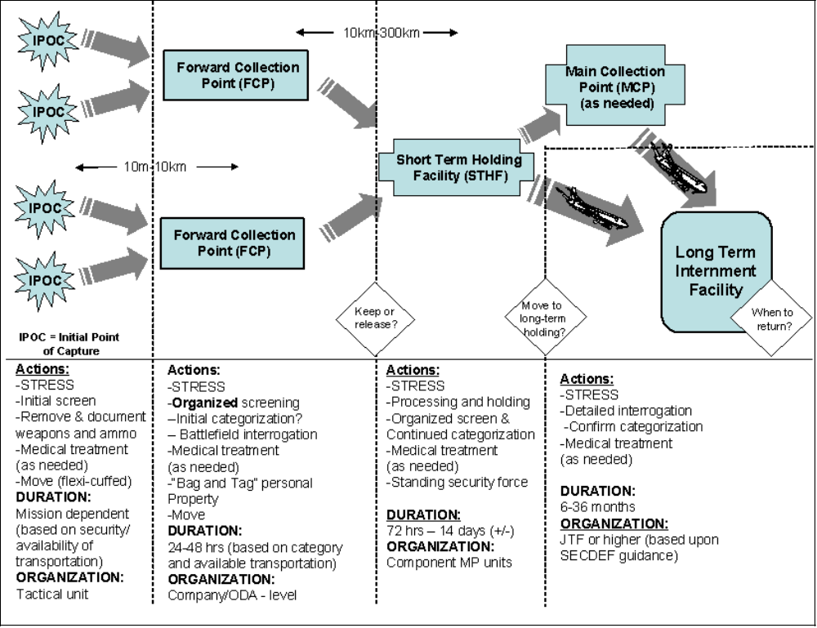The capturing unit must consider the following when determining an initial status of an individual:
  - Acted hostile to US/coalition forces during the operation?
  - Is there a physical difference/appearance between the individuals captured? For example, some might have shoes, some might not. Do some have teeth in better condition than others? How are they clothed differently?
  - Is there a language difference amongst those in the group?
  - Did they have weapons on their persons when they were captured?
  - Did they drop the weapons and attempt to escape?
  - Did the individual shoot at the capturing unit at any time during the operation?
- These might be some indicators that either the person was in the wrong place at the wrong time or might be someone of intelligence value requiring further questioning by intelligence personnel at a holding facility.
- The capturing unit could categorize these individuals determined to be either detained for future interrogation or immediate release. These categories include:
  - “A” – High-level detainees (high value target or HVT personalities) whose broad or specific knowledge makes it necessary for them to be questioned without delay by specifically qualified interrogators or debriefers. These detainees will require multiple interrogations and/or debriefings. In the event the detaining unit has no qualified interrogation personnel, CAT A detainees should be transferred immediately to a holding facility. If that is not possible, a Mobile Interrogation Team (MIT) composed of specifically qualified interrogators and/or debriefers with a security element should be dispatched to the location of the CAT A detainees or the FCP.
  - “B” – Non-high level detainees who have enough enemy information on any subject of itnelligence value, including information of immediate tactical value, to warrant a second interrogation or debriefing at a holding facility.
  - “C” – Detainees who have only information of immediate tactical value and do not warrant further questioning at a holding facility.
  - “D” – Other detainees who have no information of intelligence value. (NOTE: The fact or determination that a detainee has no information of intelligence value has nothing to do with their detention status and should not be linked to a determination of transfer and release).
- The ongoing war on terrorism will also require US personnel to screen and categorize detainees for priority transport using the above guidelines. Regardless of status, all personnel should be restrained until an initial determination is made on who should be transported and who should be released.
- The capturing unit is responsible for safeguarding and accounting for the detainee at each stage of his removal from the point of capture. The processing procedure begins upon capture and continues until the detainee reaches a collection point or a holding facility. The process of identifying and tagging a detainee aids US/allied/and coalition forces control and account for him as he is moved from the point of capture.
Note: All detainees should be restrained using flex-cuffs until a determination is made of their status.
- Units should have flex cuffs, capture cards and some form of material/equipment to transport items found on the detainees, to the facility.
- Units should also consider that combat camera or public affairs personnel may accompany them on a mission. Commanders and leaders must ensure that theater regulations/policies are followed as it relates to photography of detainees or public release of information.
- CAPTURING UNIT
- The “Five S’s and T” principles are implemented by the capturing unit. The basic principles are search, segregate, silence, speed, safeguard, and tag (see Table 2-1).
Table 2-1. Five Ss and T Procedure
Procedure | Description
Search | Search detainees for weapons and ammunition, items of intelligence value, and other inappropriate items. The search should include all clothing on the individual, to include shoes. Nothing should be excluded to ensure the safety and security of the capturing forces.  NOTE: Conduct same-gender searches when possible. If mixed-gender searches are necessary for speed or security, conduct them in a respectful manner and avoid any action that could be interpreted as sexual molestation or assault. To prevent allegations of sexual misconduct, the on-site supervisor carefully controls soldiers who perform mixed-gender searches.
Segregate | Segregate detainees based on perceived status of authority or position. During initial screening, leaders may be identified and thus must be segregated from the remainder of the population.
Silence | Do not allow detainees to speak or allow anyone to speak to them. Speak to detainees only to give orders.
Speed | Remove detainees from the point of capture as quickly as possible.
Safeguard | Safeguard detainees according to the Geneva Conventions and the US policy. Provide medical care as needed.
Tag | Tag detainees with a DD Form 2745(Capture Tag) or a field-expedient capture tag that includes the following information:  Date of capture.  Location of capture (grid coordinates).  Capturing unit.  Special circumstances of capture (how the person was captured, if he resisted, if he gave up, and so forth).  Did the persons have weapons on them during their capture?  NOTE: The capturing unit must complete a capture tag because failure to do so hinders further processing and disposition.
- The STRESS (Search, Tag, Report, Evacuate, Segregate, and Safeguard) principles are also applied to detainee operations. Following these principles, along with the “Five S’s and T” procedure, will make for a smooth and successful transition of detainees from initial capture to a forward collection point or a holding facility.
  - Search
    - Search and inspect each detainee and his possessions, to include all clothing, shoes, headgear. Conduct same-gender searches when possible. If mixed-gender searches are necessary for speed or security, conduct them in a respectful manner and avoid any action that could be interpreted as sexual molestation or assault. To prevent allegations of sexual misconduct, the on-site commander/leader carefully controls soldiers who perform mixed-gender searches. Some items are impounded and eventually returned, and certain items are confiscated and never returned, even if the detainee is released or repatriated. Determination of what items may be returned is made at the holding facility.
    - Personal protective equipment, once all items have been searched and deemed safe to US/allied and coalition forces, may be returned to the captured person. These items include:
- Helmet.
- Protective clothing and equipment (NBC suits, helmets, and protective masks) for use during evacuation from the CZ.
    - Confiscated Items. All items, minus the above protective equipment, is confiscated and accompanies the capturing unit to the holding facility where it is turned over to appropriate officials for determining final disposition.
    - The capturing unit coordinates with accompanying interrogation/intelligence teams (if available) to determine which confiscated items have intelligence value. Personal items (diaries, letters from home, and family pictures) can be taken by interrogation/intelligence teams for review.
NOTE: For an in-depth discussion on impounded and confiscated property, see multi-Service regulation AR 190-8 and DFAS-IN 37-1.
    - Property Accountability. When seizing property from a detainee bundle it or place it in a bag to keep it intact and separate from other detainee’s possessions. Such carrying items could include:
- Ziplock bags
- Sandbags
- Duck Tape
- 5x50 cord
- Socks
- Duct tape
- Prepare for the turnover of those items to the holding facilities.
  - Tag
    - Tag each detainee with a DD Form 2745. The following information is required:
- Date and time of capture.
- Capturing unit.
- Place of capture.
- Circumstances of the capture.
- Did the individual have a weapon on them during capture?
- The remaining information on the tag is included as it becomes available.
    - The DD Form 2745 is a perforated, three-part form that is individually serial-numbered. It is constructed of durable, waterproof, tear-resistant material with reinforced eyeholes on Parts A and C. Part A is attached to the detainee with wire or string, Part B is maintained by the capturing unit for their records, and Part C is attached to confiscated property so that the owner can be identified later.
    - The DD Form 2745 is placed on each detainee prior to the arrival at the holding facility. The holding facility may direct the capturing unit to complete a capture tag before accepting the detainee.
    - Instruct the detainee not to remove or alter the tag.
    - Annotate the tag's serial number and the detainee's name on a locally developed manifest.
NOTE: See Soldier Training Publication (STP) 21-24-SMCT for more information on DD Form 2745.
  - Report
Report the number of detainees at each point of capture through appropriate command channels. This aids in determining transportation and security requirements.
  - Evacuate
    - Evacuate detainees from the point of capture through appropriate channels as humanely and quickly as possible. When moving detainees, give them clear, brief instructions in their own language when possible. Military necessity may require a delay in movement. When this occurs, ensure that there is an adequate supply of food, potable water, appropriate clothing, shelter, and medical attention available.
    - When time and mission priorities allow, the capturing unit ensures the proper paperwork (DA Form 4137 (Evidence/Property Custody document), DD Form 515 (Roster of Prisoners), and DD Form 2708(Receipt for Inmate or detained person)) is complete before detainees are evacuated. If necessary, a DD Form 2708 (annotated with the number of prisoners) and a manifest will suffice. Do not expose detainees to unnecessary danger, and protect them while they are awaiting evacuation. For seriously wounded or sick detainees, medical personnel must determine if prompt evacuation is more dangerous than retaining them in the CZ.
  - Segregate
    - The commander/leader is responsible for the custody of detainees. He designates segregation procedures and levels to ensure their security, health, and welfare. Segregate detainees as required to ensure safety to US/coalition forces.
    - A detainee is protected under the rules of the Geneva Conventions and the US policy until competent authorities can determine forma status. (See multi-Service regulation AR 190-8 for further information.)
    - Do not use coercion to obtain information from detainees. Coercion or inhumane treatment of detainees is prohibited and is not justified by the stress of combat or deep provocation. Inhumane treatment is a serious violation of international law and the UCMJ.
    - Do not speak to detainees except to give orders or directions. Do not let detainees talk to or signal each other; use a gag only for as long as needed to ensure that it does not harm the captive. This prevents them from plotting ways to counter security and plan escapes.
  - Safeguard
    - To safeguard detainees according to the Geneva Conventions and the US policy—
- Provide first aid and medical treatment for wounded and sick detainees. Evacuate them through medical channels, using the assets available to evacuate US and coalition forces.
- Provide food and water. These supplies must be commensurate to those for US and coalition forces (see FM 27-10 and STANAG 2044).
- Provide firm, but humane treatment.
- Allow detainees to use protective equipment in case of hostile fire or NBC threat.
- Protect detainees from abuse by other detainees and local civilians.
- Report acts and allegations of inhumane treatment through appropriate command channels (see AR 190-40).
- Do not locate detainees near obvious targets (ammunition sites, fuel facilities, and communications equipment).
- EVACUATING DETAINEES
- General information applies to both sick and wounded detainees and able-bodied detainees and the following issues need to be addressed:
  - Dependent on METT-TC (see Appendix A, Definitions for explaination of METT-T and METT-TC), the detainees may be evacuated to either a forward collection point (FCP) or to the detainee detention facility. The FCP, if in operation, will allow for more detailed intelligence screening. Thus, those individuals captured may be filtered out from having to be transferred to the detention facility. Having an FCP in operation and the conduct of a more detailed screening process will allow for a more consolidated and finely-tuned intelligence collection effort at the actual detention facility.
  - If the FCP is not available, then the detainees are moved from the point of capture directly to the detention facility. Current doctrine stipulates that units move forward to a collection point to pickup and transport, in this case, detainees from a collection point. However, depending on METT-TC, this may not be feasible.
  - At either the IPOC or the FCP, the decision to retain the detainees for subsequent movement to a detention facility or immediate release is made. The decision point is made by the senior ground commander based on his knowledge of the mission and any input from HUMINT questioning and/or circumstances that warrant detention. If no HUMINT teams are available, the commander makes the best decision based on guidance from higher headquarters and categories (A-D) identified earlier in this chapter. Geographic considerations also apply with respect to the distances from the IPOC to either the FCP or the detention facility. For example, the detainee’s may be in a ship offshore.
- SICK AND WOUNDED DETAINEES
  - Medical personnel (combat lifesavers or other medically trained personnel), if attached, must decide which detainees must be medically transferred earlier. However, if not attached, the capturing unit must adhere to the following guidelines. Litter transfers are moved through the appropriate channels.
  - Seriously wounded or ill detainees are stabilized and evacuated through existing channels to a medical facility as quickly as possible. If the detainee requires medical evacuation—
    - Report the detainee's medical condition through command channels to the next higher echelon.
    - Request disposition instructions from the higher command authority.
    - The command authority coordinates transportation and identifies the treatment facility where wounded and sick detainees are taken.
    - The capturing unit determines if there is a security risk during medical evacuation of wounded and sick detainees. Ordinarily, detainees who require medical evacuation are less likely to be a security risk. However, detainees well enough to be a security risk are treated and returned to control.
- ABLE-BODIED DETAINEES
  - The capturing unit guards able-bodied detainees during movement to prevent escape, liberation by the enemy, or injury. A general planning consideration when determining the number of guards necessary is one for every five to ten detainees (Note: during extended transport in/or out of theater, the ratio is 1:1, guard to detainee. A unit tasked to escort detainees considers the following information when determining the number of guards needed:
    - The mission, enemy, terrain, troops, time available, and civilian considerations (METT-TC).
    - The number of detainees being moved.
    - The condition and morale of the detainees.
    - The type of transportation and its scheduled arrival.
    - The type of terrain along the evacuation route. Routes where dense vegetation is close to the road often require more guards then open, clear terrain.
    - The threat level along the route. As the threat level increases, so does the need to increase security. Consider the anticipated presence of suspected sympathizers and hostile, local nationals along the route.
    - The location of US/coalition units along the route.
    - The location and number of rest stops. This is based on the transportation, the distance, and the terrain.
Detainee Personal Identification Data (PID)
Collection Process in Afghanistan
by CPT Richard J. Hughbank, 519th MP Bn, Ft Polk, LA and
MAJ Jennifer L. Curry, Total Force Integrator, Ft Leonard Wood, MO
When the U.S. Army began Operation Enduring Freedom and their campaign in Afghanistan, the Afghan Military Forces (AMF) were already holding up to 4,500 detainees throughout the Coalition Joint Operational Area (CJOA) Afghanistan. U.S. forces were directed to collect personal identification data (PID) on all potential Taliban and al-Qaeda members in an effort to identify America’s newest enemies.
The purpose of collecting PID is to create a better database for identifying potential enemy threats and to screen these individuals to determine if they meet the criteria to be treated as detainees. If an individual meets the specified criteria, they are taken into custody in a detainee status and secured for further processing. Host Nation forces would encounter pockets of resistance throughout the area of operation (AO) and secure them for U.S. forces to conduct PID collection operations. These operations were conducted in conjunction with multiple battlefield operating systems (BOS) in a combined arms effort to properly conduct the collection of PID. PID collection packets, consisting of names, fingerprints, DNA, and digital photos, has become a key tool in America’s “War On Terrorism.”
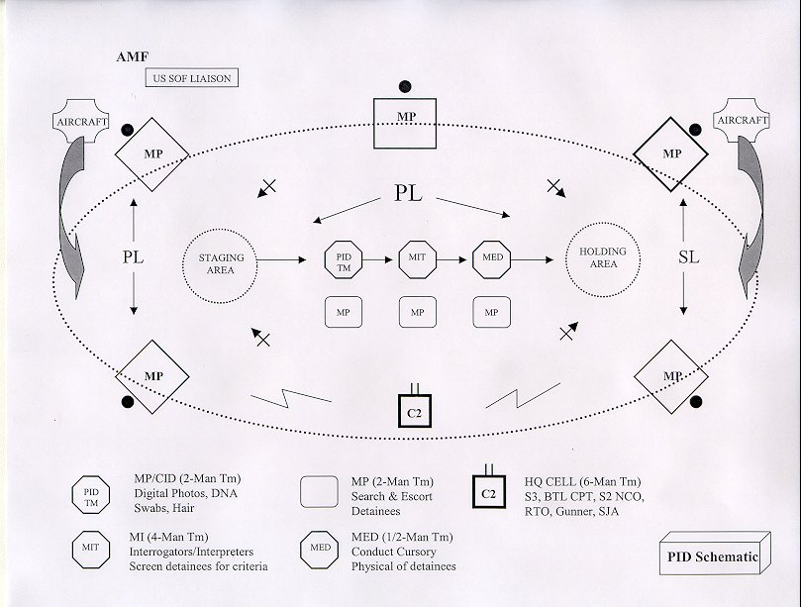
Prior to the arrival of the PID team, Special Operations Forces (SOF) liaison with leaders of the local indigenous population, ensuring candidates for detainee status actually exist at a prescribed location and that the area is prepared for military forces to enter and conduct PID collection operations. A PID collection operation consists of eight different teams (refer to schematic):
- Command and Control (C2) Team. The C2 team consists of key leaders and support soldiers. Key members of this team include the battalion S3 (or similar type capability), a battle captain, a communications soldier, a driver/gunner, and a Staff Judge Advocate (SJA) officer. This team is located inside the security perimeter in a position that allows for observation of the entire operation. Members of the team maneuver throughout the PID area, ensuring a smooth transition between the various stations and positive control over the detainees until they reach the holding area. The S3 is responsible for overall mission accomplishment, proper detainee handling, and guidance in any case not covered during the mission brief. The battle captain ensures mission success by conducting liaison operations with the SOF on the ground and ensuring the PID collection site is established and operational. The communications specialist carries FM capability for communicating with air support and other friendly forces in the AO, and as a secondary communications system for internal communications with the security forces on the perimeter for conducting detainee operations. Communications is maintained internally between the security positions and the C2 communications specialist. Actions on the objective and rules of engagement (ROE) are discussed during mission rehearsals. The driver/gunner remains vigilant of the surroundings throughout the PID collection operation. The SJA representative provides legal assistance/guidance as needed throughout the entire operation.
- Perimeter Security Team. The perimeter security team is comprised of two military police (MP) squads and a platoon leader (security element size is based on METT-TC). Organic MP teams are placed to ensure 360-degree outward coverage of the perimeter. The perimeter size is determined by METT-TC. The number of detainees dictates the size of the holding and staging areas and the number of personnel at the mobile interrogation team (MIT) stations. The MIT stations determine the distance necessary to ensure privacy with each detainee during the screening process. The PID and medical teams need minimal space to conduct operations within the security perimeter.
- Staging Area Security Team. The staging area is a preliminary location from which to isolate and establish control over those individuals selected for processing. The staging area security team consists of two soldiers with either an M4/16 or M249 in tactical overwatch positions. All detainees are bound at the feet and hands and have hoods covering their heads for disorientation. Two guards are positioned with their backs to the center of the perimeter to prevent potential fratricide if weapons fire becomes necessary.
- Personal Identification Data Collection Team (PID). MP and Criminal Investigations Division personnel are ideal for PID collection operations based on their organic functions of detaining personnel and conducting investigative operations. The PID team is the second stage in all PID collection operations. A team consists of three soldiers, with multiple teams operating • simultaneously if enough security teams are available. The purpose of PID gathering is to build or add to an existing database through the collection of dexorybo nucleic acid (DNA) samples by swabbing the mouth and collecting hair follicles, fingerprints, and digital photos of the upper torso area. All individuals being detained must be put through this process for data collection. Upon collecting the data and storing it in the proper containers, all information will be processed through the appropriate database.
- Mobile Interrogation Team (MIT). The MIT consists of interrogators and interpreters. The purpose of an MIT is to determine if a detainee fits the screening criteria given by higher headquarters. The screening process takes approximately 10-15 minutes per individual. If a person does not fit the criteria, they are turned back over to the leader of the indigenous population or, in this case, the AMF. If they do meet the criteria, they are taken into U.S. forces’ custody and escorted to the medical station.
- Medical Team. The medical team consists of a unit medic at a minimum, but a Physician’s Assistant is preferable. The purpose of the medical team is to conduct a cursory medical examination of the detainee for any previous injuries sustained before coming under control of U.S. forces. Any injuries identified are noted accordingly and, if necessary, tended to at that time. The medical team also allows for prior notification at the theater collection point if more advanced medical attention is necessary upon arrival.
- Holding Area Team. The holding area is established in order to maintain control over those individuals who have been identified as meeting the criteria by the MIT, and who will remain in U.S. forces’ custody for transport out of the AO to the theater collection point. The staging area security team consists of two soldiers with either an M4/16 or M249 in tactical overwatch positions. All detainees are bound at the feet and hands and have hoods covering their heads for disorientation. Two guards are positioned with their backs to the center of the perimeter to prevent potential fratricide if weapons fire becomes necessary.
- Detainee Security Team. Once the detainees are brought into the PID operations security perimeter, the detainee security team will take charge of all movement and detainee control until they are either released back to the AMF or transported back to the theater collection point. Each security team consists of two soldiers that secure the detainee throughout the process. Once the detainee enters the holding area, the detainee falls under the control of the holding area security team, and the detainee security team returns to the staging area to conduct another PID escort. This process continues until all detainees have been processed through the PID and screening areas. The perimeter security teams will only assist if absolutely necessary to help maintain positive control. Overall security of the detainees while in flight is also the responsibility of the detainee security team.
To date, PID operations have been conducted in over five different areas throughout Afghanistan, collecting data on over 3,500 potential members of terrorist organizations.
The military police corps is playing a critical role in the PID collection process. From the collection of data, to the security of detainees during the operations, and subsequent aerial escort missions back to the collection points, the military police have proven to be a true combat multiplier in Afghanistan.
Military Police units who have contributed to PID collection operations in the AO Afghanistan are the 65th MP Co (Airborne) and 108th MP Co (ASSLT), Ft Bragg, North Carolina; 211th MP Co (USAR), North Carolina; 511th MP Co, Ft Drum, New York; 545th MP Co, Ft Hood, Texas; and the 519th MP Bn, Ft Polk, Louisiana.
Editor’s Note: Both CPT Hughbank and MAJ Curry are MPs who served on a CALL CAAT team.

Initial Internment and Screening Facility
- Definition and Overview:
- The Initial Internment and Screening Facility is the “theater” level internment site within a combatant commanders area of responsibility (AOR) in which Detainees with an undetermined status are secured while their status is pending or where a Detainee who has been determined to be an UEC is interrogated and exploited for actionable intelligence for use by the combatant commander. This facility should exist as a permanent or semi-permanent facility within the general regional area of combat operations. Each situation or operation will dictate the type or level of interment and screening that is available and it is possible that detainees will by-pass an initial facility and be transferred directly to a long-term internment facility.
- It is the policy of the United States to treat all detainees humanely. Those detainees entitled to protected status under the laws and customs of war (e.g., the Geneva Conventions of 1949) will be afforded such protections. Those detainees determined not to be entitled to protected status under the laws and customs of war will, to the extent appropriate and consistent with military necessity, be treated in a manner consistent with the principles of the Geneva Conventions. Accordingly, commanders shall ensure that detainees are:
  - treated humanely, without any adverse distinction based on race, color, religion, gender, wealth, or similar criteria;
  - afforded adequate food, drinking water, shelter, clothing, and medical treatment;
  - allowed the free exercise of religion consistent with the requirements of such detention; and detained in accordance with other such conditions as the Secretary of Defense may prescribe.
  - Internment Length is determined according to the mission and intelligence requirements and logistical conditions that exist during the operation. In general, interment at this level should last only until it is administratively / logistically feasible to process, determine status and transfer detainees as appropriate. Length of internment will be influenced heavily by recommendation or requests of the commanders Intelligence Community and assets. Transfers or releases of detainees is the responsibility of the combatant commander.
- Positions Roles and Responsibility
- The personnel required to run this type of facility will vary and is dependent on mission requirements and current operational situation. As a rule and for planning purposes, use 1 Internment Company per 300 captives (Ideally this unit will be comprised of Military Police / Security Police Corrections personnel).
  - Combatant Commander – Overall responsibility, receives guidance from SECDEF
    - Be responsible for all facets of the operation of internment facilities, and all facility-related administrative matters.
    - Ensure detention operations meet with the principals of the Geneva Convention and the intent of the Commander-In-Chief (POTUS)
    - Support and improve the intelligence gathering process with all those who have contact with detainees.
  - Joint Internment Operations Group/Chief of Internment Operation
  - Staff officer on the Joint Task responsible for Internment Operations - Responsibilities include drafting, editing, and staffing detainee policies, fragos, and directives; tracks and reports operational data (TDRC); establishes, maintains, and participates in the detainee review process.
  - Facility Commander - A commander tasked with operating an Internment facility is also the facility commander. As such, he is responsible for the safety and well-being of all personnel housed within the facility. Since the unit may be tasked to handle different categories of personnel (EPW, CI, PUC, refugee, and US military prisoner), the commander, the cadre, and support personnel must be aware of the requirements for each category.
  - Joint Facility Interrogation Team - This section delineates the intelligence and interrogation procedures initial in-processing into an initial internment facility.
  - Intelligence analysts/interrogators should receive as much information as possible on all incoming detainees prior to their arrival at the long term facility. This information should include basic biographical information, name, DOB, nationality, capture information and any intelligence assessments that are available. Pictures are also helpful prior to arrival. Also if any were completed Knowledgeability Briefs (KB), Intelligence spot reports, Source Directed Requirements (SDR), Intelligence Information Reports (IIR).
  - Intelligence/Interrogation personnel are set up as “Tiger Teams” for arriving detainees as follows: One JTF interrogator, one JTF analyst, one linguist, and one outside agency law enforcement person e.g. FBI, CITF.
  - The interrogation team chiefs will review all initial information and make an initial assessment as to the intelligence value of the arriving detainees. The assessments are used to rank the arriving detainees.
  - The Interrogation OIC will make Team assignments based on the assessments and will notify medical and detention operations in-processing of the arriving detainee rankings. Medical will to the best of their ability and barring medical emergency perform the detainee in-processing per the ranking order. When prior information is not available the OIC will use the information gathered during the initial interview to make team determinations.
  - Tiger Teams will review all available information concerning their detainee and will complete a KB and a Basic Source Data (BSD) card (required for entry into the Defense Source Registry). The “Tiger Team Analysts will complete the Analyst Support Package (ASP) for each detainee.
  - Immediately after in-processing Military Police/Security Forces detainee escort teams will escort the detainee(s) to the pre-arranged interrogation booth(s) to meet with the assigned “Tiger Team”. In those instances where the number of detainees out number the “Tiger Teams” the highest ranking intelligence value detainees will be scheduled the first day and the lesser assessed intelligence value detainees will be scheduled on the subsequent days following arrival. In all cases all arriving detainees will be initially interrogated within four (4) days of arrival to the long term facility.
  - All detainees will have an IIR completed on them regardless of intelligence value. If nothing else to say, the IIR needs to state “This detainee has no intelligence value.”
  - After initial interrogation and further assessment and reports the detainees will be assigned to specialized team within the interrogation element. A “Special Projects” team may also be utilized to handle high visibility/very high intelligence value detainees.
  - A clearing team will be required to assess potential continued threat to the US and it forces after all the intelligence requirements have been satisfied to determine if the detainee will be transferred and released or continued to be held or if they are candidates for legal action.
  - A typical strategic interrogation element will consist of regional interrogation teams with a team chief an officer familiar with interrogation either a warrant or other officer or a senior NCO in the interrogation MOS or AFSC. Reports officer section will act as the liaison between the interrogation element and the Collection Management Section. The reports office will task the interrogation teams with current collection requirements and SDR’s received from the collection management section. The reports office will receive the initial IIR’s and review them prior to the IIR’s going to collection management. The interrogation element also requires an Operations Section. The ops section a very critical part of the interrogation element, as this section schedules the time and location of the interrogations, act as the LNO with detention operations group for the escort teams, ensures the linguists are scheduled for the interrogations. Finally, an administration section is required for training, handling personnel requirements and needs.
  - All interrogation teams, interrogators, analysts etc will work closely with the detention operation personnel to develop rapport with the detaining personnel, to inform the detaining personnel of what to look for and what to report in order to enhance the intelligence collection efforts. The interrogation element will also use Behavior Scientist Teams (BSCT) made up of psychologists/psychiatrists and behavior science techs when available.
  - Collection Management and Fusion Sections - Collection management section will review all pertinent collection requirements, SDR’s, IIR,s. All collection requirements will be kept current and the requirements that have expired will be taken off the list. The updated collection requirements will be forwarded to the interrogation element and the fusion cell. SDR’s will be monitored for currency and the interrogation element will be notified as to overdo, late SDR’s and those SDR’s that have expired. IIR’s will be reviewed for completeness and proper syntax and then sent out from the Collection Management Section by electron to the Intelligence Community (IC).
  - The Analyst Fusion Cell will handle all analytical requirements that are not directly related to the interrogation of detainees. This will entail reports, projects from DoD, Combatant Commanders, outside agencies and commander JTF.
  - Medical Officer/JTF Surgeon -
    - A medical officer, a physician’s assistant (PA), or a nurse practitioner regularly examines each detainee —
- Records his weight on DA Form 2664-R.
- Monitors his general health, nutrition, and cleanliness.
- Examines him for contagious diseases, especially tuberculosis (TB), venereal disease, lice, louse-borne disease, and human immunodeficiency virus (HIV).
  - Ensure that medical treatment is available for all internees. Each facility has an infirmary where internees with contagious diseases, mental conditions, or other illnesses can be isolated from other patients. Internees have 24-hour access to latrines, which are clean and conform to the rules of hygiene. Provide separate latrines for male and female internees. Provide internees with facilities, soap, and water for their personal needs and laundry or develop a laundry system. Consider the following sanitation standards to prevent disease and ensure cleanliness of the facility:
    - Distributing information to internees (in their language) on the importance of proper hygiene, sanitation, and food sanitation.
    - Teaching food sanitation procedures and ensuring that they are observed and practiced.
    - Disposing of human waste properly to protect the health of everyone associated with the facility according to the guidelines established by PVNTMED. Providing—
- Adequate space to prevent overcrowding.
- Sufficient showers and latrines and ensuring that they are cleaned and sanitized daily.
- Enough potable water for drinking, bathing, doing laundry, and conducting food service operations.
- Personal-hygiene materials.
- The medical treatment facility provides isolation of communicable diseases, disinfection, and inoculations. When necessary, transfer detainees to military or civilian medical facilities where the required treatment is available.
  - SJA Officer - Assigned as part of the task force, advises commander on all matters regardiing Law of War, Geneva Covention and standing policies; coordination made through CofS.
  - ICRC Liaison – Serves as a representative for the Commander in all matters dealing with the ICRC and International Community; may also be the SJA Officer.
  - The guard commander—
    - Supervises custodial personnel.
    - Is responsible for prisoner activities during his tour of duty.
    - Monitors custody, control, and security measures.
    - Ensures compliance with the facility schedule.
    - Initiates emergency control measures.
    - Maintains the facility blotter.
    - Deals with situations involving prisoner admission in the absence of the Facility Commander.
  - Guards – Missions will be assigned based on situation and current threat.
    - Prisoner Control Team - The prisoner control team NCOIC performs many of the same duties in an I/R battalion module as in a garrison confinement facility. This specialized environment requires the same corrections background to respond to behavioral incidents requiring calm, decisive action. During I/R operations, the NCOIC is responsible for—
- Security.
- Accountability.
- Intelligence. Intelligence is information obtained through observation and reports submitted by guards who are in daily contact with prisoners. The best source of intelligence gathering for the CSB is the guard force.
- The guard force. There are two types of orders for the guard force—general and special. General orders apply to all guards, and special orders apply to particular posts and duties.
- Escape prevention. The MWDs can be used to track an escapee, but they cannot be used to apprehend him.
    - Cellblock Guards
- Maintain custody, control, and discipline of prisoners under their supervision.
- Supervise all activities according to the schedule of calls.
- Supervise the response to emergency action plans.
- Conduct periodic inspections, searches, head counts, roll calls, and bed checks.
    - Close-Confinement Guards
- Maintain custody and control of prisoners who are segregated from the general population due to inprocessing or administrative or disciplinary reasons.
- Accomplish activities within the schedule of calls, as applicable to the close-confinement area.
- Conduct 30-minute checks (or 15-minute checks for special-status prisoners) when a DD Form 509 is required.
- Ensure that all required signatures on DD Form 509 are obtained on a daily basis.
    - Main Gate and Sally Port Guards
- Maintain custody and control of prisoners.
- Ensure that only authorized persons enter the facility.
- Inspect vehicles entering and exiting the facility.
- Inspect packages.
- Conduct inventories of items entering and exiting the facility.
- Require noncustodial personnel to register on sign-in logs.
    - Interview Room Guards
- Maintain custody and control of prisoners during interviews or visits by authorized persons.
- Detect violations of rules and regulations, improper behavior, and contraband.
- Position themselves in inconspicuous places and observe conversations rather than listening to them.
- Identify and report infractions, which may be grounds for terminating visits.
    - Hospital Guards
- Maintain custody and control of prisoners while escorting them to and from medical appointments and during hospitalization.
- Ensure that rooms are clear of contraband.
- Prevent unauthorized communications.
    - Tower Guards
- Maintain custody and control by observing specific sectors of the perimeter.
- Are briefed on the use of force and are familiar with assigned weapon.
- Ensure that contraband is not passed through the perimeter.
- Provide protection for compound guards.
  - Escort Teams - Established and stringent custody and control measures reduce the likelihood of escapes. Procedures and techniques for moving prisoners can be modified as needed by the facility commander or the commander directing the movement. Safety and security protocol dictate a 2 to 1 ratio for internal facility moves. For external moves the ratio will be situation dependent.
  - Religious Support - Commander’s responsibility is to respect cultural beliefs such as religious tenets and shrines. The Chaplain, Immigration and Customs Enforcement, international support groups, community leaders, CA, and HN authorities are good sources for information regarding cultural sensitivities.
  - Quick Reaction Force - Responsible for responding to multiple and diverse missions within the facility; QRF must remain at a constant state of readiness to react to any situation at a moments notice.
- Facility organization and structure
Detainees will be quartered under conditions as favorable as those for the force of the detaining power billeted in the same area. The conditions shall make allowance for the habits and customs of the prisoners and shall in no case be prejudicial to their health. The forgoing shall apply in particular to the dormitories of detainees as it regards both total surface and minimum cubic space and the general installation of bedding and blankets. Quarters furnished to detainees must be protected from dampness, must be adequately lit and heated (particularly between dusk and lights-out), and must have adequate precautions taken against the dangers of fire. In facilities accommodating both sexes, detainees of opposite sexes will be quartered separately. When possible consult the preventive medicine authority in theater for provisions of minimum living space and sanitary facilities.
- Logistics considerations:
  - Commander must ensure all logistics elements to accomplish the mission are provided.
  - Consumables: IE: uniforms, food (considerations made for religious and cultural backgrounds), health and hygiene.
  - Transportation.
  - Support equipment: medical, electrical, and communications.
  - Engineer/Construction capabilities.
  - Electricity and lighting (generators).
  - Internment Facility Operations – Figure 3-1.a and 3-1.b provide examples of internment facilities. When conducting interment operations, cell and facility design will depend on operational requirments. As a rule, design the cell and facility, then develop procedures based on the design, and formalize in writing the proper procedures regarding:
    - Entering a Cell
    - Exit of Cell
    - Restraint techniques
    - Extraction techniques/considerations
    - Security inspections
    - Use of force
    - Medical procedures
    - Key and lock control
    - Food service operations
    - Shower / hygiene operations
    - Recreation
    - Internal movement
    - Emergency plans Housed personnel actions that support the emergency action plans of the internment facility, such as—
- Fire drills.
- Air raid drills.
- Emergency evacuations.
- Natural disaster drills.
- Blackouts.
- Escapes.
    - Count procedures
    - Security and control
    - Contraband
    - Disciplinary policy
    - Administration procedures
    - Isolation/ Holding areas
    - Post orders
- Standing orders provide uniform, orderly administration of an I/R facility. The orders to be obeyed by housed personnel are published in their language and posted where they can read the orders and refer to them.
- Standing orders include rules, procedures, and instructions
    - Hunger strikes
    - Suicide prevention
    - Terminal illness and death (provide for religious/ cultural preparations as well as proper notification to ERNA and ICRC upon demise)
    - Recreation practices
    - Mail operations and other correspondence methods
    - Detainee grievance procedures
    - ICRC relations

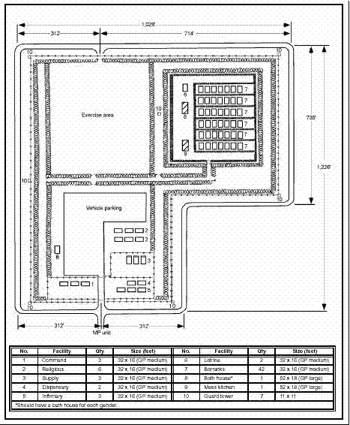
Figure 3-1.a. Example Internment Facility
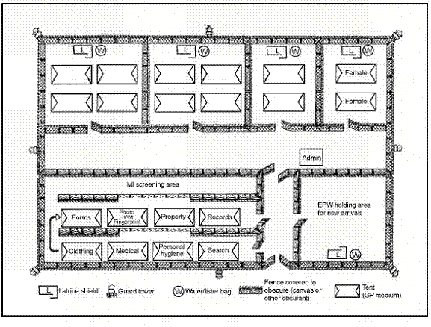
Figure 3-1.b. Example Internment Facility with Female Locations Identified.
- Receipt of Detainees
- Detainees will not be accepted for detainment or transfer to U.S. Military control from outside nations without prior approval from SECDEF. All detainees received will be properly receipted for by the officer designated to accept them. The receipt will indicate the place and date the facility assumed custody and the name, grade, and nationality of each transferred detainee. Three or more copies of the receipt will be prepared. The original, plus one copy, will be delivered to the commander of the facility to which the detainee are assigned. Upon receiving the copies, the facility commander will forward immediately one copy directly to the TDRC, or to the NDRC if the TDRC is not operational. A DA Form 4237-R or an allied equivalent form for individuals listed on the receipt should be delivered to the accepting officer at the time the transfer is effected.
  - Detainees transferred between facilities and hospitals will be receipted for as above when there is little chance that the detainee will be returned to the original facility. When detainees are transferred to hospitals outside the jurisdiction of the internment facility camp hospital guards will be assigned to accompany the injured detainee.
  - The use of a manifest identifying the name, identification number, nationality, and physical condition of each detainee transferred and received is required. The manifest will be attached to the original receipt of transfer and forwarded to the TDRC.
  - Detainees detained by other US services or agencies are turned over to the facility’s operating service at receiving points designated by the combatant commander (JTF Commander).
    - All inter-service transfers should be effected as soon as possible after initial classification and administrative processing has been accomplished.
    - A manifest is required to identify as a minimum the: name, rank/status, ISN (if assigned), power served/nationality, and physical condition of each detainee that is transferred and received. The manifest will be attached to the receipt of transfer and will become a permanent record to assure accountability of each prisoner.
  - Transfers between Service commands. The detaining command, with the advice of military medical authority, is authorized to transfer injured, sick, and wounded detainees to other commands.
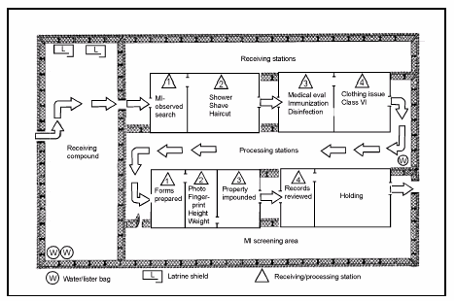
- Receiving procedures: (see figure 3-2)
Figure 3-2. Sample Processing Center (Theater)
- Chain of custody. The receiving facility will account for each detainee and his equipment when they arrive at the central receiving point. Currency will be receipted for using DA Form 4137 (Evidence/Property Custody Document). Detainees may be allowed to retain personal effects as designated by the commander such as: helmets, canteens, protective mask and chemical protective garments, clothing.
- Prepare the receiving area. (Coordinate with intellegence community for interpretures and interviewers, determine the number of detainees that will be arriving, notify medical personnel, supporting personnel, interagency assets).
- Use the STRESS method (Search, Tag, Report, Evacute, Separate and Silence, and Safeguard) as a general guide to in-process detainees into the facility. Facility personnel should focus on the aspects of separation and silence to maximize preservation of intellegence collection. Additionally, the facility will conduct a detailed medical screening, evidence collection (i.e. fingerprints and DNA sampling), orientation and integration procedures, and an intial interview (conducted by intellegence personell) of all detainees up receipt.
- Actions at drop off site. Detainees may arrive at the facility in a varity of way dependent on the location of the facility and ongoing operations. Examples of transportation could include trucks, aircraft (fixed or rotary wing), or ship. Security considerations to consider:
  - Security. (see Figure 3-3.)
    - Outer Security
    - Inner security
    - OPSEC.
  - Rules of Eengagement/ Use of Force criteria identified.
  - Team for determining property accountability and collection of that property of capturing unit or tranport personnel.
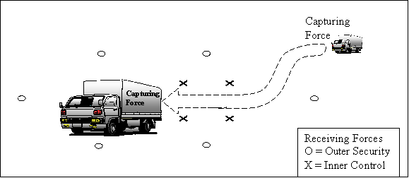
Figure 3-3. Drop-Off Site.
- Movement from drop off to facility. Detainees will be moved from the drop off site to the facility in as expeditious a manner as possible without compromising the security of the operation or the the safety of the detainees or service members. Considerations for this phase:
  - Route of movement
  - Security fomation
  - Control methods
  - Equipment/weapons needed by the movement team
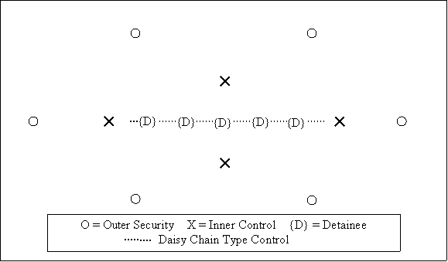
Figure 3-4. Maneuver to Facility
- Receiving line:
  - Initial Searching of the individual - Each detainee will be searched immediately upon receipt at the facility. Whenever possible, use memebers of the same sex as the detainee to conduct the searches. Weapons, ammunition, and equipment or documents with intelligence value will be confiscated and turned over to the nearest intelligence unit. Propaganda and other Psychological Operations (PSYOP) materials will be confiscated, identified by the detainee name and identification number and turned over to the supporting PSYOP unit through intelligence channels. Personnell conducting the search will focus on:
    - Security
    - Safety of the Detainee
    - Property accountability. Currency will be receipted for using DA Form 4137 (Evidence/Property Custody Document). PUCs may be allowed to retain personal effects as designated by the commander such as: helmets, canteens, protective mask and chemical protective garments, clothing.
  - Receiving and processing begin when detainees arrive. However, due to limited manning, these functions are not operational 24 hours a day. Detainees will be received, secured, housed, and feed until receiving and processing lines are operational. The facility should plan for and have the ability to conduct receiving operations under short notice or no notice conditions. Once the receiving lines are established, the detainees are brought forward, and the internment process begins.
  - Use a controlled-flow format to escort detainees through the processing line. Normally at this level, detainees are processed one at a time and the average is 2 per hour. These numbers may increase or decrease based on the capture rate and the nature of the operation. Secure unprocessed detainees in a holding area.
  - Request interpreters from MI, Civil Affairs, PSYOP, allied forces, or local authorities as necessary to aid in the inprocessing. Interpreters are usually necessary when collecting data for entering into the Detainee Reporting System(DRS).
  - The preparation and dispatch of Strength (ex. DA Forms 2674-R) are governed by multi-Service regulation AR 190-8, and they are prepared at each internment facility. Internment facility commanders may require feeder reports from various compounds to facilitate the preparation of internee strength reports.
- Initial Processing (See Figure 3-2 )During initial processing (at the point of capture), gather critical information from detainees.
  - The minimum information needed during initial processing includes:
    - Complete name (first, middle, and last).
    - Identification information (Service number, nationality, tribe etc).
    - Rank.
    - Capturing unit.
    - Date of capture.
    - Place of capture (grid coordinates).
    - Circumstances of capture.
  - The Initial Processing information (along with the capturing country, the TO, the power served, the sequence number, and the detainee category) is enough to move the detainee into a long term internment facility where additional information is gathered. Much of the initial information is gleaned from the capture tag. The TDRC provides block ISNs, and other information is theater- and situation-driven. The initial processing is timely and deliberately thorough.
  - Table 3-1 outlines the internment process for detainees. It shows who is responsible for each step and what actions they must accomplish. Based on current situation and conditions, the facility commander may tailor stations to meet the situation. Generally, there will be 2 guards per detainee throughout this process. Stations 1 through 4 are in the receiving line, and Stations 5 through 9 are in the processing line.

Table 3-1. Processing Actions at the Initial Processing Area
Station | Purpose | Responsible Individuals* | Actions
Receiving Line
1 | Search | Guards | Assign Control numbers  Instruct detainees on the rules and procedures on the Internment Facility  Follow accountability procedures.  Escort detainees and their property.  Strip-search detainees (by MP of the same sex if possible) before entering the processing area unless prohibited by conditions.  Remove and examine property, place it in a container or a tray, mark it with a control number, and take it to a temporary storage area. (Some property may be returned in the processing line.)  Supervise the movement of detainee to the next station.
2 | Clean/Hygiene | Guards | Shower or bathe detainee and provide haircuts.  Disinfect detainees using the guidelines established by the PVNTMED officer.  Supervise the movement of detainees to the next station.
3 | Medical Evaluation | Medical Personnel and guards | Inspect detainees for signs of illness or injury.  Evacuate detainees who need treatment at a medical facility.  Give immunizations or request immunization support from the supporting medical unit before internment or evacuation.  Initiate treatment and immunization records.  Place control numbers on medical records to reduce linguist support. (Names, service numbers, and control numbers are entered at Station 1 with the aid of an interpreter.)  Annotate medical records with the date and place detainees were inspected, immunized, and disinfected.  Weigh detainees and establish a weight register.  Supervise the movement of detainees to the next station.
*The number of people used to perform tasks depends on the number of detainees and the amount of time available. Other soldiers assigned to the unit may perform non-guard-specific tasks if necessary.
4 | Personal Items | Guards | Issue personal items (toilet paper, soap, toothbrush, and toothpaste).  Issue uniforms (clean and distinctive, like brightly colored jumpsuits if available). Uniforms may be obtained:  From detainees at Station 1.  From captured enemy supplies.  Through normal supply channels.  Ensure that uniforms are clearly marked with detainees control number.  Escort detainees to the processing area (Station 5).
Processing Line
5 | Administrative accountability | Processing clerk (assisted by interpreter, MI, or others) and guards | Ensure that control numbers are assigned to detainees. Note the capture tag numbers that the control numbers are replacing so that late-arriving property can be matched to its owner.  Initiate personnel records, ID documents, and property receipts.  Use digital equipment to generate forms and records.  Prepare forms and records to maintain the accountability of detainees and their property (STANAG 2044).  Supervise the movement of detainees to the next station.
6 | Photography and fingerprinting | Guards | Fingerprint detainees. Identify and record the information on fingerprint cards.  Take two photographs (with instant film or digital technology).  Have detainees look straight ahead, and fill the frame with their face.  Use photograph name boards (black background with white characters). List control numbers and names (translated into English) at the bottom center.  Attach one photograph to the detainee’s personnel record.  Collect DNA samples (saliva swabs and hair or nail samples)  Supervise the movement of detainees to the next station.
*The number of people used to perform tasks depends on the number of detainees and the amount of time available. Other soldiers assigned to the unit may perform non-guard-specific tasks if necessary.
7 | Personal property | Guards | Inventory and record property (in the presence of detainees) brought from temporary property storage areas.  Make separate lists for returned, stored, impounded, and confiscated property. List property to be returned to detainees or stored during internment on a separate list.  Provide receipts for property placed in temporary storage.  Provide receipts for money placed in detainee accounts (multi-Service regulation AR 190-8 and DFAS-IN-37-1).  Return retained property that was taken from the detainee at Station 1 (as deemed by the facility commander.  Supervise the movement of detainees to the next station.
8 | Records review | Guards | Review processed records for completeness and accuracy.  Escort detainees back to processing stations to correct errors if necessary.  Prepare and maintain an accountability roster of all detainees.
9 | Accountability transfer | Guards | Sign for and take custody of detainees (can use movement manifest), their records, and their impounded property if moving to another facility.  Evacuate or ship impounded property separately according to JTRs.
*The number of people used to perform tasks depends on the number of detainees and the amount of time available. Other soldiers assigned to the unit may perform non-guard-specific tasks if necessary.
- Follow-On Processing / Interviews - Per multi-Service regulation AR 190-8, the TDRC is responsible for collecting the following items to complete the intermediate processing:
  - The date of birth.
  - The city of birth.
  - The country of birth.
  - The name and address of next of kin (NOK) (father/mother).
  - The location of confiscated property.
  - The nationality.
  - A general statement of health.
  - The nation in whose armed services the individual is serving.
  - The name and address of a person to be notified of the individual’s capture.
  - The address to which correspondence may be sent.
  - Certificates of death or authenticated lists of the dead.
  - The location of war graves (grid coordinates) and particulars of the dead.
  - The notification of capture (including the date sent).
  - The list of personal articles of value not restored upon repatriation.
- Preparations of Detainees for movement
- RECEIPT OF TANSFER NOTIFICATION.
Upon receipt of approval to transfer or move a detainee from the Initial facility, actions must be taken to prepare the detainee and the detainee records. Commanders should consider the following when preparing for any movement.
- medical screening and physicals
- record review and preparation
- property accountability
- Detainee briefs and segregation
- TRANSFER BETWEEN FACILITIES.
- A transfer may be a result of reclassification or another situation requiring the movement of an UEC. Transfer an UEC from one facility to another under conditions that are comparable to those for a member of the US armed forces when possible. Security measures are determined by transferring unit and are influenced by the type of UEC being transferred, the mode of transportation used, and other pertinent conditions. (Reference CH 4)
  - The facility commander—
    - Publishes a transfer order and inform the TDRC.
    - Verifies the accuracy and completeness of UEC personnel records and provides records (in a sealed envelope) to the guards accompanying the movement.
    - Verifies that UECs possess their authorized clothing and equipment.
    - Prepares impounded personal property for shipment with escorting unit or separate shipment as appropriate.
    - Briefs escort personnel on their duties and responsibilities, including procedures to be followed in case of an escape, a death, or another emergency.
    - Provides or arranges for rations, transportation, and notifications according to prescribed procedures.
    - Ensures that UECs are manifested by name, ISN, nationality, and physical condition. Attach the manifest to the original receipt and forward it to the IRIC.
    - Prepares written manifest for dissemination by chain of command to CA and any appropriate NGOs after tranfer.
    - Prepares paperwork in English and other languages (if required) before transferring UECs.
    - Ensures the originating detential center medical authority conducts and reports the results of medical screening and/or treatments for each UEC to be transfered. The minimum medical information required includes medical diagnosis(es), treatments that must continue during transport, mental health/behavior assessment, infectious diseases detected in the UEC, and the prescribed infection control/protection measures to protect transportation personnel/assets. Utilize SF 600, Chronological Record of Medical Care (see atch XX Sample SF600) to document all medical information before/during/after transport.
- TRANSFER TO Established Recognized National Authority (ERNA), ALLIED FACILITIES, or INTERSERVICE agency.
The permanent transfer of an EC from the custody of US forces to the ERNA or other allied forces requires the approval of the Secretary of Defense (SECDEF). The permanent transfer of an EC to ERNA / FN control is governed by bilateral national agreements. A detainee can only be transferred from US custody to a power that is a party to the Geneva Conventions. A US representative visits the power’s internment facilities and ensures that the power is willing and able to comply with the Geneva Conventions.
- RELEASE
- Release is the process of returning a detainee to his country of birth or citizenship. A detainee who is not sick or wounded is released upon determination that he does not or no longer meets the criteria for detention as directed by the Office of the Secretary of Defense (OSD). The keys to a successful release process are control and accountability.
- To complete the transfer, the escort guard company forwards the official receipt of transfer (DD 2708) to the TDRC. Upon notification from the NDRC that the transfer is complete, the losing internment facility forwards official records and unreleased confiscated property to the TDRC for final disposition. The TDRC—
  - Notifies the NDRC of the final status of released detainees.
  - Disposes of confiscated property according to the national IRIC and applicable regulations.
- Table 3-2 outlines the release requirments for detainees. It shows who is responsible for each step and what actions they must accomplish. Based on current situation and conditions, the facility commander may tailor stations to meet the situation.

Table 3-2. Release Procedures
Step | Actions
Control and accountability | Maintain control and accountability until releases are received by the serving power or the designated protecting power.  Maintain a manifest that contains the—  -Name.  -Rank/status.  -Control number.  -Power served/nationality.  -Physical condition.  NOTE: A manifest is used as an official receipt of transfer and becomes a permanent record to ensure accountability of each PUC until his final release.
Records | Ensure that copies of appropriate personnel, finance, and medical records accompany released detainees. Transfer the records to the designated receiving authority
Personal property | Ensure that confiscated personal property (that can be released) accompanies released detainees.  Conduct an inventory and identify discrepancies.  Ensure that detainees sign property receipts.  Ensure release is provided with appropriate food, clothing, and equipment for safe transition and movement upon release.

TRANSPORT MISSION PROCEDURES
- Background.
The primary consideration in all facets of the detainee escort mission is to ensure the security of the conveyance and safety all US resources. This will be accomplished by a properly trained and equipped force of military specialists, capable of providing the entire continuum of force, to include deadly force. The secondary consideration is to ensure the security of the detainees. No single instruction can outline all tactics, techniques and procedures to be used throughout the detainee escort missions thus it is necessary for security elements and other personnel to use their best judgment when determining what course of action to take when completing their mission. Given time, questions should be addressed through the chain of command for resolution.
- Planning Considerations.
- All mission information should be routed through appropriate command and control cells. To ensure mission success detainee information and requirements (security, intel, operational, and medical) will be shared and coordinated between supported and supporting agencies.
  - Security. Exceptionally dangerous detainees or those designated as leaders will be identified to the transport team.
  - Medical. Forward medical units at the detention site will screen all detainees and provide the air component surgeon with a summary of each detainee’s medical condition. The patient movement requirements center and/or air evac control team personnel may assist security forces planners in mission planning as required.
  - Liaison Officer (LNO). Medical, security, and operations LNO’s should be located at embarkation, transit and debarkation points to coordinate their respective areas.
  - Operations. Operations of conveyance/crew will be as specified in appropriate service regulations.
  - Linguistics. Coverage of detainees’ languages and dialects must be accommodated.
- Procedures.
A thorough METT-T analysis of the situation and the application of troop leading procedures will provide the framework for accomplishing the mission. The guidelines and tactics, techniques, and procedures for completing the transport missions are outlined in attachments to this document.
- The following apply to all detainee handling. operations:
  - Prior to transport teams receiving the detainees from the pick-up location processing unit, all detainees will receive a complete medical exam, be deloused and thoroughly bathed, classified, and shaved. Also, a complete cavity inspection will be conducted prior to and immediately before boarding the conveyance. Detainees will be briefed about total restrictions while on-board. Detainees will be escorted to the conveyance, under positive control, from the holding area by pick-up location personnel.
  - Coordinate key mission details (outlined in pre-departure brief) between conveyance commander and security OIC/NCOIC.
  - Crew Pre-departure Briefing. Prior to mission departure the security OIC/NCOIC will complete a pre-departure briefing with the crew.
    - Security OIC/NCOIC will introduce self and team to crew.
    - Security OIC/NCOIC will ensure the briefing is in a secure area.
    - Chain of Command on board conveyance.
    - Communication.
    - Situation: How many detainees, changes to configurations, etc.
    - Security element responsibilities.
    - Crew responsibilities.
    - Requests/requirements from crew.
    - Contingency operations.
    - Review/practice emergency procedures.
    - Review/practice egress procedures.
    - Converse with crew on what weapons/equipment is on board and ROE in use.
    - Anti-hijacking procedures.
    - Force health protection briefing by medical personnel.
- ON-BOARD
Detainees will be under positive control of security personnel at all times. (For specific guidance see Appendix H.)
- IN-TRANSIT OPERATIONS FOR ESCORT MISSIONS
- BACKGROUND. In-transit operations represent the most vunerable period of detainee operations. The security of detainees will require feeding, latrine escorts, and other actions such as the adjustment of restraints. The security OIC/NCOIC has tactical command and control of all operations in the detainee holding area and will adopt tactics, techniques, and procedures to meet mission requirements. Emergency actions may be implemented, for example emergency evacuation, rapid decompression of an aircraft, on board fire, or abandon ship.
- PERSONNEL. The security, medical, linguistic, communication personnel to include combat camera and the conveyance crew will be determined by the type of mission being performed, mode of conveyance and other operational requirements. (possible link to AMC doc)
- PROCEDURES. Only one detainee should be allowed out of his/her seat/cell. Whenever possible, detainees will be isolated and not allowed to interact with each other. All restraints will remain in place at any one time except during an emergency evacuation or egress. Friendly forces personnel will not be allowed to operate or move within a close proximity to detainees without a second security person able to immediately detect and respond to hostile action against the friendly forces. There are no exceptions to this rule. Buffer zones shall be established around the area where the detainees are secured in to provide room for the friendly forces to maneuver. Security personnel will not spontaneously respond to security or medical incidents without alerting others to the situation. They will alert friendly forces to the incident and then respond with them to restore control, order or safety.
  - Adjusting Restraints. Minor adjustments of restraints may not require their removal. Restraints are never released without the order of the security OIC or NCOIC.
    - Only the minimum amount of restraint equipment will be removed if the restraints need to be adjusted.
    - If utilized goggles, hearing protection and gloves will remain on the detainees at all times.
    - Security personnel will maintain positive control of the detainees at all times. At least three security element personnel will secure the detainee/adjust the restraints if they must be removed.
    - The adjustment of restraints will be documented if the restraints are required to be removed in the process. If a minor adjustment is completed that does not require the removal of any of the equipment, documentation is not required.
  - Administering Medication or Aid (for Friendly Forces). Medication and aid will be administered by medical personnel assigned to the mission within established protocols and directives. This will be done in a secure location (buffer zone) away from any detainee operations (seating, feeding, latrine escorts, etc.). The security OIC/NCOIC will be notified of any medication or aid applied to friendly forces and the possible impact on the mission.
  - Administering Medication or Aid (for Detainees). Medication will be administered by medical personnel assigned to the mission within established protocols and directives. Medication will not be administered to any detainee without security personnel restraining the detainee. The security OIC/NCOIC will be notified of any medication or aid given to the detainees.
    - Medical personnel will be alerted by security personnel that medical care is required. This may be verbally or by hand and arm signals.
    - A minimum of two will restrain the detainee prior to medical personnel coming in contact with the detainee. If masks/blindfolds, hearing protection equipment and gloves are utilized, security personnel will ensure they remain in place and properly applied to provide security and health of the detainee. The restraining equipment will not be removed except at the direction of the security OIC/NCOIC.
    - Medical personnel will administer aid or medications as needed while the detainee is secured. These personnel should exercise caution and good situational awareness so as to not unduly expose themselves to danger with the detainees.
    - Medical aid and administration of medication will be documented.
  - Feeding/Hydration. Detainees will be fed and provided water on a schedule determined by the security OIC/NCOIC. OICs will ensure all detainees are fed only culturally appropriate meals. (Add who provides meals to air annex)
    - Security personnel are assigned the responsibility of feeding the detainees. The security personnel will provide the food for the detainee to feed him or herself.
    - If utilized, gloves and ear/hearing protection will not be removed.
    - Security personnel will position themselves in a manner to observe the detainees’ feeding and be able to alert others to security and medical incidents. They will assist the detainees with eating or drinking to the extent it does not endanger their safety or reduced the overall security posture on the conveyance.
    - Feeding and hydration will be documented.
  - Latrine/Head Escorts. Detainees will be restrained and under the physical control of security personnel at all times. Latrine/head visits will be documented. (For specific guidance refer to appropriate annex.)
  - Emergency Evacuation/Egress.
    - Upon orders of the conveyance commander, the security and supporting forces will begin emergency evacuation. For platform specific guidance refer to the appropriate annex.
    - The OIC/NCOIC will be the last person of the security/support team to exit the conveyance and will conduct an accounting of personnel. The OIC/NCOIC will make every effort to carry the information package(s) provided at the processing unit with him/her.
    - If on land, the detainees and security/support personnel will rally at a location directed by the conveyance commander.
    - Once off the conveyance, a security perimeter will be established. For specific guidance see appropriate annex?
    - It is imperative that the security team OIC/NCOIC and crew discuss emergency evacuation procedures prior to the start of each mission. Rehearsals should be conducted when possible.
  - Divert Security Procedures. Security and supporting actions during conveyance diverts are outlined in the appropriate annex.
  - Deadly Force. Refer to appropriate annex.
  - Decompression/Depressurization. Refer to air annex.
- LOGISTICS. Security team equipment will be accounted for as it is issued prior to the mission and then accounted for after the mission is complete. Medical equipment and supplies will be maintained under the positive control of the medical custodian (see Appendix XM for AF Medical Kit Inventory). Meals provided to detainees must be culturally appropriate. Conveyance coordination and repair will be accomplished through specified service command and control centers.
- STAND-DOWN. The security team OIC/NCOIC will order a stand-down of security and supporting forces only after all mission requirements are complete.
- ADMINISTRATION AND REPORTS. The security team OIC/NCOIC and senior medical official have administrative requirements during the mission.
  - The security team OIC/NCOIC will collect all documentation on each detainee after the mission.
  - A security blotter will be maintained under the direction of the security team OIC/NCOIC during the mission and will outline significant events and incidents.
  - Any use of force will be documented on the Use of Force Form. The security team OIC/NCOIC will collect these forms after the mission. The OIC/NCOIC may request the completion of voluntary statements to supplement/support the Use of Force Form found in appendix _____.
  - The senior medical representative will maintain SF 600 forms and ensure accountability for dispensed medications. An example SF 600 for medical is found in appendix _____.
  - The security team OIC/NCOIC may request the completion of voluntary statements or incident reports to document any incidents, events or occurrences relating to the mission.
  - The security team OIC/NCOIC will maintain custody logs, packages, and articles concerning the detainees and ensure they are delivered to the appropriate office or agency.
- ESCORT MISSION CONVEYANCE EMBARKATION/DEBARKATION OPERATIONS
- BACKGROUND. All embark/debark operations will be conducted under the supervision of the security team OIC/NCOIC. Accountability of detainees and friendly forces will be maintained between the security team OIC/NCOIC and the Processing Unit OIC/NCOIC.
- PERSONNEL. The number of security, supporting, medical, and linguistic personnel to include and the crew will be determined by the mission.
- PROCEDURES. Security OIC’s and NCOIC’s are responsible for the embarkation and debarkation of all detainees to/from the conveyance and will adopt tactics, techniques, and procedures to meet mission requirements.
  - The security OIC/NCOIC will alert and position security elements and supporting units and will move in position to oversee embark/debark operations. The gaining OIC/NCOIC receives a package from the losing OIC/NCOIC (documents, manifests, medical records, personal effects, military intelligence folders, forensic folder, and identification CD-ROM, and keys if required). The losing OIC/NCOIC also provides a threat briefing on the detainees.
  - Medical personnel will accomplish a transfer briefing.
  - Prior to embarkation a search of each detainee will be conducted by the receiving team.
  - After the detainee search is completed the detainee will be escorted on to the conveyance and secured. Ensure that appropriate security measures are utilized in accordance with the appropriate annex. If required, ensure the detainee is masked/blindfolded and that proper hearing protection is in place.
  - Medical and linguistic personnel will be called in to assist the OIC/NCOIC as needed.
- LOGISTICS. The security team OIC/NCOIC will ensure that any security supplies and/or materials destined for that location are off-loaded and handed to the appropriate agency/personnel.
- TEAM COMPOSITION FOR ESCORT MISSIONS
- BACKGROUND. Experience has shown that the most efficient ratio of security personnel to detainees is one to one. This ratio provides adequate personnel for two escorts during movement, while in transit, latrine/head calls, emergency situations, egress, etc. Minimum number of security personnel will be affected by situations such as emergency evacuation and/or emergency divert. Specific guidance may be found in the appropriate annex.
  - Support Personnel.
    - Medical personnel
    - Linguist
    - Communications personnel
- RELIEF CONCEPT. During the course of the mission, a relief schedule will be established and enforced by the Officer-in-Charge to ensure an adequate number and security and other personnel are alert and on post at any given time.
- TRAINING
- BACKGROUND. This type of specialized mission requires knowledge of procedures and techniques not normally encountered during regular training.
  - SECURITY ELEMENT TRAINING. Training for the security element should be focused on essential knowledge-level subject areas, the development of basic tactics, techniques, and procedures, and on critical actions on the objective. Subject areas should represent mission-essential tasks and events for the mission. Training will be structured to develop the necessary skills for meeting the minimum standards of the required tasks. For specific guidance see the appropriate annex.
  - SUPPORT ELEMENT TRAINING. Training for the support elements should be focused on essential knowledge-level subject areas and on critical actions on the objective. There is no requirement for instruction on offensive or defensive battle/handling techniques when dealing with the detainees or on the application of restraining systems as these tasks will be handled almost exclusively by the security elements. For specific guidance see the appropriate annex.
- USE OF FORCE/WEAPONS
- BACKGROUND. Security element personnel must remember at all times to use force appropriate for the circumstances. No list can give all scenarios where force is needed. The security element personnel must use their own experience and training when deciding what level of force is appropriate. The use of force will not be abusive, but under no circumstances will disruptive or violent behavior be tolerated. The safety of the crew and the detainees requires fair but firm use of force.
- PROCEDURES. All security personnel will be trained in approved Use of Force policies prior to coming in contact with any detainees.
  - Use of Deadly Force. Security OICs and NCOICs must review Supplemental Rules of Engagement, paragraph 6C (MSG DTG 052331ZJAN02) and brief all personnel before every mission.
  - Rules of Engagement (ROE). Approved Supplemental Rules of Engagement (SROE) will be briefed to all personnel prior to coming in contact with any detainees. Updates or changes to the ROE or SROE will be immediately briefed to all personnel.
  - Weapons. In order to meet the requirements of the mission and Use of Force policies, various weapons may be fielded by security elements. For specific guidance see specific annex.
- FORMS AND REPORTS
- BACKGROUND. Security OIC/NCOIC’s are responsible for completing/maintaining logs and forms for the detainee transport missions. Situation Reports (SITREPs) are required during detainee missions. Logs and reports will be signed by the person completing them or by the OIC/NCOIC.
- Forms Prescribed:
  - Incident Report. This form will be completed at the direction of the OIC or NCOIC for significant events, incidents, or occurrences. (link to form)
  - Statement of Witness/Suspect. This form will be completed at the direction of the OIC/NCOIC to supplement any other documentation or as a stand-alone document, as needed. (link to form)
  - Security Police Desk Blotter. This form will be completed and signed by the OIC/NCOIC for every detainee escort mission and will include a duty roster of security and supporting personnel. (link to form)
  - Temporary Hand Receipt. This form will be used to account for detainees and equipment/packages as they are transferred from person to person and agency to agency. (link to form)
  - Evidence Tag. This form will be used at the discretion of the OIC/NCOIC. (link to form)
  - Detainee Contact Log. This form will be used for every detainee on every escort mission. (link to form)
  - Use of Force Form. This form will be used for every instance of force above verbal commands when dealing with the detainees. (link to form)
  - SF 600. Chronological Record of Medical Care. This form will be used for every instance of medical care. (link to form)
  - Controlled Substance Log. This form will be used for every instance of distribution of controlled substances. (link to form)
- Reports.
  - Situation Reports (SITREPs). Formal SITREPs will be completed and forwarded verbally, electronically, or in writing as directed by HQ AMC/SF. Attachments 1, 2, and 3 to this Tab outline SITREP reporting requirements.
  - After-Action Reports (AARs). OICs will complete an AAR upon mission completion.
  - Lessons Learned. Lessons learned will be compiled after every mission. And sent to or filed with whom?
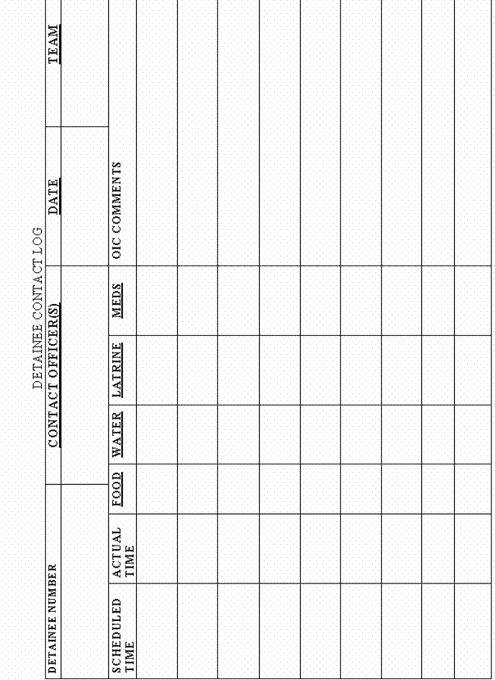
Figure 4-1. Detainee Contact Log
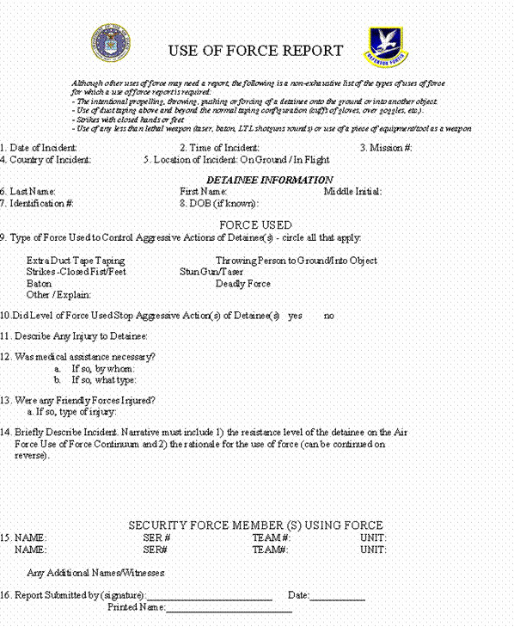
Figure 4-2. Use of Force Report (Front)
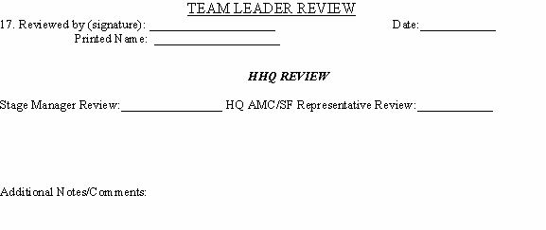
Figure 4-3. Use of Force Report (Back)

Long Term Internment Facility
- Definition and Overview:
- The Long Term Internment Facility is the internment site in both CONUS or OCONUS locations in which Detainees are secured while their disposition is pending or where a Detainee who has been determined to be a detainee is interrogated and exploited for actionable intelligence. This facility should exist as a permanent or semi-permanent facility. Each situation or operation will dictate the type or level of interment and screening that is available and it is possible that detainees will by-pass an initial facility and be transferred directly to a long-term internment facility.
- It is the policy of the United States to treat all detainees humanely. Those detainees entitled to protected status under the laws and customs of war (e.g., the Geneva Conventions of 1949) will be afforded such protections. Those detainees determined not to be entitled to protected status under the laws and customs of war will, to the extent appropriate and consistent with military necessity, be treated in a manner consistent with the principles of the Geneva Conventions. Accordingly, commanders shall ensure that detainees are:
  - treated humanely, without any adverse distinction based on race, color, religion, gender, wealth, or similar criteria;
  - afforded adequate food, drinking water, shelter, clothing, and medical treatment;
  - allowed the free exercise of religion consistent with the requirements of such detention; and detained in accordance with other such conditions as the Secretary of Defense may prescribe.
- Internment Length is determined according to the mission and intelligence requirements and logistical conditions that exist during the operation. Length of internment will be influenced heavily by recommendation or requests of the commanders Intelligence Community and assets. Transfers or releases of detainees is the responsibility of the combatant commander.
- Positions Roles and Responsibility
- The man power intensive, close quarters nature of the long term internment requires the specialized training, knowledge and skills of correction specialists and corrections support personnel. The personnel required to run this type of facility will vary and is dependent on mission requirements and current operational situation.
  - Facility Commander – Overall responsibility, complies with guidance from SECDEF
    - Be responsible for all facets of the operation of internment facilities, and all facility-related administrative matters.
    - Ensure detention operations meet with the principals of the Geneva Convention and the intent of the President of the United States (POTUS)
    - Support and improve the intelligence gathering process with all those who have contact with detainees.
  - Detention Operations Group/Center
    - Detention Operations conducts detention and area security operations in assigned sector of the Operational Area in support of intelligence operations in the Global War on Terrorism (GWOT).
    - The Commander conducts detention and security operations with emphasis on force protection, humane treatment of detainees, and an aggressive mobile defense in sector. Conduct detention operations in a manner that supports the intelligence gathering efforts such as the Interrogation Group, the Criminal Investigation Task Force (CITF), and the Counter-Terrorism Cell (CTC) while providing for the safety, security and care of the detainees. Assigned/attached security forces provide the external security necessary to detect, deter, and defend against enemy sabotage, surveillance, and attack. End state is an efficiently run detention facility, a secure operating environment, and a force protection posture that provides for the safety and security of all service members, civilian personnel, and detainees.
    - Responsibilities include drafting, editing, and staffing detainee policies, fragos, and directives; tracks and reports operational data (TDRC); establishes, maintains, and participates in the detainee review process.
  - Intelligence Team
    - This section delineates the intelligence and interrogation procedures initial in-processing into a initial internment facility.
    - Intelligence analysts/interrogators should receive as much information as possible on all incoming detainees prior to their arrival at the long term facility. This information should include basic biographical information, name, DOB, nationality, capture information and any intelligence assessments that are available. Pictures are also helpful prior to arrival. Also if any were completed Knowledge ability Briefs (KB), Intelligence spot reports, Source Directed Requirements (SDR), Intelligence Information Reports (IIR)
    - Intelligence/Interrogation personnel can be set up as “Teams” for arriving detainees as follows: One JTF interrogator, one JTF analyst, one linguist, and one outside agency law enforcement person e.g. FBI, CITF.
    - The interrogation team chiefs will review all initial information and make an initial assessment as to the intelligence value of the arriving detainees. The assessments are used to rank the arriving detainees.
    - The Interrogation OIC will make Team assignments based on the assessments and will notify medical and detention operations in-processing of the arriving detainee rankings. Medical will to the best of their ability and barring medical emergency perform the detainee in-processing per the ranking order. When prior information is not available the OIC will use the information gathered during the initial interview to make team determinations.
    - Teams will review all available information concerning their detainee and will complete a KB and a Basic Source Data (BSD) card (required for entry into the Defense Source Registry). The Team Analysts will complete the Analyst Support Package (ASP) for each detainee.
    - Immediately after in-processing Military Police/Security Forces detainee escort teams will escort the detainee(s) to the pre-arranged interrogation booth(s) to meet with the assigned “Team”. In those instances where the number of detainees out number the “Teams” the highest ranking intelligence value detainees will be scheduled the first day and the lesser assessed intelligence value detainees will be scheduled on the subsequent days following arrival. In all cases all arriving detainees will be initially interrogated within four (4) days of arrival to the long term facility.
    - All detainees will have an IIR completed on them regardless of intelligence value, if nothing else to say this detainee has no intelligence value.
    - After initial interrogation and further assessment and reports the detainees will be assigned to specialized team within the interrogation element. A “Special Projects” team may also be utilized to handle high visibility/very high intelligence value detainees.
    - A clearing team will be required to assess potential continued threat to the US and it forces after all the intelligence requirements have been satisfied to determine if the detainee will be transferred and released or continued to be held or if they are candidates for legal action.
    - A typical strategic interrogation element will consist of regional interrogation teams with a team chief an officer familiar with interrogation either a warrant or other officer or a senior NCO in the interrogation MOS or AFSC. Reports officer section will act as the liaison between the interrogation element and the Collection Management Section. The reports office will task the interrogation teams with current collection requirements and SDR’s received from the collection management section. The reports office will receive the initial IIR’s and review them prior to the IIR’s going to collection management. The interrogation element also requires an Operations Section. The ops section a very critical part of the interrogation element, as this section schedules the time and location of the interrogations, act as the LNO with detention operations group for the escort teams, ensures the linguists are scheduled for the interrogations. Finally, an administration section is required for training, handling personnel requirements and needs.
    - All interrogation teams, interrogators, analysts etc will work closely with the detention operation personnel to develop rapport with the detaining personnel, to inform the detaining personnel of what to look for and what to report in order to enhance the intelligence collection efforts. The interrogation element will also use Behavior Scientist Teams (BSCT) made up of psychologists/psychiatrists and behavior science techs when available.
    - Interrogations teams will continually make assessments using the A – B – C – 1 – 2 – 3 DOD approved method: Each detainee will receive a letter and a number to identify his category. Example A,2 or B,1(Used ABCD earlier. Do we use both? If so, maybe recognize that here)
- A – Intel Value
- B – Some Intel Value
- C – No Intel Value
- 1 – Cooperative
- 2 – Somewhat Cooperative
- 3 – Not Cooperative
  - Collection Management and Fusion Sections
    - Collection management section will review all pertinent collection requirements, SDR’s, IIR,s. All collection requirements will be kept current and the requirements that have expired will be taken off the list. The updated collection requirements will be forwarded to the interrogation element and the fusion cell. SDR’s will be monitored for currency and the interrogation element will be notified as to overdo, late SDR’s and those SDR’s that have expired. IIR’s will be reviewed for completeness and proper syntax and then sent out from the Collection Management Section by electron to the Intelligence Community (IC).
    - The Analyst Fusion Cell will handle all analytical requirements that are not directly related to the interrogation of detainees. This will entail reports, projects from DoD, Combatant Commanders, outside agencies and commander JTF.
  - Medical Support :
    - Medical personnel, regularly examines each detainee —
- Records his weight on appropriate forms.
- Monitors his general health, nutrition, and cleanliness.
- Examines him for contagious diseases, especially tuberculosis (TB), venereal disease, lice, louse-borne disease, and human immunodeficiency virus (HIV).
    - The medical treatment facility provides isolation of communicable diseases, disinfection, and inoculations. When necessary and authorized, transfer detainees to military or civilian medical facilities where the required treatment is available.
  - SJA Officer. Advises commander on all matters regardiing Law of War, Geneva Covention and standing policies.
  - ICRC Liaison – Serves as a representative for the Commander in all matters dealing with the ICRC and International Community; may also be the SJA Officer
  - The guard commander—
    - Supervises custodial personnel.
    - Is responsible for prisoner activities during his tour of duty.
    - Monitors custody, control, and security measures.
    - Ensures compliance with the facility schedule
    - Initiates emergency control measures.
    - Maintains the facility blotter / log.
    - Deals with situations involving detainee admission in the absence of the Facility Commander.
  - Guards – Missions will be assigned based on situation and current threat.
    - Cellblock Guards
- Maintain custody, control, and discipline of detainees under their supervision.
- Supervise all activities according to the schedule of calls.
- Supervise the response to emergency action plans.
- Conduct periodic inspections, searches, head counts, roll calls, and bed checks.
- Maintain custody and control of detainees who are segregated from the general population due to in-processing or administrative or disciplinary reasons.
- Accomplish activities within the schedule of calls, as applicable to the close-confinement area.
- Conduct 15-minute checks.
- Ensure that all required signatures on DD Form 509 are obtained on a daily basis.
    - Main Gate and Sally Port Guards
- Maintain custody and control of detainees.
- Ensure that only authorized persons enter the facility.
- Inspect vehicles entering and exiting the facility.
- Inspect packages.
- Conduct inventories of items entering and exiting the facility.
- Require noncustodial personnel to register on sign-in logs.
    - Interview Room Guards
- Maintain custody and control of detainees during interviews or visits by authorized persons.
- Detect violations of rules and regulations, improper behavior, and contraband.
- Position themselves in inconspicuous places and observe conversations rather than listening to them.
- Identify and report infractions, which may be grounds for terminating visits.
    - Hospital Guards
- Maintain custody and control of detainees while escorting them to and from medical appointments and during hospitalization.
- Ensure that rooms are clear of contraband.
- Prevent unauthorized communications.
    - Tower Guards
- Maintain custody and control by observing specific sectors of the perimeter.
- Are briefed on the use of force and are familiar with assigned weapon.
- Ensure that contraband is not passed through the perimeter.
- Provide protection for compound guards.
  - Escort Teams - Established and stringent custody and control measures reduce the likelihood of escapes. Procedures and techniques for moving detainees can be modified as needed by the facility commander or the commander directing the movement. Safety and security protocol dictate a 2 to 1 ratio for internal facility moves. For external moves the ratio will be situation dependent.
  - Religious Support - Commander’s responsibility is to respect cultural beliefs such as religious tenets and shrines. The Chaplain, Immigration and Customs Enforcement, international support groups, community leaders, CA, and HN authorities are good sources for information regarding cultural sensitivities. See Appendix I for more information.
  - Emergency Response Teams - There are two types of emergency crisis one is an external threat and the other is an internal situation involving detainees. Commanders must establish trained and equipped teams to respond to both types of emergencies. The size and make-up of the teams is situational dependant.
- Facility Organization and Structure
- The conditions shall make allowance for the habits and customs of the detainees and shall in no case be prejudicial to their health. The forgoing shall apply in particular to the housing units of detainees as it regards both total surface and minimum cubic space and the general installation of bedding and blankets (refer to ACA Standards Manual edition 4, SECNAVINST 1640.9 SER, AR 190-47). Quarters furnished to detainees must be protected from dampness, must be adequately lit and heated (particularly between dusk and lights-out), and must have adequate precautions taken against the dangers of fire. In facilities accommodating both sexes, detainees of opposite sexes will be quartered separately, as well as, juveniles from adults.
- Logistics considerations:
  - Commander must ensure all logistics elements to accomplish the mission are provided.
  - Consumables: IE: uniforms, food (considerations made for religious and cultural backgrounds), health and hygiene
  - Transportation. (any considerations here?)
  - Support equipment: medical, electrical, and communications
  - Engineer/Construction capabilities
- Internment Facility Operations – Commander will formalize in writing the proper procedures regarding: (for an example refer to GTMO SOP Link)
  - Entering a Cell
  - Exit of Cell
  - Restraint techniques
  - Extraction techniques/considerations
  - Security inspections
  - Use of force
  - Medical procedures – (Note: security constraints related to detainee operations/movement make it necessary to have secondary medical care capabilities on site, IE: Post Surgery ICU sutainable for up to a year.)
  - Key and lock control procedures
  - Food service operations
  - Shower / hygiene operations
  - Recreation
  - Internal movement
  - Emergency plans Housed personnel actions that support the emergency action plans of the internment facility, such as—
    - Fire drills.
    - Air raid drills.
    - Emergency evacuations.
    - Natural disaster drills.
    - Blackouts.
    - Escapes.
    - Mass casualty drills
  - Count procedures
  - Security and control
  - Contraband
  - Disciplinary policy
  - Administration procedures
  - Segregation areas
  - Post orders – for both cadre and detainees
    - Standing orders provide uniform, orderly administration of an detention facility. The orders to be obeyed by housed personnel are published in their language and posted where they can read the orders and refer to them.
    - Standing orders include rules, procedures, and instructions
  - Hunger strikes
  - Suicide prevention
  - Terminal illness and death (provide for religious/ cultural preparations as well as proper notification to host nation and ICRC upon demise)
  - Recreation practices
  - Mail operations and other correspondence methods (refer to GTMO SOP LINK)
  - Detainee grievance procedures
  - ICRC relations
- Receipt of Detainees
- Detainees will not be accepted for detainment or transfer to U.S. Military control from outside nations without prior approval from SECDEF. All detainees received will be properly receipted for by the officer designated to accept them. The receipt will indicate the place and date the facility assumed custody and the name, grade, and nationality of each transferred detainee. Three or more copies of the receipt will be prepared. The original, plus one copy, will be delivered to the commander of the facility to which the detainee are assigned. A DD Form 2708 or an allied equivalent form for individuals listed on the receipt should be delivered to the accepting officer at the time the transfer is effected.
- When directed detainees transferred between facilities and hospitals will be receipted for as above and will be returned to the original facility. When detainees are transferred to hospitals outside the jurisdiction of the internment facility hospital guards will be assigned to accompany the injured detainee.
- The use of a manifest identifying the name, identification number, nationality, and physical condition of each detainee transferred and received is required. The manifest will be attached to the original receipt of transfer and forwarded to the appropriate authorities.
- Detainees detained by other agencies are turned over to the facility’s operating service at receiving points designated by the facility commander.
- All other agency transfers should be effected as soon as possible after initial classification and administrative processing has been accomplished.
- A manifest is required to identify as a minimum the: name, rank/status, ISN (if assigned), power served/nationality, and physical condition of each detainee that is transferred and received. The manifest will be attached to the receipt of transfer and will become a permanent record to assure accountability of each prisoner. Example of manifest?
- Receiving procedures:
  - Chain of custody. The receiving facility will account for each detainee and his belongings when they arrive at the central receiving point. Currency will be receipted for using DD Form XXXX (Evidence / Property Custody Document ) (NOTE: THE OPNAV 5527/22 AND DA FORM 4137 ARE IDENTICAL AND IT IS RECOMMENDED THAT THEY BE MADE INTO ONE DD FORM). Detainees may be allowed to retain personal effects as designated by the commander.
  - Prepare the receiving area (Coordinate with intellegence community for interpretures and interviewers, determine the number of detainees that will be arriving, notify medical personnel, supporting personnel, interagency assets)
  - Actions at drop off site. Detainees may arrive at the facility in a variety of ways dependent on the location of the facility and ongoing operations. Examples of transportation could include trucks, aircraft (fixed or rotary wing), or ship. Security considerations to consider: (See Figure 3-3)
    - Outer Security
    - Inner security
    - OPSEC
  - Rules of Engagement/ Use of Force criteria identified
  - Team for determining property accountability and collection of that property of tranport personnel.
  - Movement from drop off to facility. Detainees will be moved from the drop off site to the facility in as expeditious a manner as possible without compromising the security of the operation or the the safety of the detainees or service members. Considerations for this phase: (See Figure 3-4)
    - Route of movement
    - Security fomation
    - Control methods
    - Equipment/weapons needed by the movement team
    - Communications
    - Coordination with local authority (if applicable)
  - Receiving line:
    - Initial Searching of the individual
    - Each detainee will be searched immediately upon receipt at the facility. Whenever possible, use memebers of the same sex as the detainee to conduct the searches Personnell conducting the search will focus on:
- Security
- Safety /Condition of the Detainee
- Property accountability.
    - Receiving and processing begin when detainees arrive.
    - Use a controlled-flow format to escort detainees through the processing area. Normally at this level, detainees are processed one at a time. Secure unprocessed detainees in a holding area.
    - Facility staff interpreters from military inteligence (MI), Civil Affairs, PSYOP, or local authorities as necessary to aid in the inprocessing. Interpreters are usually necessary when collecting data for entering into the Detainee Reporting System(DRS).
    - Facility commanders will prepare strength reports. Format and periodicity will be determined by higher authority.
  - In-processing
    - Periodically, detainees will arrive at the detention facility to be detained until an appropriate disposition is decided. An example in-processing procedures for this process can be found in Table 5-1, at a minimum must include:
- Clothing Removal
- Cavity Search
- Shower
- Dressing/Shackle Exchange
- DNA Sample
- Height and Weight
- Local Data Acknowledgement of New Arrivals
- Internment Serial Number
- Capturing Country
- Theater Command / Combatant Command
- Power Served
- Prisoner Category
- Last Name
- First Name
- Grade
- Place of Birth
- Nationality
- Sex.
    - Intelligence representatives may be present and ask additional questions.
    - ID Wristband/Dossier/Pictures
    - Fingerprint
    - Facility Rules
- Post the facility rules.
- If detainee cannot read, provide a linguist to read the rules to him.
  - Follow-On Processing / Interviews
    - Commander may be requested by NDRC to assist in collecting data per SECDEF guidance, (refer to SECDEF Guidance – Titled Detainee Capture and Handling Guidance dated 7 Feb 02)examples are:
- The date of birth.
- The city of birth.
- The country of birth.
- The name and address of next of kin (NOK) (father/mother).
- The location of confiscated property.
- The nationality.
- A general statement of health.
- The nation in whose armed services the individual is serving.
- The name and address of a person to be notified of the individual’s capture.
- The address to which correspondence may be sent.
- Certificates of death or authenticated lists of the dead.
- The location of war graves (grid coordinates) and particulars of the dead.
- The notification of capture (including the date sent).
- The list of personal articles of value not restored upon repatriation.

Table 5-1.Generic In-Processing Actions
Station | Purpose | Responsible Individuals* | Actions
Receiving Line
1 | Search | Guards | Assign Control numbers  Instruct detainees on the rules and procedures on the Internment Facility  Follow accountability procedures.  Escort detainees and their property.  Strip-search detainees (by MP of the same sex if possible) before entering the processing area unless prohibited by conditions.  Remove and examine property, place it in a container or a tray, mark it with a control number, and take it to a temporary storage area. (Some property may be returned in the processing line.)  Supervise the movement of detainee to the next station.
2 | Clean/Hygiene | Guards | Shower or bathe detainee and provide haircuts.  Disinfect detainees using the guidelines established by the PVNTMED officer.  Supervise the movement of detainees to the next station.
*The number of people used to perform tasks depends on the number of detainees and the amount of time available. Other soldiers assigned to the unit may perform non-guard-specific tasks if necessary.
3 | Medical Evaluation | Medical Personnel and guards | Inspect detainees for signs of illness or injury.  Evacuate detainees who need treatment at a medical facility.  Give immunizations or request immunization support from the supporting medical unit before internment or evacuation.  Initiate treatment and immunization records.  Place control numbers on medical records to reduce linguist support. (Names, service numbers, and control numbers are entered at Station 1 with the aid of an interpreter.)  Annotate medical records with the date and place detainees were inspected, immunized, and disinfected.  Weigh detainees and establish a weight register.  Supervise the movement of detainees to the next station.
4 | Personal Items | Guards | Issue personal items (toilet paper, soap, toothbrush, and toothpaste).  Issue uniforms (clean and distinctive, like brightly colored jumpsuits if available). Uniforms may be obtained:  -from detainees at Station 1.  -from captured enemy supplies.  -through normal supply channels.  Ensure that uniforms are clearly marked with detainees control number.  Escort detainees to the processing area (Station 5).
Processing Line
5 | Administrative accountability | Processing clerk (assisted by interpreter, MI, or others) and guards | Ensure that control numbers are assigned to detainees. Note the capture tag numbers that the control numbers are replacing so that late-arriving property can be matched to its owner.  Initiate personnel records, ID documents, and property receipts.  Use digital equipment to generate forms and records.  Prepare forms and records to maintain the accountability of detainees and their property (STANAG 2044).  Supervise the movement of detainees to the next station.
*The number of people used to perform tasks depends on the number of detainees and the amount of time available. Other soldiers assigned to the unit may perform non-guard-specific tasks if necessary.
6 | Photography and fingerprinting | Guards | Fingerprint detainees. Identify and record the information on fingerprint cards.  Take two photographs (with instant film or digital technology).  Have DETAINEES look straight ahead, and fill the frame with their face.  Use photograph name boards (black background with white characters). List control numbers and names (translated into English) at the bottom center.  Attach one photograph to the detainee’s personnel record.  Collect DNA samples (saliva swabs and hair or nail samples)  Supervise the movement of detainees to the next station.
7 | Personal property | Guards | Inventory and record property (in the presence of detainees) brought from temporary property storage areas.  Make separate lists for returned, stored, impounded, and confiscated property. List property to be returned to detainees or stored during internment on a separate list.  Provide receipts for property placed in temporary storage.  Provide receipts for money placed in detainee accounts (multi-Service regulation AR 190-8 and DFAS-IN-37-1).  Return retained property that was taken from the detainee at Station 1 (as deemed by the facility commander.  Supervise the movement of detainees to the next station.
8 | Records review | Guards | Review processed records for completeness and accuracy.  Escort detainees back to processing stations to correct errors if necessary.  Prepare and maintain an accountability roster of all detainees.
9 | Accountability transfer | Guards | Sign for and take custody of detainees (can use movement manifest), their records, and their impounded property if moving to another facility.  Evacuate or ship impounded property separately according to JTRs.
*The number of people used to perform tasks depends on the number of detainees and the amount of time available. Other soldiers assigned to the unit may perform non-guard-specific tasks if necessary.
- TRANSFER BETWEEN FACILITIES
- A transfer may be a result of reclassification or another situation requiring the movement of a detainee. Transfer a detainee from one facility to another under conditions that are comparable to those for a member of the US armed forces when possible. Security measures are determined by transferring unit and are influenced by the type of detainee being transferred, the mode of transportation used, and other pertinent conditions. (Reference CH 4)
- The facility commander—
  - Publishes a transfer order and inform the TDRC.
  - Verifies the accuracy and completeness of detainee personnel records and provides records (in a sealed envelope) to the guards accompanying the movement.
  - Verifies that detainees possess their authorized clothing and equipment.
  - Prepares impounded personal property for shipment with escorting unit or separate shipment as appropriate.
  - Briefs escort personnel on their duties and responsibilities, including procedures to be followed in case of an escape, a death, or another emergency.
  - Provides or arranges for rations, transportation, and notifications according to prescribed procedures.
  - Ensures that detainees are manifested by name, ISN, nationality, and physical condition. Attach the manifest to the original receipt and forward it to the TDRC. Commander prepares written manifest for dissemination by chain of command to CA and any appropriate NGOs after tranfer.
  - Prepares paperwork in English and other languages (if required) before transferring detainees.
  - Ensures the originating detential center medical authority conducts and reports the results of medical screening and/or treatments for each detainee to be transfered. The minimum medical information required includes medical diagnosis(es), treatments that must continue during transport, mental health/behavior assessment, infectious diseases detected in the detainee, and the prescribed infection control/protection measures to protect transportation personnel/assets. Utilize SF 600, Chronological Record of Medical Care (see atch XX Overprint SF600) to document all medical information before/during/after transport.
- TRANSFER TO HOST NATION OR ALLIED FACILITIES AND INTERSERVICE (Not sure if paragraph relates fully to title…more info?)
The permanent transfer of a detainee from the custody of US forces to the host nation or other allied forces requires the approval of the Secretary of Defense (SECDEF). The permanent transfer of a detainee to host nation / FN control is governed by bilateral national agreements. A detainee can only be transferred from US custody to a power that is a party to the Geneva Conventions. A US representative visits the power’s internment facilities and ensures that the power is willing and able to comply with the Geneva Conventions.
- RELEASE
- Release is the process of returning a detainee to his country of birth or citizenship. A detainee who is not sick or wounded is released upon determination that he does not or no longer meets the criteria for detention as directed by the Office of the Secretary of Defense (OSD). The keys to a successful release process are control and accountability.
  - To complete the transfer, the escort guard company forwards the official receipt of transfer (DD Form 2708) to the TDRC. Upon notification from the TDRC that the transfer is complete, the losing internment facility forwards official records and unreleased confiscated property to the TDRC for final disposition. The TDRC—Notifies the national TDRC of the final status of released detainees.
  - Disposes of confiscated property according to the national TDRC and applicable regulations.
  - Table 5-2 outlines the internment process for detainees. It shows who is responsible for each step and what actions they must accomplish. Based on current situation and conditions, the facility commander may tailor stations to meet the situation.
Table 5-2. Generic Release Procedures
Step | Actions
Control and accountability | Maintain control and accountability until releases are received by the serving power or the designated protecting power.  Maintain a manifest that contains the—  -Name.  -Rank/status.  -Control number.  -Power served/nationality.  -Physical condition.  NOTE: A manifest is used as an official receipt of transfer and becomes a permanent record to ensure accountability of each DETAINEE until his final release.
Records | Ensure that copies of appropriate personnel, finance, and medical records accompany released detainees. Transfer the records to the designated receiving authority
Personal property | Ensure that confiscated personal property (that can be released) accompanies released detainees.  Conduct an inventory and identify discrepancies.  Ensure that detainees sign property receipts.  Ensure release is provided with appropriate food, clothing, and equipment for safe transition and movement upon release.

TRANSFER/RELEASE FROM LONG-TERM DETENTION
- Review and Approval Process
The Secretary of the Army and relevant combatant commanders shall assess detainees for potential release (including conditional or other release) or transfer on a comprehensive and ongoing basis. Recommendations for release or transfer, coordinated with the Department of State, Department of Justice, and the Central Intelligence Agency as appropriate, shall be made to the Secretary of Defense or his designee for decision.
- Definitions
- Transfer. A transfer is the change of custody of the detainee between competent authority.
- Release. A release is the process of returning an detainee to his country of birth or citizenship.
- Transfer.
Official notification of transfer/release will be received from SECDEF or his designee. Procedures for conducting the actual transfer are provided below.
- Preparing detainees for movement
  - Chain of Custody
    - Prior to the transfer or release a draft manifest will forwarded to the National Detainee Reporting Center (NDRC).
    - A transfer data file and transfer receipt will be generated from the Detainee Reporting System. The transfer data file and transfer receipt will accompany the escorts to be handed to gaining authority as documentation of chain of custody.
    - Upon departure of the detainee aboard the designated mode of transport, a Departure Manifest (“Wheels Up” Manifest if the case of aircraft) will be forwarded to the NDRC, due not later than one hour after departure.
    - Upon arrival an Arrival Manifest (“Wheels Down” Manifest in the case of aircraft) will be forwarded to the NDRC, due not later than one hour after arrival.
    - The receiving entity will then show the status of the transfer or release on their daily status report/upload within 6 hours of their arrival.
    - To complete the transfer, the escort forwards the official receipt of transfer or release and transfer data file to the area of responsibility/Theater Detainee Reporting Center (TDRC). Upon notification from the TDRC that the transfer or release is complete, the losing facility forwards official records and unreleased confiscated property to the TDRC for final disposition. The area of responsibility/Theater Detainee Reporting Center:
- Notifies the National Detainee Reporting Center of the final status of transferred or released detainees.
- Disposes of confiscated property according to the National Detainee Reporting Center and applicable regulations.
  - Table 6-1 outlines the release process for detainees. It shows who is responsible for each step and what actions they must accomplish. Based on current situation and conditions, the facility commander may tailor stations to meet the situation.
Table 6-1. Release Procedures
Step | Actions
Control and accountability | Maintain control and accountability until releases are received by the serving power or the designated protecting power.  Maintain a manifest that contains the—  -Name.  -Rank/status.  -Control number.  -Power served/nationality.  -Physical condition.  NOTE: A manifest is used as an official receipt of transfer and becomes a permanent record to ensure accountability of each PUC until his final release.
Records | Ensure that copies of appropriate personnel, finance, and medical records accompany released detainees. Transfer the records to the designated receiving authority
Personal property | Ensure that confiscated personal property (that can be released) accompanies released detainees.  Conduct an inventory and identify discrepancies.  Ensure that detainees sign property receipts.  Ensure release is provided with appropriate food, clothing, and equipment for safe transition and movement upon release.
  - Individual detainee preparation.
    - Segregation and out briefing
    - Medical screening
- Determination of receipt/transfer location. As the Secretary of Defense may direct.
- Movement routes to transfer location. Legal and political considerations must be taken into account when developing movement routes. All routes should be approved at the combatant commander level, at a minimum, prior to implementation.
- Movement operations. For Information on Detailed Movement Requirments see Appendix for Air Lift Operations.
- Procedures for receipt and release/transfer of detainees in AOR.
  - Preparations at receiving station.
    - Security considerations
    - Determine what agency is responsible for receiving the returning detainees.
    - Receipt procedures.
    - Transfer procedures
    - Release.
- Records. Upon transfer/release, the manifest will be attached to the original receipt and forwarded to the area of responsibility/Theater Detainee Reporting Center.
  - Appendices:
  - Services??
  - Intel??
  - Psyop??

DEFINITIONS
CIVILIAN INTERNEE. A Civilian Internee (CI) is a person who is interned during armed conflict or occupation for security reasons or for protection or because he committed an offense (insurgent, criminal) against the detaining power (JP 1-02). A CI is protected according to the Geneva Convention Relative to the Protection of Civilian Persons in Time of War (GC), 12 August 1949.
COMBAT ZONE. That area required by combat forces for the conduct of operations. The territory forward of the Army rear area boundary (JP 1-02).
COMMUNICATIONS ZONE. The communications zone (COMMZ) is the rear part of a theater of war or theater of operations (behind but contiguous to the combat zone) which contains the lines of communications, establishments for supply and evacuation, and other agencies required for the immediate support and maintenance of the fielded forces (JP 1-02). It reaches to the continental United States (CONUS), to a supporting combatant command’s area of responsibility (AOR), or to both. NOTE: For a complete discussion on the operational framework of a CZ, see JP 4-0 and FM 3-0.
CONDITIONAL RELEASE. The release of an EC who has been determined no longer to pose a threat to the United States or US interests, under a promise or agreement of that EC not to take up arms, or participate in further fighting, against the United States or its allies in exchange for freedom.
DETAINEE. Any person captured or otherwise detained by an Armed Force (JP 1-02). Detainees include, but are not limited to, those persons held during operations other than war (DODD 2310.1).
DETAINEE REPORTING SYSTEM. The automated system utilized to collect, maintain and report detainee information.
DISLOCATED CIVILIAN. A broad term that includes a displaced person, a stateless person, an evacuee, an expellee, or a refugee. Also called DC. JP 1-02. NOTE: If further definition is required a generic term that is further subdivided into the following categories:
Displaced Person. A DP has been dislocated because of war, a natural disaster, or political/economic turmoil. Consequently, the motivation for civilians to flee and their status under international and domestic laws vary, as does the degree of assistance required and the location for relief operations. Likewise, the political, geographical, environmental, and threat situations also vary.
Refugee. The Geneva Convention Relative to the Status of Refugees (1951) states that a refugee is a person who “owing to a well-founded fear of being persecuted for reasons of race, religion, nationality, membership in a particular social group, or political opinion, is outside the country of his nationality, and is unable to or, owing to such fear, is unwilling to avail himself of the protection of that country.”
Evacuee. An evacuee is a civilian who is removed from his place of residence by military direction because of personal security or other requirements of the military situation.
Stateless person. A stateless person is a civilian who has been denationalized, whose country of origin cannot be determined, or who cannot establish his right to nationality claimed.
War victim. A war victim is a civilian who suffered an injury, a loss of a family member, or damage to or destruction of his home because of war.
Migrant. A migrant is a person who moves from one region to another by chance, instinct, or plan.
Internally Displaced Person. An IDP may have been forced to flee his home for the same reasons as a refugee, but he has not crossed an internationally recognized border.
Expellee. An expellee is a civilian who is outside the boundaries of his country of nationality or ethnic origin and is being forcibly repatriated to that country or a third country for political or other purposes.
DOD DETENTION FACILITY. As directed by the Secretary of Defense, or his designee, a facility authorized to detain Enemy Combatants under DOD control.
ENEMY COMBATANT (EC). Any person that US or allied forces could properly detain under laws and customs of war.
EVACUATION. 1. The process of moving any person who is wounded, injured, or ill to and/or between medical treatment facilities. 2. The clearance of personnel, animals, or materiel from a given locality. 3. The controlled process of collecting, classifying, and shipping unserviceable or abandoned materiel, US or foreign, to appropriate reclamation, maintenance, technical intelligence, or disposal facilities. 4. The ordered or authorized departure of noncombatants from a specific area by Department of State, Department of Defense, or appropriate military commander. This refers to the movement from one area to another in the same or different countries. The evacuation is caused by unusual or emergency circumstances and applies equally to command or non-command sponsored family members. See also evacuee; noncombatant evacuation operations. JP 1-02.
METT-T. Necessary information that includes Mission, Enemy, Terrain and weather, Troops and support available and Time available. This term is recognized across the services.
METT-TC.This term is used by the U.S. Army and includes those elements of METT-T with the addition of Civil considerations. FM 3-0.
NATIONAL DETAINEE REPORTING CENTER (NDRC). The central tracing agency established by Headquarters, Department of the Army (DAMO-ODL) at the directive of the Secretary of the Army, for the collection, maintenance and reporting of Detainee accountability information for the Global War on Terrorism. NDRC is responsible for reporting to the Army Leadership, ASD/SOLIC and the International Committee of the Red Cross (ICRC) (SECDEF Memo of 16 Jan 02).
OTHER DETAINEE. Person in the custody of the US Armed Forces who has not been classified as an enemy prisoner of war (article 4, Geneva Convention of 1949 Relative to the Treatment of Prisoners of War (GPW)), retained person (article 33, GPW), or civilian internee (article 78, Geneva Convention). Also called OD. JP 1-02.
PRISONER OF WAR. A Prisoner of War (POW) is a detained person as defined in Articles 4 and 5 of the Geneva Convention Relative to the Treatment of Prisoners of War of August 12, 1949. In particular, one who, while engaged in combat under orders of his or her government, is captured by the armed forces of the enemy. As such, he or she is entitled to the combatant''s privilege of immunity from the municipal law of the capturing state for warlike acts which do not amount to breaches of the law of armed conflict. For example, a prisoner of war may be, but is not limited to, any person belonging to one of the following categories who has fallen into the power of the enemy: a member of the armed forces, organized militia or volunteer corps; a person who accompanies the armed forces without actually being a member thereof; a member of a merchant marine or civilian aircraft crew not qualifying for more favorable treatment; or individuals who, on the approach of the enemy, spontaneously take up arms to resist the invading forces. Also called POW or PW (JP 1-02). NOTE: US personnel are generally referred to as POWs when held by an enemy force, while enemy combatants held by US or coalilition forces, and entitled to the protections of Geneva Conventions, are referred to as Enemy Prisoners of War (EPW).
RELEASE. The process by which an individual, who has been determined no longer to pose a threat to the United States or US interests, is released to a foreign government with no promise, in return, for continued detention.
REPATRIATION. 1. The procedure whereby American citizens and their families are officially processed back into the United States subsequent to an evacuation. 2. The release and return of enemy prisoners of war to their own country in accordance with the 1949 Geneva Convention Relative to the Treatment of Prisoners of War. JP 1-02. Applies only to EPW/CI/RP. Can take place for the sick or wounded after a Mixed Medical Commission is established and the case is reviewed,; or can take place at the cessation of hostilities (multi Service regulation AR 190-8, 3-12.).
RETAINED PERSONNEL. Enemy personnel who come within any of the categories below are eligible to be certified as retained personnel. a. Medical personnel exclusively engaged in the: (1) Search for collection, transport, or treatment of the wounded or sick; (2) Prevention of disease; and/or (3) Staff administration of medical units and establishments exclusively. b. Chaplains attached to enemy armed forces. c. Staff of national Red Cross societies and other voluntary aid societies duly recognized and authorized by their governments. The staffs of such societies must be subject to military laws and regulations. Also called RP. JP 1-02.
TRANSFER. The process by which the control of an individual is transferred to a foreign government with the promise that certain conditions will be fulfilled, usually including the promise of continued detention as an EC until returned to US control or until his release is authorized by the United States.
UNDER DOD CONTROL. An individual either in the physical control of DoD or who, if in the physical control of another agency, has been designated by the President or his designee for transfer to DoD control.
UNPRIVILEGED ENEMY COMBATANT. An enemy combatant who is not entitled to protected status under the laws and customs of war, (e.g., the Geneva Conventions of 1949) such as a member or agent of al Qaeda, the Taliban, or another international terrorist organization against which the United States is engaged in an armed conflict.

Confinement of Enemy Combatants at DOD Military Confinement Facilities
- Background
- Confinement and release authority of enemy combatants at DOD military confinement facilities rest with the Secretary of Defense or his designee.
- When confined at DOD military confinement facilities, enemy combatants shall be administered separately and no member of the U.S. Armed Forces may be placed in their immediate association (10 USC, Section 812).
- In the absence of applicable guidance, to the largest extent practical, the provisions of DODD 1325.4, DODI 1325.7 and applicable Service regulations shall be followed in administering correctional functions.
- Enemy combatants, not adjudged by military commission, shall be considered national security risk prisoners and confinement facility commanders shall ensure appropriate security safeguards are implemented for purposes of control, to prevent escape or belligerent acts, for prevention of injury to themselves or others, and for the orderly and safe administration of the confinement facility.
- Military Commissions
- DOD Military Commission Order No. 1 of March 21, 2002 and accompanying instructions implements policy, assigns responsibilities, and prescribes procedures for trials before military commissions of individuals subject to the President’s Military Order.
- Upon conviction of an accused by the Commission that includes a sentence to confinement, the adjudged confinement shall begin immediately following the trial at a place of confinement designated by the Secretary of Defense or his designee.
- Post-trial procedures are identified within DOD Military Commission Order No. 1 of March 21, 2002 and accompanying instructions.

Intelligence/Interrogation
- Background.
- This section delineates the initial intelligence and interrogation procedures for in-processing into a long term facility.
- Intelligence analysts/interrogators should have received information on all incoming detainees through electronic means prior to their arrival at the long term facility. This information should include basic biographical information, name, DOB, nationality, capture information and any intelligence assessments that are available. Pictures are also helpful prior to arrival. Also if any were completed Knowledgeability Briefs (KB), Intelligence spot reports, Source Directed Requirements (SDR), Intelligence Information Reports (IIR)
- Intelligence/Interrogation personnel are set up as “Tiger Teams” for arriving detainees as follows: One JTF interrogator, one JTF analyst, one linguist, and one outside agency law enforcement person e.g. FBI, CITF.
- The interrogation team chiefs will review all electronic material received from the initial internment facility and make an initial assessment as to the intelligence value of the arriving detainees. The assessments are used to rank the arriving detainees.
- The Interrogation OIC will make Team assignments based on the assessments and will notify medical and detention operations in-processing of the arriving detainee rankings. Medical will to the best of their ability and barring medical emergency perform the detainee in-processing per the ranking order.
- Tiger Teams will review all available information concerning their detainee and will complete a KB (unless a KB was completed at the initial internment facility) and a Basic Source Data (BSD) card (required for entry into the Defense Source Registry). The “Tiger Team Analysts will complete the Analyst Support Package (ASP) for each detainee.
- Immediately after in-processing Military Police/Security Forces detainee escort teams will escort the detainee(s) to the pre-arranged interrogation booth(s) to meet with the assigned “Tiger Team”. In those instances where the number of detainees out number the “Tiger Teams” the highest ranking intelligence value detainees will be scheduled the first day and the lesser assessed intelligence value detainees will be scheduled on the subsequent days following arrival. In all cases all arriving detainees will be initially interrogated within four (4) days of arrival to the long term facility.
- All detainees will have an IIR completed on them regardless of intelligence value, if nothing else to say this detainee has no intelligence value.
- After initial interrogation and further assessment and reports the detainees will be assigned to Regional Interrogation Teams within the interrogation element. These teams are set up geographically for example detainees arriving from the Middle East AOR, North Africa-Europe, Saudi Arabia, Gulf States, Central Asia. A “Special Projects” team may also be utilized to handle high visibility/very high intelligence value detainees.
- A clearing team will be required to assess potential continued threat to the US and it forces after all the intelligence requirements have been satisfied to determine if the detainee will be transferred and released or continued to be held or if they are candidates for legal action.
- A typical strategic interrogation element will consist of regional interrogation teams with a team chief an officer familiar with interrogation either a warrant or other officer or a senior NCO in the interrogation MOS or AFSC. Reports officer section will act as the liaison between the interrogation element and the Collection Management Section. The reports office will task the interrogation teams with current collection requirements and SDR’s received from the collection management section. The reports office will receive the initial IIR’s and review them prior to the IIR’s going to collection management. The interrogation element also requires an Operations Section. The ops section a very critical part of the interrogation element, as this section schedules the time and location of the interrogations, act as the LNO with detention operations group for the escort teams, ensures the linguists are scheduled for the interrogations. Finally, an administration section is required for training, handling personnel requirements and needs.
- All interrogation teams, interrogators, analysts etc will work closely with the detention operation personnel to develop rapport with the detaining personnel, to inform the detaining personnel of what to look for and what to report in order to enhance the intelligence collection efforts. The interrogation element will also have at a minimum two Behavior Scientist Teams (BSCT) made up of psychologists/psychiatrists and behavior science techs.
- Collection Management and Fusion Sections
- Collection management section will review all pertinent collection requirements, SDR’s, IIR,s. All collection requirements will be kept current and the requirements that have expired will be taken off the list. The updated collection requirements will be forwarded to the interrogation element and the fusion cell. SDR’s will be monitored for currency and the interrogation element will be notified as to overdo, late SDR’s and those SDR’s that have expired. IIR’s will be reviewed for completeness and proper syntax and then sent out from the Collection Management Section by electron to the Intelligence Community (IC).
- The Analyst Fusion Cell will handle all analytical requirements that are not directly related to the interrogation of detainees. This will entail reports, projects from DoD, Combatant Commanders, outside agencies and commander JTF.

Detainee Reporting System
- Introduction -
This annex is designed to provide an overview of the Detainee Reporting System (DRS) software. The DRS software is written to automate the processing, data entry, tracking, and reporting of detainee information from beginning of detention to termination of detention. This includes the automated issuance of Internment Serial Number, collection of processing data (to include digital photo), generation of automated forms, standardized and query reports, tracking of data changes, generation of transfer orders/receipts and release or repatriation documents, and the generation of transfer data uploads, change only uploads or complete uploads to meet the requirements established by the Executive Agent for EPW/CI and detainee operations.
- Background -
The Secretary of Defense, per Department of Defense Directive 2310.1 directs the Secretary of the Army to be the Department of Defense's (DOD's) executive agent for all EPW/CI and detainee operations. Within the Army, the Office of the Deputy Chief of Staff, G-3, Security, Force Protection and Law Enforcement Division (DAMO-ODL) has responsibility for the staffing of a National Prisoner of War Information Center (NPWIC) and National Detainee Reporting Center (NDRC) as policy oversight to the EPW/CI and Detainee program. The Detainee Reporting System (DRS) is established as the sole automated software authorized for all EPW/CI and detainee data collection, management and reporting for the Army and all of the US Armed Forces, Combatant Commanders, Task Force Commanders, Joint Task Force Commanders and EPW/CI/Detainee facility commanders. Current information and support for the DRS and other EPW/CI and Detainee links can be found at the NPWIC/NDRC website at the following address: http://www.hqda-aoc.army.pentagon.mil/AOC_Org/ODL/NDRC/NDRC.htm
- DRS Software
- The DRS software was written to provide an automated system to relieve the paperwork burden on processing units as well as to standardize the data collection and reporting requirements into one user friendly system. The user’s manual for the system is located at the following website: http://www.hqda-aoc.army.pentagon.mil/AOC_Org/ODL/NDRC/Detainee%20Reporting%20System.htm
- The User’s Manual was written for individual self instruction and provides the “how to” for use of the system. It is organized in conjunction with the four main modules within the software: Processing, Query, Standard Reports, and System Administration. The basic purpose of each module is as follows:
  - Accounting – This provides three functions, which allow the user to perform administration functions, as well as internee admissions, releases, transfers, escapes, and deaths.
  - Query – This provides two functions, which enable the user to generate various selected queries.
    - Standard Reports – This provides four functions, which enable the user to generate standard reports.
    - System Admin. – This provides five functions that allow the user to perform various database maintenance functions, as well as username and password access.
- Database Management -
The DRS creates a sizeable database. As all databases, the management and maintenance can require special education or knowledge. With the DRS, those database management and maintenance requirements have been minimized to improve user friendliness of the program and can be accessed through the DRS software System Administration menu. The primary administrative functions are backing up data, and compacting and repairing the database. These functions are routine operations that will ensure the integrity of the database and should be performed periodically. The system administrator also assigns permissions to approved users to access specific areas of the database.
- DRS Integration with Military Police Doctrine -
The Detainee Reporting System was developed to assist receiving and processing centers of Interment/Resettlement (I/R) facilities and to automate the manual system of military forms and files used to maintain records according to multi-Service regulation AR 190-8. The Military Police Field Manual 3.19-40, Chapter 6 outlines the structure of receiving and processing centers for I/R facilities. Although there is no set standard for the setup of the processing stations, understanding this manual will enable the user to employ METT-TC to operate the DRS in a networked configuration and enable maximum productivity. See figure 3-1 b for an example of a processing center integrated within an Internment Facility.

FIELD EXPEDIENT RESTRAINTS
- Purpose.
To identify tactics for use of field expedient restraints on detainees to ensure unit security and provide temporary custody and control.
- Guidance.
In tactical situations, the use of field expedient restraints include flexi-cuffs, duct tape, parachute cord, and other assets are necessary to temporarily restrain detainees for force protection, custody and control, and movement. The following considerations are provided:
- Field expedient restraints on detainees shall be employed in a manner that is safe, secure, humane, and professional.
- Combat commanders shall plan for and train personnel in field expedient restraint measures. US personnel are expected to employ restraints in a manner consistent with training provided by the Service.
- US personnel handling detainees shall make an assessment of the detainee’s risks to the unit mission. This assessment will include, at a minimum, the detainees’ behavior and physical condition for purposes of restraint positioning (i.e., front or rear). US personnel should also take into consideration the nature of the mission, such as type of detainee, length of travel, destination, and current situation.
- Regardless of whether restraints are used, or the level of restraints, no detainee shall be transported without first being searched for weapons or contraband except when circumstances pose a safety hazard or danger to the mission. In the latter case, a search will be conducted as soon as practicable. A pat down search shall be the minimum search conducted. Confiscated items shall be bagged and tagged as soon as practical. The use of zip lock bags is suggested to secure identity documents and small personal items. An inventory sheet of all items confiscated should be placed in the zip lock bag and affixed to the detainee to prevent loss. Duct tape may be used to secure zip lock bag to the detainee during transport. Large trash bags may be used to secure larger items.
- Caution should be exercised in cases where detainees are gagged and/or hooded, as such field expedient measures, when required, may impair, restrict, prevent, or stop a detainee’s ability to breathe. Sand bags as hoods restrict airflow and should be used as a last resort. In some areas of the world, the detainees’ own headgear can be used as an ideal hood device, i.e. turbans and/or burqas.
- Detainees who have demonstrated violent behavior or a strong likelihood of escape shall be restrained behind the back while being transported as well as at any other time in custody when held in an area that is not secure, including vehicles or buildings. Compliant detainees are restrained in the front to facilitate movement during transport.
- There may be advantages in restraining detainees to fixed objects, or in multiples, in emergent circumstances. For example, detainees can and should be linked together during transport.
- Removal, adjustment or application of restraints during transportation or escort shall be at the discretion of the mission leader.
- The level and types of restraints used shall be reasonable under the circumstances. Restraints shall not be used to inflict punishment nor to restrict blood circulation or breathing. US personnel shall take reasonable and prudent care to avoid causing unnecessary physical pain or extreme discomfort when applying restraints.

Tactical Level Logistics Considerations
NEEDS AND CONSIDERATIONS CHECKLIST
- Planning Factors:
  - Acquisition law/procedures for detainee supply requirements.
  - Aerial/seaport throughput capacity (current and projected).
  - Airfields/airstrips in area of operations.
  - Air line of communications requirements and status.
  - Allied/coalition support provided and required.
  - Area damage control and fire fighting resources.
  - Armed services blood program status.
  - Chemical alarms.
  - Clothing for detainees
  - Combat health logistics.
  - Commander's supply priorities.
  - Concept of support coordination (engineer, medical, dental, religious)
  - Consumption factors CL I (current and projected for detainees).
  - Consumption rates CL I (estimated and actual in the facility).
  - Contractor support (with local indigenous personnel).
  - Current mission(s) versus current detention supply requirements.
  - Echelon above corps (EAC) logistics unit adequacy.
  - Emergency resupply plans.
  - Engineering and construction standards/policies.
  - Engineer support to the facility.
  - Flex cuffs availability
  - Food service support.
  - Force provider.
  - Generator availability.
  - Health service support posture (current and projected).
  - Heavy equipment transport (HET) asset posture.
  - Host nation support (HNS) arrangements (food, clothing).
  - In-transit visibility (ITV) of logistics resources.
  - International laws and customs determined.
  - Intra-theater airlift and/or sealift capabilities.
  - Key control SOP established.
  - Labor and funding sources.
  - Lighting (internal/external) requirements for the facility
  - Linguists.
  - Local purchase procedures and theater policy.
  - Logistics force integration and task organization.
  - Logistics situational understanding at all levels.
  - Logistics preparation of the battlefield.
  - Logistics capabilities (current and projected).
  - Logistics shortfalls/challenges.
  - Logistics work-arounds (current and projected).
  - Logistics infrastructure maturation.
  - Logistics force adequacy.
  - Logistics lessons learned.
  - Long-lead procurement items.
  - Maintenance force adequacy.
  - Maturation of logistics C4I system.
  - Media coverage.
  - Mortuary affairs.
  - Movements management status (current and projected).
  - Public address system (Giant Voice Box)
  - Ration cycle for detainees.
- Initial Point of Capture (IPOC) requirements:
  - Ziplock bags
  - Flex cuffs
  - 5x50 cord
  - Duct tape
  - Capture tags
- Riot control considerations and equipment:
  - Non-Lethal weapon agents/determination for release authority
  - Shinguards
  - Helmet/face shield
  - Baton
  - Body shield
  - Groin protector (NBC mask)
  - Gloves

Forms
- Purpose -
- The forms provided here are for use as examples. They are to be used as the actual forms only when other means have been exhausted to obtain current forms through appropriate channels.
- Forms List - The following forms are located in this appendix:
  - DA Form 4137 - Evidence/Property Custody Document (front and back)
  - DD Form 2745 - Capture Tag (front and back)
  - DD Form 2708 - Receipt For Inmate Or Detained Person
  - DD Form 515 - Roster Of Persons
  - Detainee Capture Card
  - Standard Form 600 - Medical overprint for SF 600 (front and back)
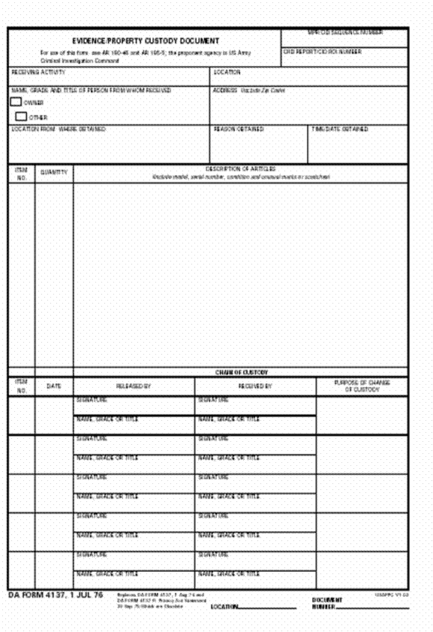
DA Form 4137 - Evidence/Property Custody Document (Front)
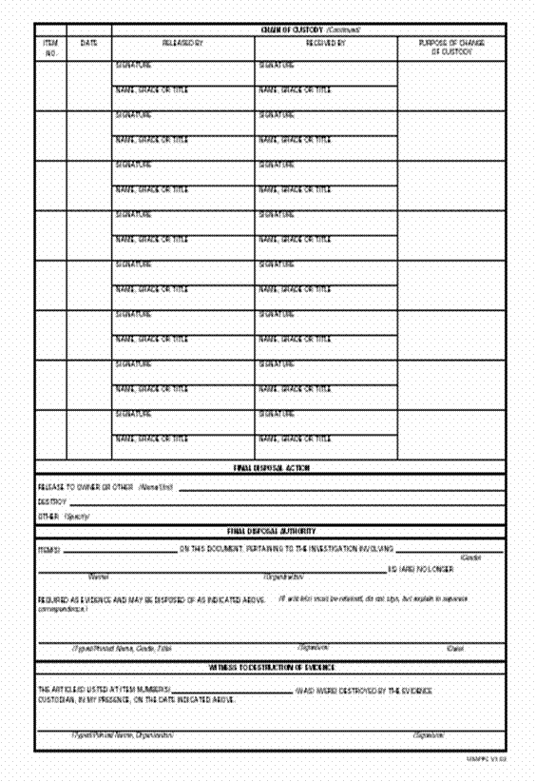
DA Form 4137 - Evidence/Property Custody Document (Back)

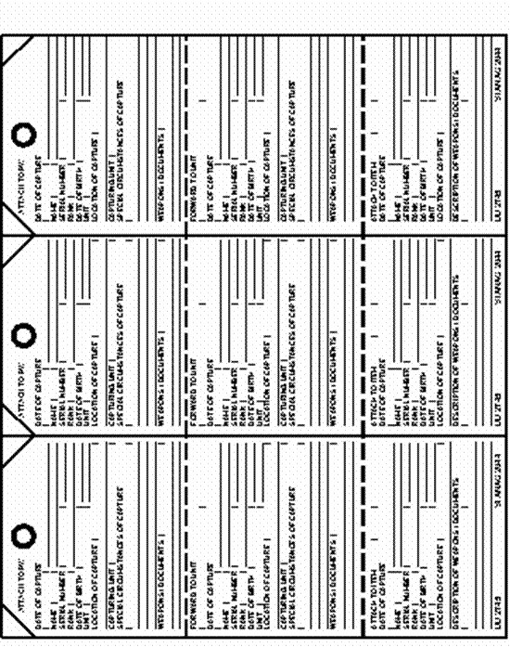
DD Form 2745 - Capture Tag (Front)
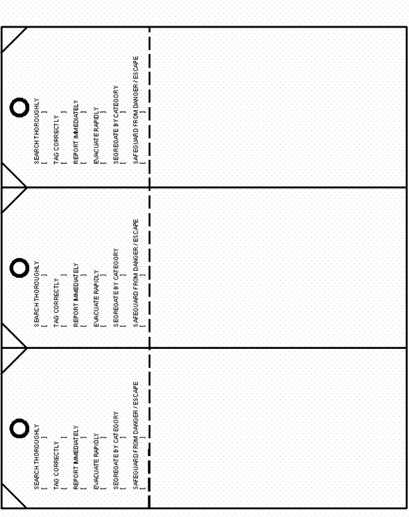
DD Form 2745 - Capture Tag (Back)

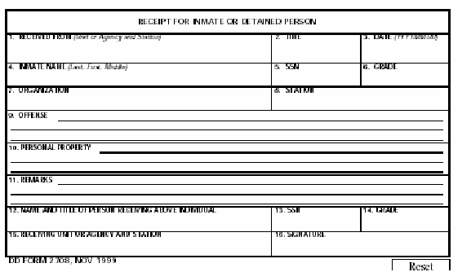
DD Form 2708 - Receipt For Inmate Or Detained Person
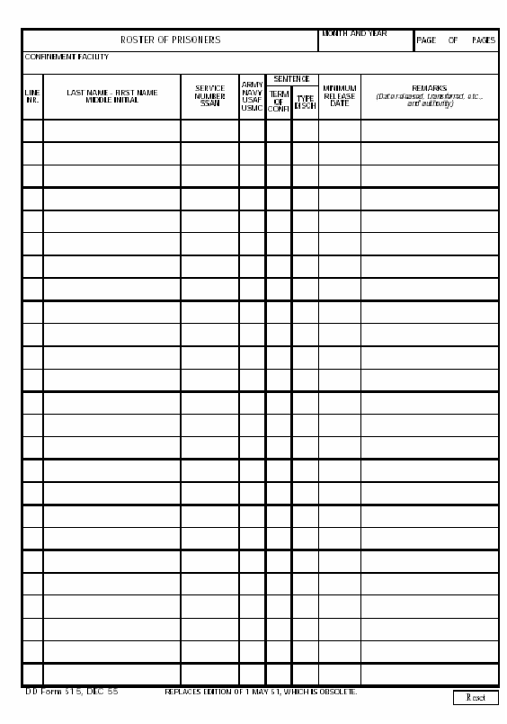
DD Form 515 - Roster Of Persons
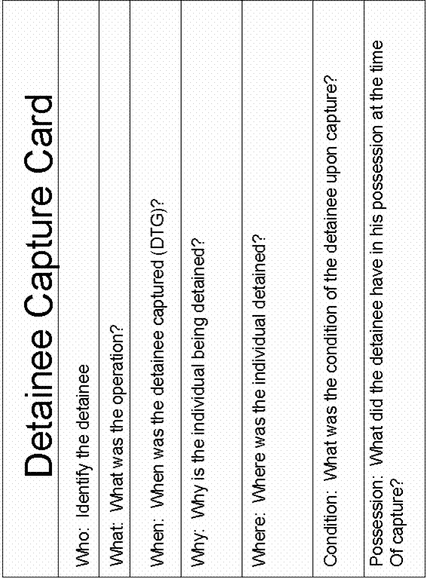
Detainee Capture Card
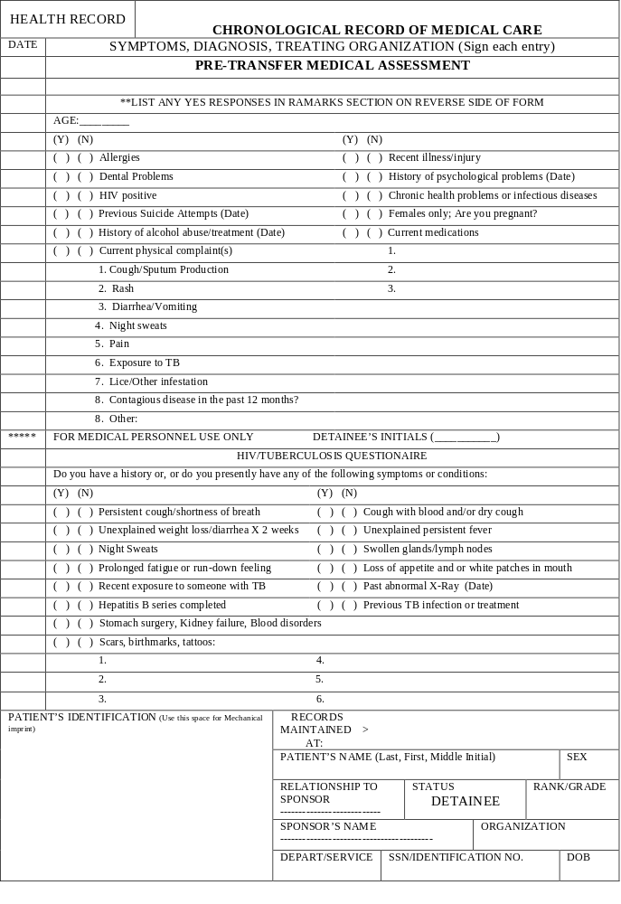
Standard Form 600 - Medical overprint for SF 600 (Front)
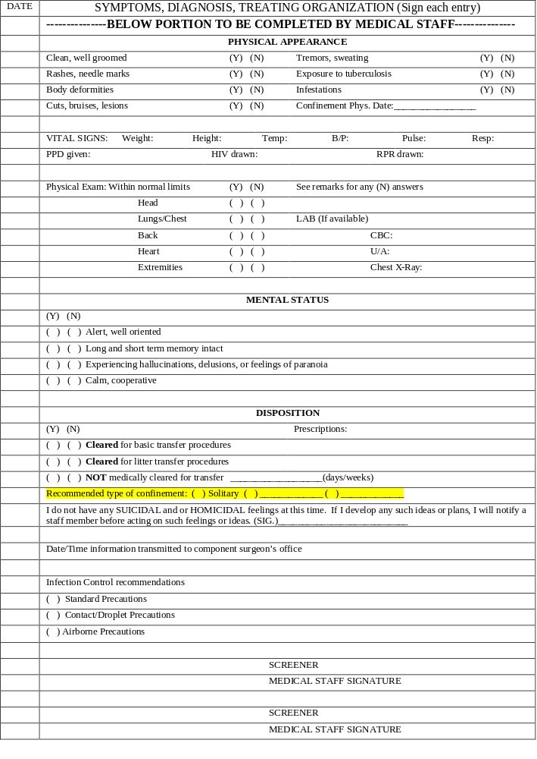
Standard Form 600 - Medical overprint for SF 600 (Back)

DETAINEE MOVEMENT by MILAIR
- Purpose -
The purpose of this concept of operations (CONOPS) is to provide guidance for the transportation of detainees onboard military aircraft. For more indepth guidance and instructions, refer to ______________________.
- Background -
This appendix is divided into ___ tabs. They are as follows:
- TAB A - CONOPS
- TAB B - TASK ORGANIZATION
- TAB C - C-141 AIRCRAFT AND BACKEND TEAM CONFIGURATIONS
- TAB D - C-17 AIRCRAFT AND BACKEND TEAM CONFIGURATIONS
TAB A
CONOPS
- MISSION.
Safely and securely transport detainees by military aircraft from ________________ to _______________.
- ASSUMPTIONS.
- DoD does not have a current requirement for personnel trained and experienced in this type of activity.
- DoD does not have aircraft configured for the secure and safe movement of this type of detainee.
- REQUIREMENTS.
- Primary. Ensure the safety of the aircraft and all US resources. Accomplished by a properly trained and equipped force of military specialists, capable of providing the entire continuum of force, to include deadly force.
- Secondary. Ensure the security of the detainees.
  - Pre-Departure. All detainees will receive a complete medical exam, be deloused and thoroughly bathed, classified, possibly shaved, and a complete cavity inspection (initial and immediately before boarding the aircraft. Briefed about total restrictions while on-board.
  - On-Board.
    - Shackled (cuffed) to leg and wrist irons connected to belly irons and the aircraft…at all times.
    - Blindfolded at all times.
    - No talking or touching of other detainees.
    - No movement…except to use a bathroom.
    - Fed with water and peanut butter/honey or jelly sandwiches.
- OPERATIONS.
- The “Transfer Team” is initially identified as 41 personnel for 36 detainees (Tab B, Attach 1) and would travel with the aircraft. Required training is at Tab I. Required Equipment is in Tab J.
- Processing Liaison Team of approximately 2 personnel will go to the pickup point approximately 3 days early to coordinate with the Detainee Processing Team.
- Timeline for overall execution, including training and equipment acquisition is approximately 10 days.
- The Transfer Team will maintain positive control of all detainees, 100% of the time while they are on the aircraft and until turned over to the receiving organization. All personnel will be equipped with soft-body armor (lvl 2), BDUs, anti-puncture kevlar gloves, flashlights.
- Quick Reaction Team (4 personnel on 4 hour shifts). Responds immediately to ALL incidents. Provides escort for bathroom requests (2 team members on each side of the detainee with the other 2 members armed with stunguns). Equipment. Stungun, tactical baton, flashlights. Comm: all personnel will communicate via headsets or intercom PA system or hand & arm signals.
  - No Lone Zone. Specific area designated where the detainees are located that requires 2 military personnel at all times.
  - Custody Element. One squad (13 personnel) on-duty (4 hour shifts) that provides a squad leader and 6 2-person mobile and/or static patrols. They maintain constant visibility on all detainees, provide food, and in-place sanitation as necessary. Equipment: tactical batons, flashlights. Comm: squad leaders will communciate via headsets or intercom PA system or hand & arm signals.
  - Cockpit Denial Team (2 on 4 hour shifts). Armed with 9mm pistols, loaded with hollow-point munitions. Stop all unauthorized personnel from entering the flight crew area. Equipment: 9mm pistols w/hollow-point munitions, tactical batons, flashlights. Comm: Same as QRT.
- COMMAND AND CONTROL.
- The chain of command will flow as follows: The Aircraft Commander (AC) is the overall authority on board the aircraft. The senior ranking USAF Security Forces Officer has overall authority in the backend of the aircraft with the NCOIC as his second in command. From the NCOIC, authority flows to the senior ranking member of the USAF cockpit denial team, quick reaction teams, and finally to the senior ranking member of the custody squads.
- Due to the special nature of these missions, the standard operational chain of command for medical operations does not apply. Medical/Aeromedical personnel will take direction from the Security team.

TAB B
TASK ORGANIZATION
- BACKGROUND -
Staff and command and control elements for the transportation of detainees will be established as determined by HQ AMC/SF. Line elements will consist of detainee transport teams; the number of teams fielded will be determined by HQ AMC/SF.
- PROCEDURES
- HQ AMC Security Forces. The Director of Air Mobility Command Security Forces will oversee HQ AMC/SF staffing in support of the detainee transport operation through the Division Chief of the Security Forces Operations Division (HQ AMC/SFO).
- McGuire Stage. Staffing and support for the McGuire AFB stage will be determined by HQ AMC/SF.
- Incirlick Stage. Staffing and support for the Incirlick AB stage will be determined by HQ AMC/SF and HQ USAFE/SF MOA.
- Detainee Transport Teams. The number and composition of detainee transport teams will be based on an METT-T assessment of the situation. Personnel and specialists (to include Aeromedical Evacuation teams) may be attached or detached for missions based upon the commander’s assessment of the mission requirements. Mission requirements may also require the reconfiguration of teams or cross-attachment of personnel between teams. Changes to team composition must be approved by HQ AMC/SFO prior to the start of the mission. In a three-team structure, the teams will be designated Alpha through Charlie and will comprise of the following:
  - 1 US Air Force Unit Type Code (UTC) QFEBS (Flight Headquarters Element) totaling 5 personnel (grade enhancements due to mission)
  - 2 US Army MP Platoons (-) totaling 31 personnel
  - 1 US Air Force Flight Surgeon (sourced by US Southern Command)
  - 1 US Air Force Independent Duty Medical Technician (sourced by US Southern Command)
  - 1 Qualified Arabic Linguist (sourced by US Southern Command)
- Additional personnel may be added for the mission such as JCSE communications teams sourced by USTRANSCOM or Combat Camera personnel to provide documentary support for missions.
TAB C
C-141 AIRCRAFT AND BACKEND TEAM CONFIGURATIONS
- BACKGROUND -
The primary concern in configuring the aircraft is to ensure the safety of the aircraft and all US resources. The secondary concern is to ensure the security of the detainees. Aircraft configurations will be determined based on the mission type and detainee through-put requirements. Missions may be classified as one of the following:
- Escort. Missions transporting mobile detainees and ambulatory patients only.
- Aeromedical Evacuation. Mission transporting litter-bound detainees only.
- Mixed Escort/Aeromedical. Mission transporting both litter-bound non-ambulatory detainees and mobile detainees or ambulatory patients.
- TECHNICAL CONSIDERATIONS -
Technical considerations will drive many of the configurations of the aircraft. As a rule, twenty-inch centers will be used for the bench seating on the aircraft. General technical considerations include, but are not limited to:
- Weight considerations.
- Maximum passenger considerations.
- Positioning of the friendly forces comfort pallet forward in pallet position 1.
- Positioning of the detainee comfort pallet aft in pallet position 11.
- The use of pallet position 12 for crew baggage.
- The use of pallet position 13 for backend crew baggage and equipment.
- Space and weight limitations for the ramp pallet on pallet position 13.
- Available litter positions for aeromedical missions.
- Floor-loaded equipment, weapons crates, supplies,etc., at various locations.
- Crew-driven considerations.
- TACTICAL CONSIDERATIONS -
The inside of an aircraft is basically a linear environment, running fore to aft, and requires friendly forces to adjust their tactics based upon the terrain inside the aircraft. The ability to establish a physical security framework within the aircraft to ensure positive control of every detainee all the time is the primary driver for the establishment of the backend team configuration and aircraft configuration. General tactical considerations include, but are not limited to:
- The ability of security elements to contain any attempted breach of security.
- The mobility of friendly security elements.
  - The ability of security elements to respond in a timely and safe manner.
  - The lateral and forward/backward movement of forces.
  - The timely ability for leaders, support specialists, and response forces to maneuver to incidents and positively affect the situation to ensure mission success.
  - The reduction of physical congestion at critical points.
  - The ability to mass friendly forces when needed.
  - The ability to maneuver to economize forces when necessary and respond to multiple security and/or medical incidents simultaneously.
  - The ability of security elements to mutually support each other.
- The counter-mobility of detainees.
- The ability to position forces for immediate and continual visual assessment of detainees.
- The ability to establish a defense-in-depth for critical or sensitive aircraft areas such as the flight deck.
- The ability to rapidly and safely egress the aircraft in the event of an emergency.
- Aircraft configuration should provide friendly forces with adequate engagement lanes should deadly force be necessary and ensure fire is directed away from critical aircraft systems.
- CONFIGURATIONS -
The establishment of a functional, efficient and effective configuration on the aircraft for each type of mission will provide for better security and servicing of the detainees. Mated with an appropriate backend team configuration, tactics will be devised and fielded to meet the known and postulated security and medical problems associated with the detainee transport. A proper aircraft and team configuration will also reduce the likelihood of an escalation of force within the aircraft and allow security elements to minimize risk and liability by allowing them to respond quickly and effectively to keep the incident at a lower level of risk and threat to the aircraft and friendly forces.
- NOTE ON SCHEMATICS -
The schematics in the attachments to this Tab are representative of the aircraft configuration and seating and are not entirely to scale.
ATTACHMENT 1 to TAB B
TEAM CONFIGURATION FOR NOTIONAL (36-36) ESCORT MISSION
- BACKGROUND -
This attachment outlines team configuration for a notional escort mission that will comprise 36 security members and 5 specialist personnel for a maximum delivery of 36 detainees. The forces listed in the backend of the aircraft do not include organic aircraft crewmembers performing duties in the cargo areas.
- TOTAL DETAINEE LOAD -
Forty (36) detainees set in centerline seats. They are positioned approximately between pallet positions 5 and 9 on a C-141.
- FRIENDLY FORCES IN BACKEND OF AIRCRAFT -
The total backend load of friendly personnel is approximately 41 personnel comprised of security and support specialists.
- 36-Person Security Element
  - Officer-in-Charge (USAF Security Forces)
  - Noncommissioned Officer-in-Charge (USAF Security Forces)
  - 2 Two-Person Cockpit Denial Teams (4 USAF Security Forces)
  - 3 Four-Person Quick Reaction Teams (12 USA Military Policemen)
  - 18 Contact Personnel (18 USA Military Policemen)
- 1 Flight Surgeon
- 1 Individual Duty Medical Technician
- 1 Linguist
- 2 Communications Personnel (Generally in Cockpit Area)
- Variable Number of Combat Camera Personnel
- TEAM COMPOSITIONS -
Within the Quick Reaction Teams USA Military Policemen personnel may be replaced by USAF Security Forces. Within the contact personnel, USA Military Policemen may be replaced by USAF Security Forces personnel.
- RELIEF CONCEPT -
During the course of the mission, a relief schedule will be established and enforced by the Officer-in-Charge to ensure an adequate number and security and other personnel are alert and on post at any given time.
- 100% Stand-to of Security Element during On/Off Load Operations
- 100% Stand-to of Security Element during Take-off/Landing
- Rotating Relief Schedule during Flight
  - The Officer-in-Charge or Noncommissioned Officer-in-Charge will remain on post at all times.
  - One of the two-person flight deck denial teams will remain on post at all times.
  - Two of the three four-person quick reaction teams will remain alert and on post at all times. One of these teams will be positioned fore of the detainee seating area and one will be positioned aft of the detainee seating area.
  - At least half of the contact personnel will remain alert and on post at all times.
  - Either the flight surgeon or the IDMT will remain alert and able to provide immediate medical support at all times to friendly forces or detainees.
  - The linguist will be available to provide translator support for security or medical personnel at all times.
ATTACHMENT 1-A TO TAB B
GRAPHIC OF AIRCRAFT CONFIGURATION: 36 Security/36 Detainee
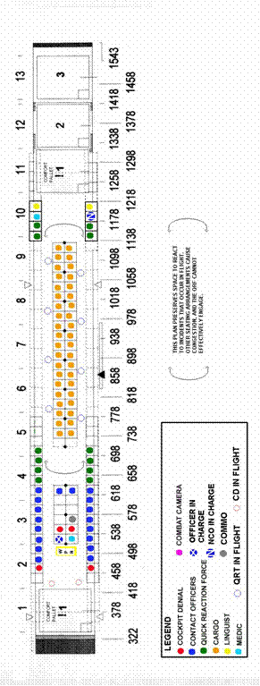

ATTACHMENT 2 TO TAB B
TEAM CONFIGURATION FOR NOTIONAL (45-30) ESCORT MISSION
- BACKGROUND -
This attachment outlines team configuration for a notional escort mission that will comprise 45 security members and 5 specialist personnel for a maximum delivery of 30 detainees. The forces listed in the backend of the aircraft do not include organic aircraft crewmembers performing duties in the cargo areas.
- TOTAL DETAINEE LOAD -
Thirty (30) detainees set in centerline seats. They are positioned approximately between pallet positions 5 and 9 on a C-141.
- FRIENDLY FORCES IN BACKEND OF AIRCRAFT -
The total backend load of friendly personnel is approximately 42 personnel comprised of security and support specialists.
- 45-Person Security Element
  - Officer-in-Charge (USAF Security Forces)
  - Noncommissioned Officer-in-Charge (USAF Security Forces)
  - 2 Two-Person Cockpit Denial Teams (4 USAF Security Forces)
  - 3 Four-Person Quick Reaction Teams (12 USA Military Policemen)
  - 27 Contact Personnel (USA Military Policemen)
- 1 Flight Surgeon
- 1 Individual Duty Medical Technician
- 1 Linguist
- 2 Communications Personnel (Generally in Cockpit Area)
- Variable Number of Combat Camera Personnel
- TEAM COMPOSITIONS -
Within the Quick Reaction Teams USA Military Policemen personnel may be replaced by USAF Security Forces. Within the contact personnel, USA Military Policemen may be replaced by USAF Security Forces personnel.
- RELIEF CONCEPT -
During the course of the mission, a relief schedule will be established and enforced by the Officer-in-Charge to ensure an adequate number and security and other personnel are alert and on post at any given time.
- 100% Stand-to of Security Element during On/Off Load Operations
- 100% Stand-to of Security Element during Take-off/Landing
- Rotating Relief Schedule during Flight
  - The Officer-in-Charge or Noncommissioned Officer-in-Charge will remain on post at all times.
  - One of the two-person flight deck denial teams will remain on post at all times.
  - Two of the three four-person quick reaction teams will remain alert and on post at all times. One of these teams will be positioned fore of the detainee seating area and one will be positioned aft of the detainee seating area.
  - At least half of the contact personnel will remain alert and on post at all times.
  - Either the flight surgeon or the IDMT will remain alert and able to provide immediate medical support at all times to friendly forces or detainees.
  - The linguist will be available to provide translator support for security or medical personnel at all times.
ATTACHMENT 2-A TO TAB B
GRAPHIC OF AIRCRAFT CONFIGURATION: 45 Security/30 Detainee
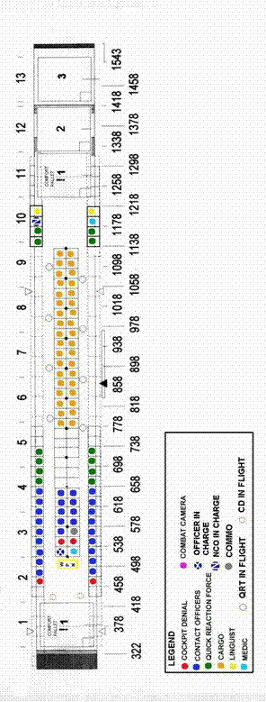
ATTACHMENT 3 TO TAB B
TEAM CONFIGURATION FOR LONG-HAUL ESCORT MISSION
- BACKGROUND -
This attachment outlines team configuration for a long-haul escort mission (nonstop, extremely long ((20+ hours))flight time) that will comprise 36 security members and 6 specialist personnel for a maximum delivery of 26 detainees. The forces listed in the backend of the aircraft do not include organic aircraft crew members performing duties in the cargo areas.
- TOTAL DETAINEE LOAD -
Twenty-six (26) detainees set in centerline seats. They are positioned approximately between pallet positions 6 and 9 on a C-141.
- FRIENDLY FORCES IN BACKEND OF AIRCRAFT -
The total backend load of friendly personnel is approximately 44 personnel comprised of security and support specialists.
- 36-Person Security Element
  - OIC (USAF Security Forces)
  - NCOIC (USAF Security Forces)
  - 2 Two-Person Cockpit Denial Teams (4 USAF Security Forces)
  - 3 Four-Person Quick Reaction Teams (12 USA Military Policemen)
  - 18 Contact Personnel (18 USA Military Policemen)
- 1 Flight Surgeon
- 2 Individual Duty Medical Technicians
- 3 Linguists (at least two able to speak Arabic)
- 2 Communications Personnel (Generally in Cockpit Area)
- Variable Number of Combat Camera Personnel
- Up to six members of the augmented aircrew
- TEAM COMPOSITIONS -
Within the Quick Reaction Teams USA Military Policemen personnel may be replaced by USAF Security Forces. Within the contact personnel, USA Military Policemen may be replaced by USAF Security Forces personnel.
- RELIEF CONCEPT -
During the course of the mission, a relief schedule will be established and enforced by the Officer-in-Charge to ensure an adequate number and security and other personnel are alert and on post at any given time.
- 100% Stand-to of Security Element during On/Off Load Operations
- 100% Stand-to of Security Element during Take-off/Landing
- 100% Stand-down during Flight
- Rotating Relief Schedule during Flight
  - The Officer-in-Charge or Noncommissioned Officer-in-Charge will remain on post at all times.
  - One of the two-person flight deck denial teams will remain on post at all times.
  - Two of the three four-person quick reaction teams will remain alert and on post at all times. One of these teams will be positioned fore of the detainee seating area and one will be positioned aft of the detainee seating area.
  - At least half of the contact personnel will remain alert and on post at all times.
  - Two of the three medical personnel will remain alert and able to provide immediate medical support at all times to friendly forces or detainees.
  - The linguist will remain available to provide translator support for security or medical personnel at all times.
- SIGNIFICANT AIRCRAFT CONFIGURATION CHANGES -
Six centerline litters will be added in litter positions V-4 and W-4 on C-141 AE Floor Plan AE-4. These are added as rest positions for security or support personnel.
ATTACHMENT 3-A TO TAB B
GRAPHIC OF AIRCRAFT CONFIGURATION: Long-Haul Mission
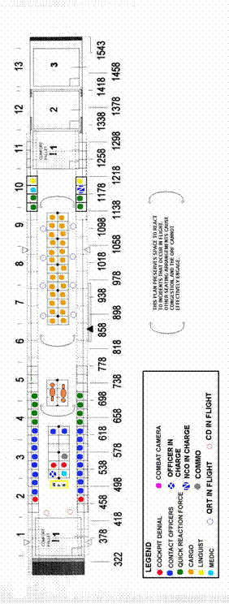
ATTACHMENT 4 TO TAB B
TEAM CONFIGURATION FOR NOTIONAL LITTER SUPPORT MISSION (18 LITTERS)
- BACKGROUND -
This attachment outlines team configuration for a notional litter support mission that will comprise 36 security members and 11 specialist personnel for a maximum delivery of 18 litter detainees (loaded three high on six litter positions). The forces listed in the backend of the aircraft do not include organic aircraft crewmembers performing duties in the cargo areas.
- ADDITIONAL REQUIREMENTS - Medical care
- TOTAL DETAINEE LOAD - Eighteen (18) detainees set in six centerline litter positions.
- FRIENDLY FORCES IN BACKEND OF AIRCRAFT -
The total backend load of friendly personnel is approximately 46 personnel comprised of security and support specialists.
- 36-Person Security Element
  - OIC (USAF Security Forces)
  - NCOIC (USAF Security Forces)
  - 2 Two-Person Cockpit Denial Teams (4 USAF Security Forces)
  - 3 Four-Person Quick Reaction Teams (12 USA Military Policemen)
  - 18 Contact Personnel (18 USA Military Policemen)
- Aeromedical Personnel
  - 1 Flight Surgeon
  - 2 Flight Nurses
  - 3 AE Techs
  - 1 Individual Duty Medical Technicians
- 1 Linguist
- 2 Communications Personnel (Generally in Cockpit Area)
- Variable Number of Combat Camera Personnel
- TEAM COMPOSITIONS -
Within the Quick Reaction Teams USA Military Policemen personnel may be replaced by USAF Security Forces. Within the contact personnel, USA Military Policemen may be replaced by USAF Security Forces personnel.
- RELIEF CONCEPT -
During the course of the mission, a relief schedule will be established and enforced by the Officer-in-Charge to ensure an adequate number and security and other personnel are alert and on post at any given time.
- 100% Stand-to of Security Element during On/Off Load Operations
- 100% Stand-to of Security Element during Take-off/Landing
- Rotating Relief Schedule during Flight
  - The Officer-in-Charge or Noncommissioned Officer-in-Charge will remain on post at all times.
  - One of the two-person flight deck denial teams will remain on post at all times.
  - Two of the three four-person quick reaction teams will remain alert and on post at all times. One of these teams will be positioned fore of the detainee seating area and one will be positioned aft of the detainee seating area.
  - At least half of the contact personnel will remain alert and on post at all times.
  - Medical personnel will develop a relief schedule according to the senior medical representative and able to provide immediate medical support at all times to friendly forces or detainees.
  - The linguist will remain available to provide translator support for security or medical personnel at all times.
- SIGNIFICANT AIRCRAFT CONFIGURATION CHANGES -
Six centerline litters will be added in litter positions P-4, Q-4, H-4, O-4, K-4 and L-4 on C-141 AE Floor Plan AE-4.
- COORDINATION REQUIREMENTS -
Must plan for approximately 800 pounds of AE equipment/supplies. All medical personnel must attend pre-mission training at McGuire Stage.
ATTACHMENT 4-A TO TAB B
GRAPHIC OF AIRCRAFT CONFIGURATION: Notional Aeromedical Evacuation Mission
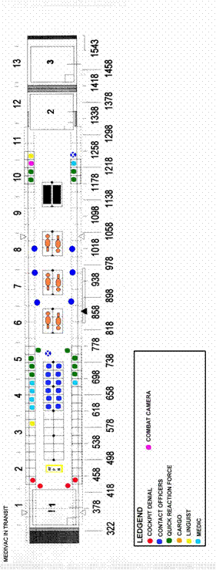

ATTACHMENT 5 TO TAB B
TEAM CONFIGURATION FOR NOTIONAL MIXED AEROMEDICAL/ESCORT MISSION (6 LITTERS, 20 DETAINEES)
- BACKGROUND -
This attachment outlines team configuration for a notional aeromedical evacuation mission that will comprise 36 security members and 11 specialist personnel for a maximum delivery of 6 litter detainees (loaded three high on one litter position) and 20 ambulatory detainees. The forces listed in the backend of the aircraft do not include organic aircraft crewmembers performing duties in the cargo areas.
- TOTAL DETAINEE LOAD -
Six litter-bound (6) detainees set in one centerline litter position and twenty detainees in centerline seats in approximately between pallet positions 7 and 9.
- FRIENDLY FORCES IN BACKEND OF AIRCRAFT -
The total backend load of friendly personnel is approximately 46 personnel comprised of security and support specialists.
- 36-Person Security Element
  - OIC (USAF Security Forces)
  - NCOIC (USAF Security Forces)
  - 2 Two-Person Cockpit Denial Teams (4 USAF Security Forces)
  - 3 Four-Person Quick Reaction Teams (12 USA Military Policemen)
  - 18 Contact Personnel (18 USA Military Policemen)
- 1 Flight Surgeon
- 1 Individual Duty Medical Technicians
- 5 Personnel in an Augmented Aeromedical Evacuation Team
- 1 Linguist
- 2 Communications Personnel (Generally in Cockpit Area)
- Variable Number of Combat Camera Personnel
- TEAM COMPOSITIONS -
Within the Quick Reaction Teams USA Military Policemen personnel may be replaced by USAF Security Forces. Within the contact personnel, USA Military Policemen may be replaced by USAF Security Forces personnel.
- RELIEF CONCEPT -
During the course of the mission, a relief schedule will be established and enforced by the Officer-in-Charge to ensure an adequate number and security and other personnel are alert and on post at any given time.
- 100% Stand-to of Security Element during On/Off Load Operations
- 100% Stand-to of Security Element during Take-off/Landing
- Rotating Relief Schedule during Flight
  - The Officer-in-Charge or Noncommissioned Officer-in-Charge will remain on post at all times.
  - One of the two-person flight deck denial teams will remain on post at all times.
  - Two of the three four-person quick reaction teams will remain alert and on post at all times. One of these teams will be positioned fore of the detainee seating area and one will be positioned aft of the detainee seating area.
  - At least half of the contact personnel will remain alert and on post at all times.
  - Medical personnel will develop a relief schedule according to the senior medical representative and able to provide immediate medical support at all times to friendly forces or detainees.
  - The linguist will be available provide translator support for security or medical personnel at all times.
- SIGNIFICANT AIRCRAFT CONFIGURATION CHANGES -
Six centerline litters will be added in litter positions G-4 and H-4 on C-141 AE Floor Plan AE-5. Another set of litter positions at I-4 and J-4 will carry the equipment of the Aeromedical crews.
ATTACHMENT 5-A TO TAB B
GRAPHIC OF AIRCRAFT CONFIGURATION: Notional Mixed Aeromedical Evacuation/Escort Mission
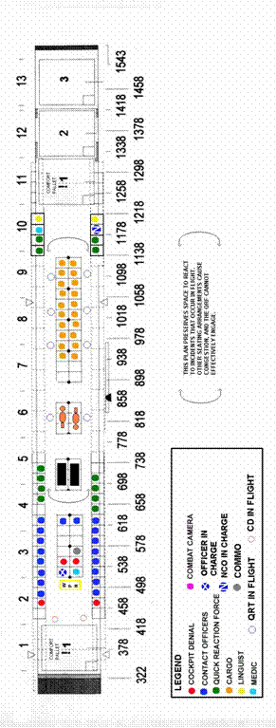

TAB D
C-17 AIRCRAFT AND BACKEND TEAM CONFIGURATIONS
- BACKGROUND -
General considerations for the C-17 remain the same as for a C-141 as outlined in Tab B.
- TECHNICAL CONSIDERATIONS -
Technical considerations will drive many of the configurations of the aircraft. General technical considerations include, but are not limited to:
- Weight considerations.
- Maximum passenger considerations.
- Positioning of the friendly forces comfort pallet forward in the starboard pallet position 1.
- Positioning of the detainee comfort pallet aft in the starboard pallet position 9.
- The use of starboard pallet position 10 for crew baggage.
- The use of starboard pallet position 11 for backend crew baggage and equipment.
- Space and weight limitations for the ramp pallet on pallet positions 10 and 11.
- The maintenance of open pallet positions 9-11 on the left-hand side of the aircraft for the loading and unloading of the detainees.
- Available litter positions for aeromedical missions.
- Floor-loaded equipment, weapons crates, supplies, etc., at various locations.
- Crew-driven considerations.
- TACTICAL CONSIDERATIONS -
Tactical considerations for the C-17 remain the same as for a C-141 as outlined in Tab B.
- TEAM COMPOSITION -
In the C-17, as with the C-141, the establishment of a functional, efficient and effective configuration on the aircraft for each type of mission will provide for better security and servicing of the detainees. Mated with an appropriate backend team configuration, tactics will be devised and fielded to meet the known and postulated security and medical problems associated with the detainee transport. A proper aircraft and team configuration will also reduce the likelihood of an escalation of force within the aircraft and allow security elements to minimize risk and liability by allowing them to respond quickly and effectively to keep the incident at a lower level of risk and threat to the aircraft and friendly forces.
- NOTE ON SCHEMATICS -
The schematics in the attachments to this Tab are representative of the aircraft configuration and seating and are not entirely to scale.
ATTACHMENT 1 to TAB C
TEAM CONFIGURATION FOR NOTIONAL (36-36) ESCORT MISSION
- BACKGROUND -
This attachment outlines team configuration for a notional escort mission that will comprise 36 security members and 5 specialist personnel for a maximum delivery of 36 detainees. The forces listed in the backend of the aircraft do not include organic aircraft crewmembers performing duties in the cargo areas.
- TOTAL DETAINEE LOAD -
Thirty-six (36) detainees set in centerline seats. They are positioned approximately between pallet positions 4 and 8 on a C-17.
- FRIENDLY FORCES IN BACKEND OF AIRCRAFT -
The total backend load of friendly personnel is approximately 41 personnel comprised of security and support specialists.
- 36-Person Security Element
  - Officer-in-Charge (USAF Security Forces)
  - Noncommissioned Officer-in-Charge (USAF Security Forces)
  - 2 Two-Person Cockpit Denial Teams (4 USAF Security Forces)
  - 3 Four-Person Quick Reaction Teams (12 USA Military Policemen)
  - 18 Contact Personnel (18 USA Military Policemen)
- 1 Flight Surgeon
- 1 Individual Duty Medical Technician
- 1 Linguist
- 2 Communications Personnel (Generally in Cockpit Area)
- Variable Number of Combat Camera Personnel
- TEAM COMPOSITION -
Within the Quick Reaction Teams USA Military Policemen personnel may be replaced by USAF Security Forces. Within the contact personnel, USA Military Policemen may be replaced by USAF Security Forces personnel.
- RELIEF CONCEPT -
During the course of the mission, a relief schedule will be established and enforced by the Officer-in-Charge to ensure an adequate number and security and other personnel are alert and on post at any given time.
- 100% Stand-to of Security Element during On/Off Load Operations
- 100% Stand-to of Security Element during Take-off/Landing
- Rotating Relief Schedule during Flight
  - The Officer-in-Charge or Noncommissioned Officer-in-Charge will remain on post at all times.
  - One of the two-person flight deck denial teams will remain on post at all times.
  - Two of the three four-person quick reaction teams will remain alert and on post at all times. One of these teams will be positioned fore of the detainee seating area and one will be positioned aft of the detainee seating area.
  - At least half of the contact personnel will remain alert and on post at all times.
  - Either the flight surgeon or the IDMT will remain alert and able to provide immediate medical support at all times to friendly forces or detainees.
  - The linguist will be available to provide translator support for security or medical personnel at all times.
ATTACHMENT 1-A TO TAB C
GRAPHIC OF AIRCRAFT CONFIGURATION: 36 Security/36 Detainee
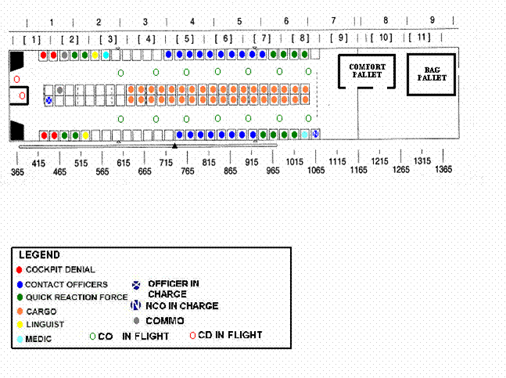

TAB D
SECURITY PROCEDURES FOR AIRCRAFT EMERGENCY DIVERT
- BACKGROUND -
To address diversion/aircraft breakdown contingencies for detainee transport operations in support of Operation ENDURING FREEDOM.
- CRITICAL ASSUMPTIONS -
The following assumptions were made in developing this plan.
- Established detention facilities may or may not be available.
- Aircraft conditions/weather may require the egress of detainees.
- SECURITY DURING EMERGENCY DIVERSION OF AIRCRAFT -
Various exigencies may cause the aircraft to divert to an unscheduled location. Upon landing at an unscheduled stop, if possible, the detainees will not be removed from the aircraft. Emergencies threatening the safety of the crew, friendly forces, or the detainees may force the evacuation of the aircraft. Upon landing the security OIC will contact HQ AMC Security Forces for guidance on security actions to be taken. If possible, the Foreign Clearance Guide will be consulted for restrictions regarding arming and employment of forces.
- Security Actions If the Detainees Can Remain On-Board The Aircraft. If the detainees are not removed from the aircraft, the OIC will establish security for the aircraft and will ensure the safety and security of the detainees.
  - The OIC will determine if friendly forces on the ground can and will provide physical security for the aircraft. OICs should be cognizant of the threats to the aircraft, and the density and importance of the personnel inside the aircraft when determining on-site security requirements. An aircraft loaded with friendly personnel and detainees warrants more than routine Protection Level 3 security. If the friendly forces can provide adequate security, the OIC will ensure appropriate communications and liaison is maintained between the on-board security element and the on-ground defense forces.
  - If inadequate security is at the divert location to protect the aircraft, the OIC will direct the flight deck denial team to arm with M-16 rifles and take up positions to defend the aircraft. If diplomatic agreements allow the arming of United States personnel off of the aircraft, an adequate number of Security Forces personnel will be positioned to protect the aircraft against hostile action. If unable to arm personnel outside of the aircraft, the OIC will position an adequate number of personnel of the flight deck denial team on the ground outside of the aircraft to perform immediate visual assessment (IVA) of the aircraft area. This will likely be the whole flight deck denial team. The OIC will arm one of the quick reaction teams with M-16 rifles for external protection of the aircraft and position them inside the aircraft (in hatches, doorways, et. al.) in overwatch positions in support of the on-ground IVA personnel. As a lower-threat option, a rifleman can be posted sitting on roof of the aircraft (feet on the flight deck bunk, weapon on bunk) with the top escape hatch open.
  - The OIC will ensure the security of the detainees by directing the employment of contact officer personnel and quick reaction teams inside the aircraft commensurate with in-flight operations. Medical and linguist personnel will remain on-board with the detainees and provide support as required/directed to the security operation.
  - The OIC will establish a relief schedule with available personnel to ensure sustainment of the detainee security operation until supporting or reinforcing personnel arrive.
- Security Actions If the Detainees Must be Removed From The Aircraft. If the detainees are removed from the aircraft, the OIC will, first and foremost, ensure the safety and security of the detainees and then, mission permitting, establish security for the aircraft. US Army MPs assume control of the detainees while on the ground under the command and control of the OIC/NCOIC.
  - Security elements will draw assigned weapons and ammunition if allowed by diplomatic agreements. One of the USAF Security Forces quick reaction teams will be armed and employed for aircraft security as outlined in 3.a.(2.) above.
  - Security OIC and MP Platoon Leader establishes local security for detainees.
  - Security OIC and MP Platoon Leader conduct METT-T assessment.
    - Determine local threats, possible supporting forces, and the security environment at the emergency site.
    - Assess length of stay based on Aircraft Commander input.
    - Determines if feasible fixed facility is available (optimum).
    - Determines movement requirement to facility.
    - Secure food/water for detainees.
    - Secures/establishes latrine facility for detainees.
    - Determines availability of Class IV to secure facility (Collection Point).
  - Identify External Security Team (3 MP personnel with weapons, if allowed).
  - Identify Internal Security Teams (6 MP personnel without weapons).
  - Segregate detainees based on available facilities
    - If possible, remove anchor cable from aircraft to secure detainees to facility (trees if necessary).
    - Belly chain, or use 550 cord, detainees to each other securing or use of the cable is not possible (Groups of 5).
  - Identify Quick Reaction Team (from USA quick reaction team) (4 personnel employing less than lethal force) to serve as collecting point reaction force.
  - Identify flight deck denial team for immediate armed security in emergency evacuation.
  - Medical and linguist personnel will travel with the detainees and provide support as required/directed to the security operation.
- SUPPORTING/REINFORCING FORCES -
OICs and NCOICs will be knowledgeable of the contingency plans regarding supporting/reinforcing elements (this includes estimated response times, originating location(s) and configurations, et. al.). This will provide a reference point for determining requirements for security and for relief schedules for organic security and specialist support. This information may be classified.
- 3 ATTACHMENTS:
- 1. External Collection Point (Worst Case)
- 2. Forward Collection Point (Doctrinal)
- 3. Notional Aircraft Security Arrangements
ATTACHMENT 1 TO TAB D
EXTERNAL COLLECTION POINT (WORST CASE)
BACKGROUND -
This schematic outlines a doctrinal approach to the security of detainees if they must be removed from the aircraft. Schematic is not to scale.
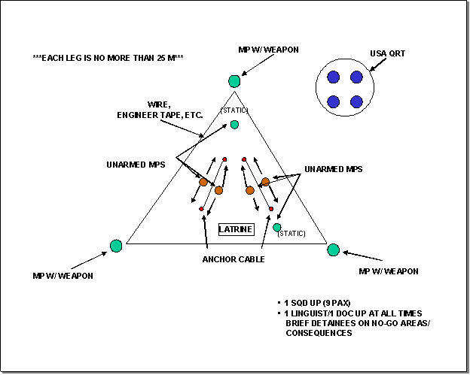
ATTACHMENT 2 TO TAB D
FORWARD COLLECTION POINT (DOCTRINAL)
BACKGROUND -
This is an extract from Field Manual 19-4 outlining the establishment of a field forward collecting point that can provide a point of reference for use if the detainees must be removed from the aircraft.
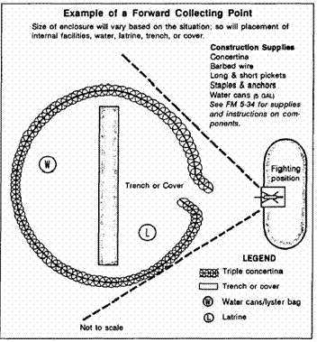
There is no set design for a forward collecting point. Build the Collecting Point to suit the climate, the weather, and the situation. When selecting or constructing a Collecting Point, consider how you will provide for:
- Security of the detainees.
- First aid.
- Food and water.
- Latrine facilities.
- Field sanitation.
- Shelter.
- Cover.
(Extract, Field Manual 19-4)

ATTACHMENT 3 TO TAB D
NOTIONAL AIRCRAFT SECURITY ARRANGEMENTS
BACKGROUND -
Aircraft security will depend on the security environment at the divert site and the threat. Security for an aircraft loaded with friendly forces and detainees will require more security than a routine Protection Level 3 (PL 3) aircraft. Security for an empty aircraft should meet PL 3 requirements after security of the detainees is assured. Security requirements and tactical employment of forces will be driven by the OIC’s METT-T assessment of the situation.
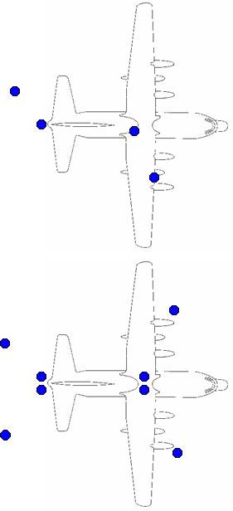

Figure 1: Low-End Threat and/or PL 3 Security Option

Figure 2: Higher Threat Option

TAB E
TRANSPORT MISSION SECURITY PROCEDURES (Tactics, Techniques, and Procedures)
- BACKGROUND -
The primary consideration in all facets of the detainee escort mission is to ensure the safety of the aircraft and all US resources. This will be accomplished by a properly trained and equipped force of military specialists, capable of providing the entire continuum of force, to include deadly force. The secondary consideration is to ensure the security of the detainees. No instruction can outline all tactics, techniques and procedures to be used throughout the detainee escort missions thus it is necessary for security elements and other personnel to use their best judgment when determining what course of action to take when completing their mission. Given time, questions should be addressed through the chain of command for resolution.

- PROCEDURES -
A thorough METT-T analysis of the situation and the application of troop leading procedures will provide the framework for accomplishing the mission. The guidelines and tactics, techniques, and procedures for completing the transport missions are outlined in attachments to this Tab.
- The following apply to all handling of detainees:
  - Prior to transport teams receiving the detainees from the pickup location processing unit, all detainees will receive a complete medical exam, be deloused and thoroughly bathed, classified, possibly shaved, and a complete cavity inspection (initial and immediately before boarding the aircraft. Detainees will be briefed about total restrictions while on-board. Detainees will be escorted to the plane, under positive control, from the holding area by SF personnel.
  - On-board the aircraft:
    - Detainees will be under positive control by security element personnel at all times.
    - Detainees will be shackled (cuffed) to leg and wrist irons connected to belly irons and the aircraft.
    - Detainees will be blindfolded at all times.
    - Detainee’s gloves will remain in place at all times.
    - Detainees will have ear/hearing muffs on.
    - Detainees will not be allowed to speak unless for bathroom breaks.
    - Detainees will not talk or touch each other.
    - Detainees will not move or be removed from their seats without the authorization of the security OIC or NCOIC.
    - Detainees will be provided water and culturally-sensitive food only.
  - Aircrew pre-departure Briefing - Prior to departure on a flying leg of a mission, the security OIC will complete a pre-departure briefing with the aircrew.
    - Security OIC will introduce self and team to aircrew.
    - Security OIC will ensure the briefing is in a secure area.
    - Chain of Command on board aircraft
    - Situation: How many detainees, changes to configurations, etc.
    - Security element responsibilities
    - Aircrew responsibilities
    - Requests/requirements from aircrew
    - Contingency operations
    - Review/practice emergency crash procedures
    - Review/practice egress procedures
    - Communication
    - Converse with aircrew on what weapons/equipment is on board and ROE for use.
    - Anti-hijacking procedures and cockpit denial
- 7 ATTACHMENTS:
- Escort Mission C-17 Up-load When Detainees Fully Restrained
- Escort Mission C-17 Down-load (Trans-load)
- Escort Mission C-141 Up-load (Trans-load)
- Escort Mission C-141 Down-load at Final Destination
- Escort Mission C-17 Down-load at Final Destination
- Escort Mission C-17 Up-Load When Detainees Not Fully Restrained
- Maintenance Problem Trans-load
- In-Flight Operations for Escort Missions in the C-141 Aircraft
ATTACHMENT 1 TO TAB E
ESCORT MISSION C-17 UPLOAD DETAINEES FULLY RESTRAINED
- BACKGROUND -
Detainees will be received from the processing unit and loaded onto the aircraft under the supervision of the Security Forces OIC. Accountability of detainees and friendly forces will be maintained between the Security Forces OIC and the Processing Unit OIC.
- PERSONNEL -
The security compliment, supporting medical and linguist personnel, and aircrew will be determined by the type of mission being flow (either a notional escort flow mission or a long-haul non-stop mission).
- PROCEDURES -
Security OICs and NCOIC have tactical command and control of all up-load operations in the cargo compartment of the aircraft and will adopt tactics, techniques, and procedures to meet mission requirements.
- All security elements will stand-to prior to the aircraft blocking-in.
- It is not necessary to off-load the rear pallets on the aircraft prior to any movement of detainees onto the aircraft. There is enough room on the C-17 to allow the safe and effective movement into the detainee seating area.
- The security OIC and NCOIC will alert and position security elements and supporting units, and will move to the rear ramp to oversee loading operations. The OIC receives a package from the processing unit OIC (documents, manifests, medical records, personal effects, military intelligence folders, forensic folder, and identification CD-ROM, and keys if required) from the Processing Unit OIC. The processing unit OIC also provides a threat briefing on the detainees. The NCOIC primarily directs the up-load operations. A minimum of ground personnel will be allowed onto the aircraft during up-load operations.
- The flight deck denial personnel will maintain a position at or near (1) in the crows’ nest and (2) at the base of the flight deck stairs forward in the cargo area for observation of the upload operation. M-9 pistols loaded with hollowpoint ammunition will not be taken off of the aircraft at J-215 under any circumstances. Flight deck denial on the ground is not a primary concern. The flight deck denial personnel that are not posted in the above positions armed will be standing by the weapons crates for immediate off-load or distribution of weapons if required.
- Contact officer personnel awaiting their detainees will assemble at the rear of the aircraft with the quick reaction teams to assist in upload operations. Contact officer personnel will remain in the contact officer seating area after their detainees are loaded onto the aircraft.
- One forward quick reaction team will remain in the forward part of the cargo area to respond to security incidents during up-load.
- The rear quick reaction team will assemble at the rear of the aircraft.
- Upon direction from the OIC/NCOIC, one of the contact officers and one of the quick reaction team members will exit the aircraft to receive a detainee.
- The QRT member/contact officer will take control of the detainee from losing security elements and will conduct a search of the detainee at the base of the ramp prior to escorting the detainee onto the aircraft.
- After the detainee search is completed the detainee will be escorted onboard the aircraft, then seated by the contact officer/QRT team.
- The detainee will be positioned in front of his/her seat and at the count of three, will be placed into the seated position by the security element.
- The detainee will be secured to the aircraft using the "D" ring first and then the seatbelt. While the “D” ring is being secured by the contact officer, the detainee will be held in place by the quick reaction team member. The security personnel will ensure the detainee is masked/blindfolded, has the hearing protection equipment properly in place, and the restraint equipment is properly applied to ensure the security and health of the detainee. The detainee will be released by the contact officer/QRT team simultaneously.
- The OIC/NCOIC will use the additional QRT personnel as needed throughout the up-load operation to assist in the safe and effective loading of the detainees with the primary concern for the safety of friendly forces and control of the detainees.
- Medical and linguist personnel will be called to assist in the up-load operation by the OIC/NCOIC as needed.
- After the loading and securing of all detainees, the cargo area personnel will maintain positions to provide the best security until the aircraft is about to block-out.
- Immediately prior to block-out, all personnel will assume their seated positions and remain at stand-to. Personnel may need to service the detainees during taxi but will make every effort to follow the instructions of the loadmaster.
- During aircraft take-off the security and supporting elements will secure themselves in their seats; they will remain at stand-to until the OIC orders the beginning of the relief schedule.
- LOGISTICS -
The Security Forces OIC/NCOIC will ensure that supplies and materials destined for this location are off-loaded and handed to the appropriate receiving agency/personnel.
ATTACHMENT 2 TO TAB E
ESCORT MISSION C-17 DOWN-LOAD (TRANS-LOAD)
- BACKGROUND -
Detainees received from the processing unit will be transported by C-17 to intermediate location and trans-loaded onto a C-141 aircraft under the supervision of the Security Forces OICs and NCOICs. Accountability of detainees and friendly forces will be maintained between the Security Forces OICs.
- PERSONNEL -
The security compliment, supporting medical and linguist personnel, and aircrew will be determined by the type of mission being flown and other operational requirements.
- PROCEDURES -
Security OICs and NCOICs have tactical command and control of all up-load operations in the cargo compartment of the aircraft and will adopt tactics, techniques, and procedures to meet mission requirements.
- All security and supporting elements will stand-to prior to the aircraft blocking-in.
- It is not necessary to off-load the rear pallets on the aircraft prior to any movement of detainees off of the aircraft. There is enough room on the C-17 to allow the safe and effective movement into the detainee seating area.
- The losing security OIC and NCOIC will alert and position security elements and supporting units, and will move to the rear ramp to oversee down-load operations. The losing OIC will go to the C-141 up-load aircraft and provide a package to the gaining OIC (documents, manifests, medical records, personal effects, military intelligence folders, forensic folder, and identification CD-ROM, and keys if required). The losing OIC also provides a threat briefing on the detainees. The NCOICs primarily direct the trans-load operations. A minimum of ground personnel will be allowed onto either aircraft during up-load operations; all non-security personnel will be kept clear of the ramp.
- The flight deck denial personnel will maintain a position at or near (1) in the crows’ nest and (2) at the base of the flight deck stairs forward in the cargo area for observation of the upload operation. M-9 pistols loaded with hollowpoint ammunition will not be taken off of the aircraft. Flight deck denial on the ground is not a primary concern. The flight deck denial personnel that are not armed will prepare the weapons crates for immediate off-load or distribution of weapons.
- Contact officer personnel awaiting down-load of their detainees will assemble with their designated detainees in the cargo compartment of the aircraft. They will remain on post observing their detainees until instructed to complete the down-load.
- One forward quick reaction team will remain in the forward part of the cargo area to respond to security incidents during down-load.
- The rear quick reaction team will assemble at the rear of the aircraft with one of the forward quick reaction teams.
- Upon direction from the OIC/NCOIC, designated contact officers and quick reaction team members will prepare to exit the aircraft with a detainee. The detainee will be secured in his/her seat by security personnel. The security personnel will ensure the detainee remains masked/blindfolded/gloved, has the hearing protection equipment properly in place, and the restraint equipment is properly applied to ensure the security and health of the detainee. The detainee’s seatbelt will be removed. The detainee will then be unhooked from the aircraft by releasing the "D" ring. While the “D” ring is being released by the contact officer, the detainee will be held in place by the quick reaction team member. The detainee will be lifted to a standing position by the contact officer/QRT team simultaneously.
- Upon orders from the OIC/NCOIC, the detainee will be escorted off the aircraft and to the trans-load C-141 where they will be received by the gaining security element. Escorting personnel will maintain their hands on the detainee at all times during the movement and will sound the alarm if the detainee poses a risk, security or other, or has a medical emergency.
- Contact officer personnel who no longer have a detainee to secure/observe will seat themselves out of the way so as to not impede down-load operations.
- The OIC/NCOIC will use the additional QRT personnel as needed throughout the down-load operation to assist in the safe and effective trans-loading of the detainees with the primary concern for the safety of friendly forces and control of the detainees.

- Medical and linguist personnel will be called to assist in the trans-load operation by the OICs/NCOICs as needed.
- After the down-loading and securing of detainees, personnel will maintain positions to provide the best security until the operation is complete.
- LOGISTICS -
The Security Forces OIC/NCOIC will ensure that supplies and materials destined for this location are off-loaded and handed to the appropriate receiving agency/personnel.
- STAND-DOWN -
The Security Forces OIC/NCOIC will order a stand-down of security and supporting forces after all mission requirements are complete.
ATTACHMENT 3 TO TAB E
ESCORT MISSION C-141 UP-LOAD (TRANS-LOAD)
- BACKGROUND -
Detainees will be received from the C-17 aircraft and loaded onto the C-141 aircraft under the supervision of the Security Forces OIC. Accountability of detainees and friendly forces will be maintained between both Security Forces OICs.
- PERSONNEL -
The security compliment, supporting medical and linguist personnel, and aircrew will be determined by the type of mission being flown and other operational requirements.
- PROCEDURES -
Security OICs and NCOICs have tactical command and control of all up-load operations in the cargo compartment of the aircraft and will adopt tactics, techniques, and procedures to meet mission requirements.
- All security elements will stand-to prior to the detainee laden C-17 aircraft blocking-in.
- The rear pallets will be off-loaded from the C-141 aircraft prior to any movement of detainees onto the aircraft. This should be accomplished prior to the arrival of the C-17 laden aircraft. Placement of the pallets should not interfere with trans-load operations between the aircraft.
- The gaining security OIC and NCOIC will alert and position security elements and supporting units, and will move to the rear ramp to oversee loading operations. The gaining OIC receives a package from the losing Security Forces OIC (documents, manifests, medical records, personal effects, military intelligence folders, forensic folder, and identification CD-ROM, and keys if required). The losing Security Forces OIC also provides a threat briefing on the detainees and hand-off to the gaining OIC. The NCOICs will primarily direct the trans-load operation. A minimum of ground personnel will be allowed onto either aircraft during trans-load operations.
- The flight deck denial personnel will maintain a position at or near the base of the flight deck stairs forward in the cargo area for observation of the upload operation. M-9 pistols loaded with hollowpoint ammunition will not be taken off of the aircraft. Flight deck denial on the ground is not a primary concern. The flight deck denial personnel that are not in the above positions will standby the weapons crates for immediate off-load or distribution of weapons if required.
- Contact officer personnel awaiting their detainees will assemble at the rear of the aircraft with the quick reaction teams to assist in upload operations. Contact officer personnel will remain with their detainees after their detainees are loaded onto the aircraft.
- One forward quick reaction team will move to the rear ramp.
- The rear quick reaction team will assemble at the rear of the aircraft with one of the forward quick reaction team.
- Upon direction from the OIC/NCOIC, one of the contact officers and one of the quick reaction team members will exit the aircraft to receive a detainee.
- The QRT member/contact officer will take control of the detainee from losing security elements and will conduct a search of the detainee at the base of the ramp prior to escorting the detainee onto the aircraft.
- After the detainee search is completed the detainee will be escorted onboard the aircraft, then seated by the contact officer/QRT team.
- The detainee will be positioned in front of his/her seat and at the count of three, will be placed into the seated position by the security element.
- The detainee will be secured to the aircraft using the "D" ring first and then the seatbelt. While the “D” ring is being secured by the contact officer, the detainee will be held in place by the member of the quick reaction team. The security personnel will ensure the Detainee is masked/blindfolded/gloved, has the hearing protection equipment properly in place, and the restraint equipment is properly applied to ensure the security and health of the Detainee. The detainee will be released simultaneously by the contact officer/QRT team.
- The OIC/NCOIC will use the additional QRT personnel as needed throughout the up-load operation to assist in the safe and effective loading of the detainees with the primary concern for the safety of friendly forces and control of the detainees.
- Medical and linguist personnel will be called to assist in the trans-load operation by the OIC/NCOIC as needed.
- After the loading and securing of all detainees, the cargo area personnel will maintain positions to provide the best security until the aircraft is about to block-out.
- The rear pallets will be loaded onto the C-141 aircraft after all detainees are on board the aircraft.
- Immediately prior to block-out, all personnel will assume their seated positions and remain at stand-to. Personnel may need to service the detainees during taxi but will make every effort to follow the instructions of the loadmaster.
- During aircraft take-off the security and supporting elements will secure themselves in their seats and remain at stand-to until the OIC orders the beginning of the relief schedule.
- LOGISTICS -
The Security Forces OIC/NCOIC will ensure that supplies and materials destined for this location are off-loaded and handed to the appropriate receiving agency/personnel. They will also ensure that materials destined for this location are received and secured for transport.
ATTACHMENT 4 TO TAB E
ESCORT MISSION C-141 DOWN-LOAD AT FINAL DESTINATION
- BACKGROUND -
Detainees received from the processing unit must be down-loaded from the aircraft under the supervision of the Security Forces OIC. Accountability of detainees and friendly forces will be maintained by the Security Forces OIC.
- PERSONNEL -
The security compliment, supporting medical and linguist personnel, and aircrew will be determined by the type of mission being flown and other operational requirements.
- PROCEDURES -
Security OICs and NCOICs have tactical command and control of all up-load operations in the cargo compartment of the aircraft and will adopt tactics, techniques, and procedures to meet mission requirements.
- All security and supporting elements will stand-to prior to the aircraft blocking-in.
- The rear pallets must be off-loaded from the C-141 aircraft prior to any movement of detainees off the aircraft.
- The security OIC and NCOIC will alert and position security elements and supporting units, and will move to the rear ramp to oversee down-load operations. The losing OIC will contact the gaining (Army or USMC) security OIC and provide a package to the gaining OIC (documents, manifests, medical records, personal effects, military intelligence folders, forensic folder, and identification CD-ROM, and keys if required). The USAF security OIC will also provide a threat briefing to the gaining OIC on the detainees and in-flight operations. The NCOIC primarily directs the down-load operation. A minimum of ground personnel will be allowed onto the aircraft during down-load operations.
- The flight deck denial personnel will maintain a position at or near (1) in the crows’ nest and (2) at the base of the flight deck stairs forward in the cargo area for observation of the upload operation. M-9 pistols loaded with hollowpoint ammunition will not be taken off of the aircraft. Flight deck denial on the ground is not a primary concern. The flight deck denial personnel that are not posted in the above positions will standby the weapons crates for immediate off-load or distribution of weapons, if required.
- Contact officer personnel awaiting down-load of their detainees will assemble with their designated detainees in the cargo compartment of the aircraft. They will remain on post observing their detainees until instructed to complete the down-load.
- One forward quick reaction team will remain in the forward part of the cargo area to respond to security incidents during down-load.
- The rear quick reaction team will assemble at the rear of the aircraft with one of the forward quick reaction teams.
- Upon direction from the OIC/NCOIC, designated contact officers and quick reaction team members will prepare to exit the aircraft with a detainee. The detainee will be secured in his/her seat by security personnel. The security personnel will ensure the detainee remains masked/blindfolded, has the hearing protection equipment properly in place, and the restraint equipment is properly applied to ensure the security and health of the detainee. The detainee’s seatbelt will be removed. The detainee will then be unhooked from the aircraft by releasing the "D" ring. While the “D” ring is being released by the contact officer, the detainee will be held in place by the quick reaction team member. The detainee will be lifted to a standing position by the contact officer/QRT team simultaneously.
- Upon orders from the OIC/NCOIC, the detainee will be escorted off the aircraft and to the rear ramp where they will be received by the gaining (Army or USMC) security elements. Escorting personnel will maintain their hands on the detainee at all times during the movement and will sound the alarm if the detainee poses a risk, security or other, or has a medical emergency.
- Contact officer personnel who no longer have a detainee to secure/observe will seat themselves out of the way so as to not impede down-load operations.
- The OIC/NCOIC will use the additional QRT personnel as needed throughout the down-load operation to assist in the safe and effective trans-loading of the detainees with the primary concern for the safety of friendly forces and control of the detainees.

- Medical and linguist personnel will be called to assist in the trans-load operation by the OICs/NCOICs as needed.
- After the down-loading and securing of detainees, personnel will maintain positions to provide the best security until the operation is complete.
- LOGISTICS -
The Security Forces OIC/NCOIC will ensure that supplies and materials destined for this location are off-loaded and handed to the appropriate receiving agency/personnel.
- STAND-DOWN -
The Security Forces OIC/NCOIC will order a stand-down of security and supporting forces after all mission requirements are complete.
ATTACHMENT 5 TO TAB E
ESCORT MISSION C-17 DOWN-LOAD
- BACKGROUND -
Detainees received from the processing unit must be down-loaded from the aircraft under the supervision of the Security Forces OIC. Accountability of detainees and friendly forces will be maintained by the Security Forces OIC.
- PERSONNEL -
The security compliment, supporting medical and linguist personnel, and aircrew will be determined by the type of mission being flown and other operational requirements.
- PROCEDURES -
The security OIC and NCOIC have tactical command and control of all up-load operations in the cargo compartment of the aircraft and will adopt tactics, techniques, and procedures to meet mission requirements.
- All security and supporting elements will stand-to prior to the aircraft blocking-in.
- It is not necessary to off-load the three rear pallets on the aircraft prior to any movement of detainees off of the aircraft. There is enough room on the C-17 to allow the safe and effective movement into the detainee seating area.
- The losing (USAF) security OIC and NCOIC will alert and position security elements and supporting units, and will move to the rear ramp to oversee down-load operations. The losing OIC will go to the C-141 up-load aircraft and provide a package to the gaining (USMC) OIC (documents, manifests, medical records, personal effects, military intelligence folders, forensic folder, and identification CD-ROM, and keys if required). The losing OIC also provides a threat briefing on the detainees and the in-flight operations to the gaining OIC. The NCOIC primarily direct the down-load operations. A minimum of ground personnel will be allowed onto the aircraft during down-load operation.
- The flight deck denial personnel will maintain a position at or near (1) in the crows’ nest and (2) at the base of the flight deck stairs forward in the cargo area for observation of the upload operation. M-9 pistols loaded with hollowpoint ammunition will not be taken off of the aircraft. Flight deck denial on the ground is not a primary concern. The flight deck denial personnel that are not in the above positions will stand by the weapons crates for immediate off-load or distribution of weapons, if required.
- Contact officer personnel awaiting down-load of their detainees will assemble with their designated detainees in the cargo compartment of the aircraft. They will remain on post observing their detainees until instructed to complete the down-load.
- One forward quick reaction team will remain in the forward part of the cargo area to respond to security incidents during down-load.
- The rear quick reaction team will assemble at the rear of the aircraft with one of the forward quick reaction teams.
- Upon direction from the OIC/NCOIC, designated contact officers and quick reaction team members will prepare to exit the aircraft with a detainee. The detainee will be secured in his/her seat by security personnel. The security personnel will ensure the detainee remains masked/blindfolded, has the hearing protection equipment properly in place, and the restraint equipment is properly applied to ensure the security and health of the detainee. The detainee’s seatbelt will be removed. The detainee will then be unhooked from the aircraft by releasing the "D" ring. While the “D” ring is being released, the detainee will be held in place by other security personnel. The detainee will be lifted to a standing position by the contact officer/QRT team simultaneously.
- Upon orders from the OIC/NCOIC, the detainee will be escorted off the aircraft and to the rear ramp where they will be received by the gaining security element. Escorting personnel will maintain their hands on the detainee at all times during the movement and will sound the alarm if the detainee poses a risk, security or other, or has a medical emergency.
- Contact officer personnel who no longer have a detainee to secure/observe will seat themselves out of the way so as to not impede down-load operations.
- The OIC/NCOIC will use the additional QRT personnel as needed throughout the down-load operation to assist in the safe and effective trans-loading of the detainees with the primary concern for the safety of friendly forces and control of the detainees.

- Medical and linguist personnel will be called to assist in the trans-load operation by the OIC/NCOIC as needed.
- After the down-loading and securing of detainees, personnel will maintain positions to provide the best security until the operation is complete.
- LOGISTICS -
The Security Forces OIC/NCOIC will ensure that supplies and materials destined for this location are off-loaded and handed to the appropriate receiving agency/personnel.
- STAND-DOWN -
The Security Forces OIC/NCOIC will order a stand-down of security and supporting forces after all mission requirements are complete.
ATTACHMENT 6 TO TAB E
ESCORT MISSION C-17 UPLOAD AT WHEN DETAINEES NOT FULLY RESTRAINED
- BACKGROUND -
Detainees will be received from the processing unit at and loaded onto the aircraft under the supervision of the Security Forces OIC. Accountability of detainees and friendly forces will be maintained between the Security Forces OIC and the Processing Unit OIC.
- PERSONNEL -
The security compliment, supporting medical and linguist personnel, and aircrew will be determined by the type of mission being flow (either a notional escort flow mission or a long-haul non-stop mission).
- PROCEDURES -
Security OICs and NCOIC have tactical command and control of all up-load operations in the cargo compartment of the aircraft and will adopt tactics, techniques, and procedures to meet mission requirements.
- All security elements will stand-to prior to the aircraft blocking-in.
- It is not necessary to off-load the rear pallets on the aircraft prior to any movement of detainees onto the aircraft. There is enough room on the C-17 to allow the safe and effective movement into the detainee seating area.
- The security OIC and NCOIC will alert and position security elements and supporting units, and will move to the rear ramp to oversee loading operations. The OIC receives a package from the processing unit OIC (documents, manifests, medical records, personal effects, military intelligence folders, forensic folder, and identification CD-ROM, and keys if required) from the Processing Unit OIC. The processing unit OIC also provides a threat briefing on the detainees. The NCOIC primarily directs the up-load operations. A minimum of ground personnel will be allowed onto the aircraft during up-load operations.
- The flight deck denial personnel will maintain a position at or near (1) in the crows’ nest and (2) at the base of the flight deck stairs forward in the cargo area for observation of the upload operation. M-9 pistols loaded with hollowpoint ammunition will not be taken off of the aircraft under any circumstances. Flight deck denial on the ground is not a primary concern. The flight deck denial personnel that are not posted in the above positions armed will be standing by the weapons crates for immediate off-load or distribution of weapons if required.
- Contact officer personnel awaiting their detainees will assemble at the rear of the aircraft with the quick reaction teams to assist in upload operations. Contact officer personnel will remain in the contact officer seating area after their detainees are loaded onto the aircraft.
- One forward quick reaction team will remain in the forward part of the cargo area to respond to security incidents during up-load.
- The rear quick reaction team will assemble at the rear of the aircraft.
- Upon direction from the OIC/NCOIC, one of the contact officers and one of the quick reaction team members will exit the aircraft to receive a detainee.
- The QRT member/contact officer will take control of the detainee from losing security elements and will conduct a search of the detainee at the base of the ramp prior to escorting the detainee onto the aircraft.
- After the detainee search is completed the detainee will be escorted onboard the aircraft, then seated by the contact officer/QRT team.
- The detainee will be positioned in front of his/her seat and at the count of three, will be placed into the seated position by the security element and his seatbelt fastened.
- The OIC/NCOIC will use the additional QRT personnel as needed throughout the up-load operation to assist in the safe and effective loading of the detainees with the primary concern for the safety of friendly forces and control of the detainees.
- Medical and linguist personnel will be called to assist in the up-load operation by the OIC/NCOIC as needed.
- Once the AC is buttoned up, the contact officers will position themselves in front of their detainees. Upon direction from the OIC/NCOIC, two QRT members will position themselves in front of the detainee and, along with that detainee’s contact officer, reconfigure the detainee with full restraints (handcuffs, leg irons, belly chain). The detainee will be secured to the aircraft using the "D" ring first and then the seatbelt. While the “D” ring is being secured by the contact officer, the detainee will be held in place by the quick reaction team member. The security personnel will ensure the detainee has the hearing protection equipment properly in place, and the restraint equipment is properly applied to ensure the security and health of the detainee. The detainee will be released by the contact officer/QRT team simultaneously.
- After the loading and securing of all detainees, the cargo area personnel will maintain positions to provide the best security until the aircraft is about to block-out.
- Immediately prior to block-out, all personnel will assume their seated positions and remain at stand-to. Personnel may need to service the detainees during taxi but will make every effort to follow the instructions of the loadmaster.
- During aircraft take-off the security and supporting elements will secure themselves in their seats; they will remain at stand-to until the OIC orders the beginning of the relief schedule.
- LOGISTICS -
The Security Forces OIC/NCOIC will ensure that supplies and materials destined for this location are off-loaded and handed to the appropriate receiving agency/personnel.
ATTACHMENT 7 TO TAB E
MAINTENANCE PROBLEM TRANS-LOAD
- BACKGROUND -
Detainees received from the processing unit must be down-loaded from the aircraft under the supervision of the Security Forces OIC. Accountability of detainees and friendly forces will be maintained by the Security Forces OIC.
- PROCEDURES -
Security OICs will follow established up-load and down-load procedures during transfer between aircraft.
- In the event of maintenance or other problem that prevents the departure of the up-loaded C-141, the detainees will be trans-loaded onto a standby C-141.
- In the event of maintenance or other problem that prevents the departure of the up-loaded standby C-141 the detainees will be trans-loaded onto a C-17 aircraft.
- In the event the C-17 cannot depart, the detainees will be loaded onto buses and secured at a temporary holding facility until an aircraft is sourced for departure.
- Perimeter security for the trans-load operations will be completed by a US Army Military Police platoon.
ATTACHMENT 8 TO TAB E
IN-FLIGHT OPERATIONS FOR ESCORT MISSIONS
- BACKGROUND -
During in-flight operations, the security of detainees will require feeding, latrine escorts, and other actions such as the adjustment of restraints. Emergency actions to include emergency evacuation and the rapid decompression of the aircraft may be implemented. No instruction can outline all tactics, techniques and procedures to be used throughout the detainee escort missions thus it is necessary for security elements and other personnel to use their best judgment when determining what course of action to take when completing their mission. Given time, questions should be addressed through the chain of command for resolution.
- PERSONNEL -
The security compliment, supporting medical and linguist personnel, combat camera, and aircrew will be determined by the type of mission being flown and other operational requirements. Aircraft and team configurations are outlined in Tab C.
- PROCEDURES -
The security OIC and NCOIC have tactical command and control of all up-load operations in the cargo compartment of the aircraft and will adopt tactics, techniques, and procedures to meet mission requirements. Only one detainee should be allowed out of his/her seat or without all restraints in place at any one time except during an emergency evacuation or egress. This includes adjusting restraints, during first aid or the administration of medication, latrine escorts, et. al. Goggles, hearing protection, and gloves will remain on the detainees at all times. A “No-Lone Zone” will be established inside the aircraft from the forward-most seated detainee to the rear-most seated detainee on both the port and starboard sides. No friendly forces personnel will be allowed to operate or move within this zone without a second security person able to immediately detect and respond to hostile action against the friendly forces. There are no exceptions to this rule. Buffer zones will be established fore and aft of the area the detainees are secured in to provide room for the friendly forces to maneuver, a location to stand-down during the work-rest cycle, and for other events such as medical care for friendly forces. Contact officers and quick reaction teams members will not spontaneously respond to security or medical incidents without alerting others to the situation. They will alert friendly forces to the incident and then interact with the situation to restore control, order or safety.
- Adjusting Restraints. Minor adjustments of restraints may not require their removal. Restraints are never released without the order of the security OIC or NCOIC.
  - Only the minimum amount of restraint equipment will be removed if the restraints need to be adjusted.
  - Goggles, hearing protection, and gloves will remain on the detainees at all times.
  - Security personnel will maintain positive control of the detainees at all times. At least three security element personnel will secure the detainee/adjust the restraints if they must be removed.
  - The adjustment of restraints will be recorded on the detainee contact form if the restraints are required to be removed in the process. If a minor adjustment is completed that does not require the removal of any of the equipment, an annotation is not required on the contact form.
- Administering Medication or Aid (for Friendly Forces). Medication and aid will be administered by medical personnel assigned to the mission within established protocols and directives. This will be done in a secure location (buffer zone) away from any detainee operations (seating, feeding, latrine escorts, etc.). The security OIC will be notified of any medication or aid applied to friendly forces and the possible impact on the mission.
- Administering Medication or Aid (for Detainees). Medication will be administered by medical personnel assigned to the mission within established protocols and directives. Medication will not be administered to any detainee without security personnel restraining the detainee. The security OIC will be notified of any medication or aid given to the detainees.
  - Medical personnel will be alerted by security elements that medical care is required. This may be verbally or by hand and arm signals.
  - Security personnel will restrain the detainee in the seat or on the litter prior to medical personnel coming in contact with the detainee. This will normally be done by at least two security personnel who will physically hold the detainee in place against the seat or litter and step on the floor chain to secure the detainee’s feet. The security personnel will ensure the detainee remains masked/blindfolded, has the hearing protection equipment and gloves properly in place, and the restraint equipment is properly applied to ensure the security and health of the detainee. The detainee’s seatbelt or restraining equipment will be not removed except at the direction of the security OIC or NCOIC.
  - Medical personnel will then administer aid or medications as needed while the detainee is secured. These personnel should exercise caution and good situational awareness so as to not unduly expose themselves to danger with the detainees.
  - Medical aid and administration of medication (for security purposes) will be recorded on the detainee contact form.
- Feeding/Hydration. Detainees will be fed and provided water on a schedule determined by the security OIC. OICs should consider planning feeding and watering around scheduled aerial refuelings and other events that might effect the feeding. OICs will ensure all detainees are fed only culturally approved cuisine.
  - Contact officers are assigned the responsibility of feeding the detainees. Linguists will be used to go to each detainee and identify which ones wish to eat. The contact officers will provide the food for the detainee to feed him or herself.
  - Gloves and ear/hearing protection will not be removed from the detainees.
  - Contact officers will position themselves in a manner to observe the detainee’s feeding and be able to alert others to security and medical incidents. They will assist the detainee’s with eating or drinking to the extent it does not endanger their safety or reduced the overall security posture on the aircraft.
  - Feeding and hydration will be recorded on the detainee contact form.
- Latrine Escorts. Latrine escorts will be completed in a combined effort by the contact officers and quick reaction team members. Upon direction of the OIC/NCOIC, the detainee will be released from his/her seat and escorted to and from the latrine.
  - A contact officer and a member of the rear quick reaction team will ensure the detainee remains masked/blindfolded, has the hearing protection equipment properly in place, and the restraint equipment is properly applied to ensure the security and health of the detainee.
  - The detainee’s seatbelt will be removed.
  - The detainee will then be unhooked from the aircraft by releasing the "D" ring. While the “D” ring is being released, the detainee will be held in place by other security personnel. The detainee will be lifted to a standing position by the contact officer/QRT team simultaneously.
  - The detainee will be escorted to the comfort pallet and will be observed at all times. The detainee will use the latrine in a seated position. After the use of the latrine is completed, the detainee will be escorted back to his/her seat. Security escort personnel will keep positive control of the detainee during all times he or she is not completely secured in his or her seat.
  - The detainee will be secured to the aircraft using the "D" ring first and then the seatbelt. While the “D” ring is being secured, the detainee will be held in place by the quick reaction team members. The security personnel will ensure the detainee is masked/blindfolded, has the hearing protection equipment properly in place, and the restraint equipment is properly applied to ensure the security and health of the detainee. The detainee will be released simultaneously by the contact officer/QRT team.
  - Latrine escorts will be recorded on the detainee contact form.
- Emergency Evacuation/Egress.
  - Upon orders of the aircraft commander, the security and supporting forces will begin emergency evacuation or egress procedures. An emergency exit point(s) will be identified to the friendly forces for the evacuation of the aircraft by the loadmaster or aircraft commander. From a security standpoint, the rear ramp is always the preferred evacuation point for the detainees.
  - If and when safe to do so, the contact officers, supported by members of the quick reaction teams, will move into the detainee seating/litter area and will position themselves to escort the detainees from the aircraft.
    - If the evacuation point is in the front of the aircraft, the rear quick reaction team will assist the contact officer and if in the rear of the aircraft, the forward quick reaction team members will assume this role.
    - If the evacuation point is in the front of the aircraft, the front quick reaction team(s) and flight deck denial personnel will be the first out of the aircraft to establish a security perimeter and assist in the off-loading of the detainees through the passenger doors. If the evacuation point is in the rear of the aircraft, the rear quick reaction team members will assume this role. Off-loading in the rear may be through the passenger doors or on the ramp.
  - Once in place, the security elements will unhook the detainees from the floor chain by unsnapping the D-ring and will remove the seatbelt from the detainee. The detainee will then by lifted into a standing position.
  - When able, the security elements escorting the detainees will begin moving the detainees off of the aircraft in an orderly fashion.
  - The OIC will be the last person of the security/support team to exit the aircraft and will conduct an accounting of personnel. The OIC will also carry the information package provided at the processing unit with him/her.
  - If on land, the detainees and security/support personnel will rally at a location directed by the aircraft commander.
  - Once off the aircraft, a security perimeter will be established. Once practical, the security divert procedures in Tab D will be initiated.
  - It is imperative that the SF OIC and aircrew discuss emergency evacuation procedures prior to the start of each mission and, if at all possible, that rehearsals are conducted.
- Divert (Security) Procedures. Security and supporting actions during aircraft diverts are outlined in Tab D.
- Deadly Force Immediate Action Drill. This paragraph applies to deadly force used by the cockpit denial teams. If possible, friendly forces will be alerted if deadly force is about to be used in flight by three sharps blasts on a whistle or the verbal alarm “DROP-DROP-DROP.” Friendly personnel will immediately take cover, in a prone position with their head away from the front of the aircraft so the cockpit denial team may engage hostile target(s).
- Decompression/depressurization of the Aircraft. In the event of an announced or unannounced decompression of the aircraft, friendly forces will don oxygen masks and complete a buddy-check of personnel around them to ensure they have properly donned their mask. After ensuring that friendly forces are secure and have taken immediate steps to respond to the depressurization, contact officer will, when safe to do so, place masks on the detainees. Additional contact officers may be detailed by the security OIC to observe the detainees during this period or assist the flight medical personnel will assessment of the detainees.
- LOGISTICS -
Security team equipment will be accounted for as it is issued prior to the mission and then accounted for after the flying mission is complete. Medical equipment will be maintained under the positive control of the medical custodian.
- STAND-DOWN -
The Security Forces OIC/NCOIC will only order a stand-down of security and supporting forces after all mission requirements are complete.
- ADMINISTRATION AND REPORTS -
The Security OIC and senior medical official have administrative requirements during the mission
- The Security OIC will collect detainee contact forms after the mission.
- A Security Blotter will be maintained under the direction of the Security OIC during the mission and will outline significant events and incidents.
- Any Use of Force will be documented on the Use of Force Form. The Security OIC will collect these forms after the mission. The OIC may direct the accomplishment of statements (AF Fm 1168) to supplement the Use of Force Form.
- The senior medical representative will maintain directed medical contact logs and reports, and accountability for medications and medical practices.
- The Security OIC may direct the accomplishment of statements (AF Fm 1168s) or incident reports (AF FM 3545s) to document any incidents, events or occurrences relating to the mission.
- The Security OIC will maintain custody logs, packages, and articles concerning the detainees and ensure they are delivered to the appropriate office or agency.
TAB F
USE OF FORCE/WEAPONS
- BACKGROUND -
Security element personnel must remember at all times to use force appropriate for the circumstances. No list can give all scenarios where force is needed. The security element personnel must use their own experience and training when deciding what level of force is appropriate. The use of force will not be abusive, but under no circumstances will disruptive or violent behavior be tolerated. The safety of the crew and the detainees requires fair but firm use of force.
- USE OF FORCE -
All security personnel will be trained in approved Use of Force policies prior to coming in contact with any detainees.
- USE OF DEADLY FORCE -
Security OICs and NCOICs must review Supplemental Rules of Engagement, paragraph 6C (MSG DTG 052331ZJAN02) and brief all personnel before every mission.
- RULES OF ENGAGEMENT (ROE) -
Approved Special Rules of Engagement (SROE) will be briefed to all personnel prior to coming in contact with any detainees. Updates or changes to the ROE or SROE will be immediately briefed to all personnel.
- WEAPONS -
In order to meet the requirements of the mission and Use of Force policies, various weapons may be fielded by security elements.
- M-16/M-16A2/M-4 Weapons Systems. Weapons will be maintained according to T.O.s and will not be modified for this operation. Ball or ball/tracer ammunition may be used on this operation. HQ AMC/SF POC is SFXT, HQ AMC/SFXT, at DSN 779-0646.
- M-9 Weapon System. Weapons will be maintained according to T.O.s and will not be modified for this operation. Hollowpoint ammunition will be used by the flight deck denial teams in-flight and ball ammunition will be used if the weapons are taken off the aircraft. Hollowpoint ammunition will under no circumstances be taken off of the aircraft in war zones or locations where its use would constitute a Law of Armed Conflict violation. HQ AMC/SF POC is SFXT, HQ AMC/SFXT, at DSN 779-0646.
- Armament Systems and Procedures (ASP) Tactical Baton. Twenty-one inch ASP batons will be used on this operation. These batons were chosen for use in the confined spaces of the aircraft. Damaged or inoperable batons will not be used; they will be repaired or replaced.
- M26 Advanced Taser, Model # 44000. The M26 Taser will be used in the contact mode only and will not have the CO2 projection cartridges attached. HQ AMC/SF POC is HQ AMC/SFXR, at DSN 779-0636.
  - Power output: 50,000 Volt, 26 Watts, 162mA, 1.76 Joules per pulse energy
  - Power supply: 8 AA Nickel Metal Hydride (NiMH) rechargeable batteries or hi-output alkaline batteries, self-contained inside polyethylene battery tray, with reverse insertion prevention feature.
  - Aiming Mechanisms:
    - Mechanical: Fixed front and rear "fin and blade" sights, optimized at 13 foot range
    - Optical: 650 nm wavelength, daytime laser sight, optimized at 13 foot range
  - Housing Dimensions: 6.4"x1.4"x5.9" (inches)
  - Material: 5% glass filled, pre-colored, virgin polycarbonate 101.
  - Activation Switch Material: High durability black Santoprene, shore A
  - Laser Lens Material: Optically clear polycarbonate
  - On Board Memory: Fast recording EEPROM chip records 585 firings, records date and time
  - Battery Indicator: High visibility red LED calibrated for alkaline batteries
TAB G
REPORTS AND FORMS
- BACKGROUND -
Security OICs are responsible for completing/maintaining logs and forms for the detainee transport missions. Situation Reports (SITREPs) are required during detainee missions. Logs and reports will be signed by the person completing them or by the OIC.
- PROCEDURES -
The following forms and reports will be used.
- Forms:
  - AF Fm 3545 Incident Report. Will be completed at the direction of the OIC or NCOIC for significant events, incidents, or occurrences.
  - AF Fm 1168 Statement of Witness/Suspect. Will be completed at the direction of the OIC/NCOIC to supplement any other documentation or as a stand-alone document, as needed.
  - AF Fm 53 Security Police Desk Blotter. Will be completed and signed by the OIC for every detainee escort mission. The mission’s AF Fm 53 will include a duty roster of security and supporting personnel.
  - AF Fm 1297 Temporary Hand Receipt. Will be used to account for detainees and equipment/packages as they are transferred from person to person and agency to agency.
  - AF Fm 52 Evidence Tag. Will be used at the discretion of the OIC/NCOIC.
  - Detainee Contact Log (Local Form). Will be used for every detainee on every escort mission.
  - Use of Force Report (Local Form). Will be used for every instance of force above verbal commands when dealing with the detainees.
- Reports:
  - Situation Reports (SITREPs). Formal SITREPs will be completed and forwarded verbally, electronically, or in writing as directed by HQ AMC/SF. Attachments 1, 2, and 3 to this Tab outline SITREP reporting requirements.
  - After-Action Reports (AARs). OICs will complete an AAR upon return to KWRI. This AAR will include the AF Fm 53, any statements or other forms completed (as applicable), lessons learned, and any narratives or other supporting data. This will be completed no later than close of business on the day after the team’s return to KWRI.
  - Lessons Learned. Lessons learned will be compiled after every mission. Lessons learned will be turned in to the KWRI stage manager in an abbreviated format from that found in Attachment 5 to AFI 31-201 Security Police Standards and Procedures. All lessons learned will include the following:
    - Name and team designation of the submitter.
    - An observation (a precise, factual description of the entire incident in a narrative format to include any background information).
    - A Discussion (a critical review of the procedures and actions accomplished during the incident to highlight potential problem areas and prevent similar incidents or prompt a review of appropriate policy and procedures).
    - Lessons Learned (a synopsis of better ways of handling the incident or occurrence to handle or prevent similar future events).
- ATTACHMENTS:
- SITREP and Status Report Frequency During Escort Flights
- SITREP/Status Report Frequency
- SITREP Format
- Detainee Contact Log
- Use of Force Report
ATTACHMENT 1 TO TAB G
SITUATION REPORT (SITREP) AND STATUS REPORT FREQUENCY DURING ESCORT FLIGHTS
- BACKGROUND -
HQ AMC/SF determines times and content of SITREPs for the security OICs during detainee transport missions. SITREPS or status reports will be called in to the HQ AMC Security Forces Contingency Operations Cell (DSN 779-0005, COMM 618-229-0005) as directed.
- PROCEDURES -
SITREPs or status reports will be called in to the HQ AMC/SF with the following frequency:
- A SITREP or status report will be called in anytime a significant incident occurs. This will be done as soon as possible after the incident via the in-flight SATCOM.
- The security/support team manifest will be called in upon departure. No SITREP is required unless 2.a. above applies.
- A SITREP will be called in upon departure from pickup location. This will include the detainee manifest.
- A SITREP will be called in upon landing at intermediate location. This will include a security/support team manifest for new team on the mission.
- A SITREP will be called in upon landing at destination.
- Upon return to KWRI, an after-action-report (AAR) and Mission Report (MISREP) will be completed NLT COB the day after return to KWRI.
ATTACHMMENT 2 TO TAB G
SITREP/STATUS REPORT FREQUENCY
BACKGROUND -
Table 1 outlines HQ AMC/SF directed SITREP and status report frequency for the detainee transfer missions.
TABLE 1: SITREP/STATUS REPORT FRENQENCY
KWRI Stage | Daily | SITREP or Status Report
KWRI Stage | As Needed | A SITREP or status report will be called in anytime a significant incident occurs. This will be done as soon as possible after the incident
Intermediate Stage | Daily | SITREP or Status Report
Intermediate Stage | As Needed | A SITREP or status report will be called in anytime a significant incident occurs. This will be done as soon as possible after the incident
Detainee Processing Unit | Daily | SITREP or Status Report
Detainee Processing Unit | As Needed | A SITREP or status report will be called in anytime a significant incident occurs. This will be done as soon as possible after the incident
Detainee Escort Teams | As Needed | A SITREP or status report will be called in anytime a significant incident occurs. This will be done as soon as possible after the incident
Detainee Escort Teams | Departure from Intermediate Stage to Pickup Location | SITREP: Include security/support team manifest
Detainee Escort Teams | Departure from Pickup Location | SITREP: Include detainee manifest
Detainee Escort Teams | Arrival at Intermediate Stage from Pickup Location | SITREP: Include new backend crew manifest
Detainee Escort Teams | Arrival at drop-off location | SITREP
Detainee Escort Teams | Return to KWRI | After-action-report (AAR) and Mission Report (MISREP) will be completed NLT COB the day after return

ATTACHMENT 2 TO TAB G
SITUATION REPORT (SITREP) FORMAT
BACKGROUND -
Table 2 outlines the directed SITREP format.
TABLE 2: SITREP FORMAT
Alpha |  | DTG (Date Time Group): Date and time of SITREP. Identified by Day, Zulu Time, Month and Year. (141135Z Oct 97 is the time date group for 14 Oct 97, at 1135 Hours Zulu)
Bravo |  | Team –  Team Leader –  Location -
Charlie |  | Reporting Individual - Name of individual submitting report
Delta |  | Incidents
Delta | Delta One | Any incidents during processing
Delta | Delta Two | Any incidents during loading the aircraft
Delta | Delta Three | Any incidents during flight
Delta | Delta Four | Any incidents during trans-load/transfer
Delta | Delta Five | What measures did you take in response to incident
Delta | Delta Six | Any recommended changes to training in response to incident
Echo |  | Threat Scale – On scale of 1 – 10 (10 Greatest threat)
Foxtrot |  | Significant Events Since Last SITREP - Self explanatory
Golf |  | Detainee’s Status
Golf | Golf One | Number of detainees transported
Golf | Golf Two | Any significant leaders among the detainees
Golf | Golf Three | Any Turkish National detainees turned over to Turkish Government
Golf | Golf Four | Who were the detainees transferred to/from
Hotel |  | Personnel Status
Hotel | Hotel One | Number of USAF/USA on team
Hotel | Hotel Two | Any injuries to back end crew or detainees
Hotel | Hotel Three | Admin Losses - Loss of personnel due to administrative reasons (i.e., sick, discipline, etc.)
Hotel | Hotel Four | Required Replacements - Number of additional personnel required to replace losses or meet mission requirements
India |  | Resupply
India | India One | Equipment - Replacement equipment items necessary to accomplish mission
India | India Two | Ammunition - Replacement ammunition of expended, damaged or destroyed ammunition
India | India Three | Supplies - Replacement supplies necessary maintain minimum levels till next resupply

ATTACHMENT 3 TO TAB G
DETAINEE CONTACT LOG
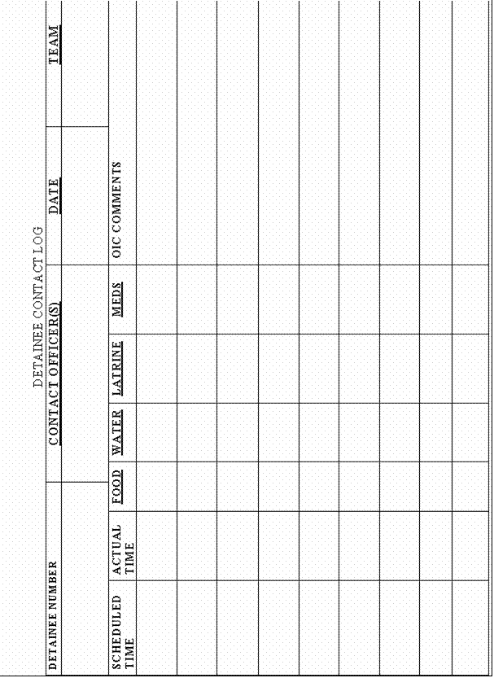

ATTACHMENT 4 TO TAB G
USA OF FORCE FORM(Front)
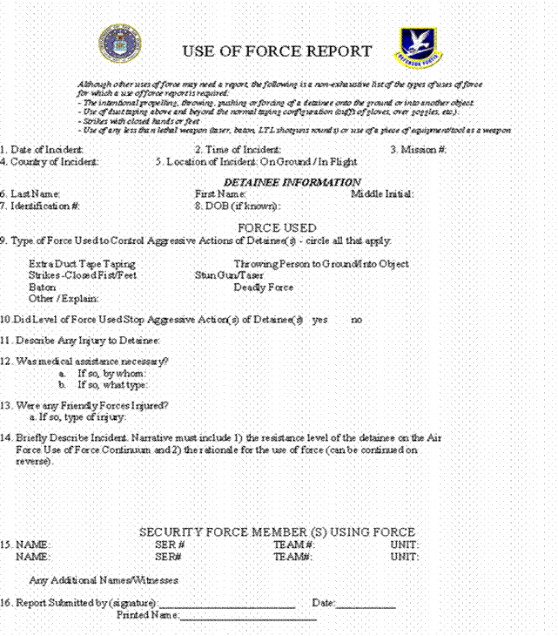

USE OF FORCE FORM (Back)
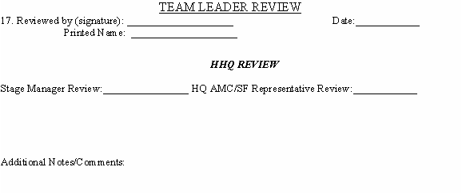

TAB H
LEGAL CONSIDERATIONS
- BACKGROUND -
Since the detainees currently have no “official status” the Geneva Convention requires that they be treated as enemy prisoners of war. This treatment will continue until a competent tribunal determines an official status. Under the Geneva Convention, evacuation of detainees shall be effected humanely. This includes supply of sufficient food and water, necessary clothing, and medical attention. Humane treatment should be considered in light of the risks presented by air movement. If detainee’s conduct poses a risk to the safety of the aircraft or personnel, the Geneva Convention does not limit appropriate force protection measures.
- USE OF FORCE -
All security personnel will be trained in approved Use of Force policies prior to coming in contact with any detainees.
- RULES OF ENGAGEMENT (ROE) -
Approved Special Rules of Engagement (SROE) will be briefed to all personnel prior to coming in contact with any detainees. Updates or changes to the ROE or SROE will be immediately briefed to all personnel.
TAB I
TRAINING
- BACKGROUND -
Based on the assumption that the Department of Defense does not have a requirement for personnel trained and experienced in this type of activity, AMC/SF directed a just-in-time (JIT) training regimen for the en-route security and supporting personnel.
- SECURITY ELEMENT TRAINING -
- Training for the security element should be focused on essential knowledge-level subject areas, the development of basic tactics, techniques, and procedures, and on critical actions on the objective. Subject areas should represent mission-essential tasks and events for the mission. Training will be structured to develop the necessary skills for meeting the minimum standards of the required tasks.
- Subject blocks will be trained to standard and not to time.
- Follow-on training, time permitting, will seek to sharpen the skills required in the initial training and will consist of additional rehearsals of actions on the objective, additional use of force training (both knowledge and application), certifications on the ASP baton (if possible), and supplementary core task instruction.
- Additional training and subject blocks determined through lessons-learned will be worked into follow-on training schedules.
- Subject areas and estimated training times for the security element training are in Table 1 along with a proposed schedule of training. Also listed in Table 1 is the desired level of learning (knowledge-level (K), performance-level (P) and performance check-level (PK)) for each major subject block.
TABLE 1
Day of Training | Lesson | Estimated Time | Learning Level
DOT 1 | Use of Force (includes SROE) | 1 Hour | PK
 | Cross Cultural Communications/Verbal Judo | 1 Hour | K
 | Concept of Operation/Aircraft Diagram Table-Top Discussion | 1 Hour | K
 | Shackling/Handcuffing | 1 Hour | PK
 | Defensive Tactics | 4 Hours | P
DOT 2 | Armament Systems Procedures (ASP) Baton | 4 Hours | P
 | Aircraft Familiarization and Team Duties  - Control Officer's Duties  - Quick Reaction Team Duties  - Flight Deck Denial Team  Duties  - OIC Duties  - NCOIC Duties  - Translator Duties  - Medic Duties  - Flight Doctor Duties | 4 Hours | K
DOT 3 | REHEARSALS  - On-Load Detainees (Pickup Location)  - Off-Load Detainees (Intermediate Stage)  - On-Load Detainees (Intermediate Stage)  - Off-Load Detainees  - On-Load Detainees (Minimally Restrained)  - Emergency Evac of Detainees  - CONOPS for A/C  Delayed/Break  - Restroom Escort Procedures  - Shoot/No-Shoot Scenarios  - Airborne Medical Emergency  (detainee)  USE OF FORCE SCENARIOS  - Detainee Handcuffs Not  Double Locked  - Detainee (Compliant)  - Detainee (Passive Resistant)  - Detainee (Active Resistant)  - Detainee (Assaultive)  - Detainee (Assaultive Serious  Bodily Harm) | 10 Hours | P  PK
- Weapons Training.
  - Any personnel armed with the M-9 or M-16/M-4 weapons systems will be qualified through their appropriate service qualification course.
  - Personnel arming with the Taser will undergo knowledge-level training prior to handling the weapon on a mission.
  - Personnel arming with the shotgun/bean bag rounds will be qualified on the weapon (M-870/M-500) for the Air Force Qualification Course and will be trained in the use of the bean bag munitions by a qualified instructor graduate from the Joint Less Lethal Weapons Course.
- SUPPORT ELEMENT TRAINING -
- Training for the support elements (flight surgeons, independent duty medical technicians, linguists, aeromedical, et. al.) should be focused on essential knowledge-level subject areas and on critical actions on the objective. There is no requirement for instruction on offensive or defensive battle/handling techniques when dealing with the detainees or on the application of restraining systems as these tasks will be handled almost exclusively by the security elements.
- Subject blocks will be trained to standard and not to time.
- Additional specialty training may be required by functional managers for any of the specialist support personnel.
- Subject areas and estimated training times for the support element training are in Table 2.
Table 2
Lesson | Estimated Time | Learning Level
Use of Force (includes SROE) | 1 Hour | K
Concept of Operation/Aircraft Diagram Table-Top Discussion | 1 Hour | K
Aircraft Familiarization and Team Duties  - Control Officer's Duties  - Quick Reaction Team Duties  - Flight Deck Denial Team  Duties  - OIC Duties  - NCOIC Duties  - Translator Duties  - Medic Duties  - Flight Doctor Duties | 4 Hours | K
REHEARSALS  - On-Load Detainees (Pickup Location)  - Off-Load Detainees (Intermediate Stage)  - On-Load Detainees (Intermediate Stage)  - Off-Load Detainees  - On-Load Detainees (Minmally Restrained)  - Emergency Evac of Detainees  - CONOPS for A/C  Delayed/Break  - Restroom Escort Procedures  - Shoot/No-Shoot Scenarios  - Airborne Medical Emergency  (detainee) | 10 Hours | P

TAB J
EQUIPMENT
ITEM | QTY | COST EA | TOTAL | VENDOR | COLOR
LEG RESTRAINTS/SHACKLES | 300 |  |  | 1
HAND RESTRAINSTS | 300 |  |  | 1
BELLY CHAIN | 300 |  |  | 1
MIL ISSUE GOGGLES/BLACKED OUT | 300 |  |  | 2
EAR MUFFS | 300 |  |  | 3
MITTENS/HAND COVERINGS | 2500 |  |  | 3 | ORANGE
HOSPITAL SCURBS | 2500 |  |  | 3 | ORANGE
SLIP ON SHOES | 2500 |  |  | 3 | ORANGE
COLD WEATHER JACKET | 500 |  |  | 3 | ORANGE
STOCKING HAT | 2500 |  |  | 3 | ORANGE
THERMAL SOCKS | 2500 |  |  | 3 | ORANGE
GUARD EQUIPMENT
STUN GUNS | 50 |  |  | 1
WILEY X SAFETY GLASSES | 100 |  |  | 2
SEARCH GLOVES/SLASH PROOF DISPOSABLE | 500 |  |  | 2
"GIMBAL GLOVES"
COMM EAR PIECES | 100 |  |  | 2
RADIOS | 100
ASP BATON 21" | 100 |  |  | 5
ASP BATON 21" NYLON HOLDER | 100 |  |  | 5
BODY ARMOR LEVEL II | 100 |  |  | 1
SURGICAL GLOVES | 5000 |  |  | 4
EQUIPMENT BAGS FOR RESTRAINTS (EAGLE) | 50 |  |  | 2
ANTI BACTERIAL HAND SCRUB | 200 |  |  | 4
TB MASKS | 1000 |  |  | 4
METAL DETECTOR | 20 |  |  | 1
VENDOR INFORMATION
COMPANY | POC |  | PHONE NUMBER
1 LAWMEN POLICE SUPPLY | DAVE FREEMAN |  | (302) 697-8740
2 SAFETY SYSTEMS | TOM GILROY |  | (630) 653-1103
3 BOB BARKERS |  |  | (800) 334-9880
4 GALL'S |  |  | (800) 477-7766
5 ASP |  |  | (800) 236-6243

INSERT HERE
TAB K
MEDICAL TRANSPORT SUPPORT FOR NOTIONAL ESCORT MISSION
- BACKGROUND -
Medical support of security team movement of detainees will (1) provide emergency and sustainment treatment of crew and (2) provide medical care and chemical restraint as necessary to detainees. Transport missions may have varied numbers of detainees and may include non-ambulatory patients.
- PERSONNEL -
- One Flight Surgeon, Air Force Specialty Code (AFSC) 48G3/48A3/48R3.
- Variable numbers of Medical Service Specialists (Independent Duty Medical Technician IDMT) AFSC 4N0XX SEI 496 as required by mission.
- PROCEDURES -
Medical personnel will be fully integrated into every detainee transport team.
- Assumptions. Medical personnel will provide detainees medical care and chemical restraint when cleared to do so by security personnel. This is a military transport of detainees and medical support is tailored to this mission. Basic cardiac life support (BCLS) and advance cardiac life support (ACLS) equipment and supplies will not be carried, as there is no expected use for this population. Any detainee that requires on going medical care must be moved on aircraft with aeromedical evacuation medical support.
- Roles and Responsibilities. The flight surgeon will serve as the medical team supervisor and the preceptor for assigned IDMTs. The flight surgeon helps determine the medical team composition for the mission and when on the transport mission will provide medical care to crew and detainees when cleared to do so by security personnel. The flight surgeon will determine the level of care provided to detainees when security forces have determined it is safe. The IDMT will provide medical care in accordance with IDMT protocols and preceptor direction. The medical team will obtain a manifest for this mission to include the individual’s home unit.
- Equipment and Supplies: Medical equipment and supplies for detainee transport (see Attachment 1 to Tab M)
- Objectives and Methodologies:
  - Pre-assessment. Available USCENTCOM aeromedical evacuation personnel and AMC MGRL personnel at origination detainee location will assist in preflight medical screening for suitability of detainees to travel by air with little or no en route care. In the event that this screening identifies detainees having medical/other conditions requiring en route care, local medical resources will further evaluate their stability for air transport. Results of this screening will be briefed to the on-board medical team supporting this mission.
  - Mission Medical Rules of Engagement. Pre-medicating detainees with motion sickness prophylaxis medication prior to the mission is highly recommended. If the threat to flight safety, mission completion or safety of detainees or US personnel is judged to be significant, it is highly recommended that detainees be chemically restrained per pre-established protocol(s). This threat assessment should be conducted jointly by the security OIC and medical personnel. Any direct contact with detainees to provide first aid must also be approved by security OIC, i.e. intravenous fluids that would be initiated to hydrate detainees. The ability to deliver BCLS resuscitation en route is severely constrained by the limited space on board the aircraft and the potential risk to medical providers, security forces and flight safety.
  - Post Evaluations. A detailed after-action report will be provided to HQ AMC SGX/SGP. The medical team will be debriefed by the 305th SGP and a qualified behavior health provider. If determined necessary a critical incident stress debriefing will be accomplished for all aircrew and security personnel following this mission.
- MEDICAL EQUIPMENT & SUPPLIES FOR DETAINEE TRANSPORT -
- Basic Equipment
  - Rolling duffle bags – black (approx $30.00 each at AFEES)
  - Plastic inserts to hold supplies (you pick sizes/quantities)
- PPE
  - Red Bags
  - Gloves, Nonsterile Exam (3 boxes each of large and extra large size)
  - Mask (N95)
  - Goggles
  - Gowns
  - Respirator, Air Filtering (4240-01-452-8331) designed for nuisance level organic vapor relief
- Wound care supplies: approx 6 each unless otherwise said
  - Kling
  - Kerlex
  - 2x2
  - 4x4
  - Eye patches
  - Tape rayon (assorted)
  - Cotton tip applicators/sterile; individual wrapped
  - Muslin slings
  - SAM splints (2 ea) (no air splints)
  - Medium battle dressings (2)
  - Large battle dressing (1)
  - OBE (smallest) type tampons (3 each)
  - Wound irrigation set (2)
  - 50 cc syringe (2)
  - Adaptic (Nonstick gauze)
- Exam Supplies
  - Otoscope
  - Stethoscope
  - B/P cuff set (assorted sized cuffs)
  - Flashlight/Penlight (3)
  - Scissors (bandage)
  - Gloves (see above)
  - Tongue blades (1 box)
- Emergency Drugs/IVs
  - Normal Saline 1000 ml (12 /1 case)
  - 16, 18, 20, 22 Intercaths (4 each)
  - Penrose Drains (4)
  - Tegaderm pads (6)
  - Povidine pads (12)
  - Alcohol pads (6)
  - Epinephrine 1:1000 (6 amps or Epi-pens)
  - (delete b/c will not have ACLS capability)
  - Valium Inj (5 mg/ml vials, 2 vials)—(seizures treatment)
  - Benedryl Inj (50 mg/ml syringes containing 1 ml, #5 syringes)
  - Naloxone (Narcan) 2 mg IM/IV/SQ, up to 10 mg max dose (1 mg/ml vials, two 2 mg amps)
  - Toradol (30 mg/ml, two 1 ml vials)
  - Flumazenil (Romazicon) 0.2 – 0.3 –0.5 mg IV, 1 min intervals if no effect. Max dose 3 mg. (0.1mg/ml, two 5 ml vials) (benzodiazepinereversal agent)
  - Droperidol 2.5-5mg IM (take-down chemical restraint if imminent threat to flight safety or personal safety)
  - Combivir (HIV exposure to be administered within first 2 hours of exposure)
  - Ativan Tabs(2 mg tabs, #25)
  - Ativan Injectable IM/IV 25 1mg doses
  - Haldol Inj IM/IV (lactate 5mg/ml, 1ml vials, 10 vials) 10 doses (antipsychotic chemical restraint)
  - Cogentin Injectable IM (1 mg/ml, five 2 ml ampules)
  - Benedryl Injectable IM/IV (Five 50 mg vials)
- Airway supplies:
  - Disposable ambu set
  - Pocket mask
  - Oral airways
  - Naso-P airways
- Routine Drugs: (approx 50-100 tabs per — but let pharmacy use their judgment)
  - Sudafed Tabs (30mg tabs, #25)
  - Cough Syrup (2 btle, 20 med cups)
  - Afrin (2)
  - Acetaminophen (#100 tabs)
  - ASA Tabs (#100 tabs)
  - Motrin Tabs (400 mg, #100 tabs)
  - Mylanta 2 Btl (20 med cups)
  - Immodium (2mg caps, #50)
  - Meclizine (antivert) (50 mg strength tabs, #25 tabs)
  - Benedryl caps
  - Ammonia ampules (1 box)
  - Bacitracin oint
  - Tigan Inj IM (100mg/ml vials, 10 vials) (antiemetic with opoiods; anxiolytic)
  - Scopalomine Patches 1 patch q 3 days (60 patches) (apply 1-4 h preflight if possible)
- Others:
  - NG tube & 50cc cath tip syringe
  - Neosporin (topical and ophthalmic)
  - Auralgan Otic Ointment
  - Condom Catheters and leg bags (2)
  - Emesis basins (20)
  - Waterless hand washing (Purell Hand Sanitizer or similar)

RELIGIOUS SUPPORT
Note: There is a requirement to determination whether or not religious support should be addressed in the chapters dealing with “short term” and “long term” holding, or remain a separate section.
Issue to be considered, probably not resolvable:
1. Are detainees accorded “confidentiality” or “privileged communication” when speaking with U.S. Armed Services chaplains?

- Command Support
The chaplain, as a special staff officer, assists the commander to meet the religious requirements of assigned personnel, is the principal advisor on the religious needs of detainees, and works with command personnel to foster humane treatment of detainees. Programming for religious support is inclusive of U.S. military personnel and the detainee population.
- Religious Requirements
- U.S. military personnel are afforded religious support consistent with the Constitution and Department of Defense policy. Religious support is to comprise those activities that support observance of faith practices, pastoral care, and faith development.
- Detainees are afforded religious support consistent with the principles of the Geneva Convention Relative to the Treatment of Prisoners of War.
- Religious Accommodation
- Commanders may choose to accommodate certain detainee religious rites and observances when mission requirements and military necessity permit such activities.
- Religious activities are open to the detainee population, without regard to race, color, nationality, or creed. Commanders may limit attendance at or discontinue a religious activity when security or good order of the facility is jeopardized. Commanders may also limit participation in a particular religious activity or practice to the members of that religious group. Ordinarily, when the nature of the activity or practice indicates a need for such a limitation, only those detainees whose files reflect the pertinent religious preference will be included.
- Religious Practices
- Detainees are to given latitude in the exercise of their religious practices, including observance of or attendance at the service of their faith, on condition that they comply with the disciplinary routine prescribed by the military authorities. When group services are permitted, adequate space should be provided. Opportunities for group services will be limited by concerns about safety, security, and the orderly operation of the facility.
- Religious beliefs or religious practices of detainees should not to be used as a means to coerce, bargain for compliance, or gather intelligence information. Withholding sacred text, time of prayer or meditation, or prohibiting other acts associated with the exercise of religious practices may have a detrimental effect and strengthen the resolve of detainees’ resistance or non-compliance. Whereas permitting expressions of faith is in accordance with humane treatment and the principles of the Geneva Convention Relative to the Treatment of Prisoners of War. However, disciplinary measures may include a loss of privilege to participate in group services.
- When approved and authorized the chaplain may secure the services of volunteers to assist detainees in observing their religious beliefs. Volunteers are those detainees that have maintained the standards of discipline, compliance with authorities, and have the trust of authorities to provide such service.
- Dietary requirements for detainees will attempt to meet the standards according to dietary regulations within that religion.
- Religious Items
- When approved and authorized by military authorities’ detainees shall have access to personal religious property, consistent with facility security.
- When authorized chaplains may distribute approved books and religious items to detainees in accordance with camp policy. During distribution of material chaplains are to be accompanied by military personnel.
- Detainee religious property should be inclusive of only those items deemed absolutely essential for faith practices. Detainees do not determine the need for such items. Verification of items to use for religious practices is determined by the chaplain or competent religious authority. Detainees’ religious items, like all items part of a detainee’s personal property, are subject to normal considerations of safety and security.
- A detainee ordinarily shall be allowed to wear or use personal religious items during religious services or ceremonies unless military authorities determine that the wearing or use of such items would threaten facility security, safety, or good order.
- Religious headwear is subject to the normal considerations of security and good order, including inspection by military personnel. Religious preference data on the detainee will assist command personnel in verifying the legitimacy of the claim to wear religious headwear.
- Religious literature is permitted in accordance with established procedures. Distribution to detainees of religious literature is contingent on approval from military authorities, the chaplain, and in consultation with SJA.
NOTE: Sacred text or religious literature is not to be shared among detainees due to the possibility of covert communications. It may be prudent to replace sacred text on a rotating basis to minimize the potential for covert communications. Any replacement should be viewed by detainees as part of camp procedures.
- Cultural Considerations
Every effort should be made to understand the ethnic and cultural makeup of detainees by military personnel. This will assist command personnel to control detainees without unintentionally angering, upsetting, or violating religious or cultural standards that govern their behavior.
- Death and Burial
- Deceased detainees are to be buried honorably in a cemetery established for them according to AR 638-30. Deceased detainees are to be buried, if possible, according to the rites of their religion and customs of their military forces. Unless unavoidable circumstances require the use of collective (group or mass) graves, detainees are to be buried individually. A body is to only be cremated only due to imperative hygiene reasons, the detainees’ religion, or the personal request for cremation.
- If a detainee dies at sea, the body is not to be buried there unless absolutely necessary. If the body has to be buried at sea, the procedures prescribed for U.S. troops is to be followed as far as possible; however, a U.S. flag is not to be used.
- Additional guidance on burial practices and services of committal by major world religions is available in JP 4-06.
- The following information concerning the deceased detainee is to be compiled and filed with their record:
  - Name
  - Registration number
  - Date of birth
  - Date, time, and location of death
  - Apparent cause of death
  - Investigative steps being taken, if necessary
  - Name and address of next of kin
  - Notifications made
  - Brief medical history related to death
  - Status of autopsy request, if necessary
  - Funeral or burial service provide consistent with religious practice
  - If funeral or memorial performed aboard ship log latitude and longitude
- U.S. Military Chaplain Involvement
- Advising the Commander. U.S. military chaplains advise commanders on those issues that affect the exercise of religious practice of detainees. This includes, but is not limited to, worship requirements, prayer, sacred text, diet, and seasonal or special observances. The chaplain provides commanders an additional resource for addressing detainee issues.
- Training and Education. In order to foster humane care and treatment chaplains, at the direction of commanders, may provide training and educational classes for command personnel that specifically address the religious tenets and faith practices of the detainees.
- Religious Support to Detainees. There is no obligation by U.S. military commanders provide its own U.S. military chaplain to detainees for their religious practices. The only legally defined role for U.S. Armed Forces chaplain is that of provision (USA) or facilitation (USN, USMC). The terms, though different, refer to the same concept, that being, the religious support that a chaplain coordinates for detained persons to ensure the exercise of their religious practices.
- Any consideration to utilize the professional service of U.S. military chaplains for detainees is decided by the commander in consultation with higher echelon command authorities, Unified or Joint Forces Command chaplain and SJA. Such a consideration, however, is to have exhausted all other possibilities to support the detainees religious practices or care. Only when the circumstances are judged to be extremis and in direct support of humane treatment or humanitarian care should the direct involvement of temporary services from a U.S. military chaplain be utilized.
- When authorized and directed by command authorities to directly interface with detainees the chaplain will be accompanied to detainee holding areas for security purposes.
- When speaking with detainees chaplains will have security personnel nearby for safety and control of detainee.
- When authorized chaplains may distribute approved books and religious items to detainees in accordance with camp policy.
- Ref to tables?
Table ____ Accommodation of Religious Practices for Detainees
Policy: Detainees are provided reasonable and equitable opportunities to observe or participate in the practices of their faith, limited only by the constraints of safety, security or the orderly operations of the facility.
Line | Components | Yes | No | Remarks
1 | Are detainees allowed to engage in religious services?
2 | Is space available for detainees to conduct religious services?
3 | Does the facility allow for detainees to observe the major “holy days” of their religious faith?
4 | Does the facility accommodate holy-day observances by:  a. Providing special meals, consistent with dietary restrictions?  b. Honoring fasting requirements?  c. Facilitating religious services?  d. Allowing activity restrictions?
5 | Is each detainee allowed religious items in his/her immediate possession?
6 | Can members of faiths not represented by clergy conduct their own services?
7 | Do military authorities allow detainees in high risk groups to participate in religious practices?

Table ____Religious Practices Inspectors Checklist
The following may serve as sources of information for inspectors to verify the support of religious practices:
Line | Source | Time | Date | Location
1 | Religious observances permitted as possible
2 | Intake procedures document religious preference
3 | Exam designated space provided for religious practices, if provided
4 | Exam established guidelines for religious support of detainee practices
Remarks: (Record significant facts, observations, other sources used, etc.)

__________________________
Signature

__________________________
Date

REFERENCES

REFERENCES
Joint Publications
JP 1-0, Doctrine for Personnel Support to Joint Operations, Appendix T
JP 1-05, JP 1-06, JP 3-02, JP 3-07.3, JP 3-07.5, JP 3-10, JP 3-10.1, JP 3-17, JP 3-50.3, JP 3-57, JP 4-01.3, JP 4-02, JP 4-02.1, JP 4-02.2, JP 4-07, and JP 5-00.2.
DOD
Department of Defense Directive 2310.1, DOD Program for Enemy Prisoners of War (EPOW) and Other Detainees.

NATO
STANAG 2033. Interrogation of Prisoners of War (PW) (Edition 6). 6 December 1994.
STANAG 2044. Procedures for Dealing With Prisoners of War (PW) (Edition 5). 28 June 1994.
STANAG 2084. Handling and Reporting of Captured Equipment and Documents (Edition 6).
6 April 1999.
Multi-Service (Section)
“Enemy Prisoners of War, Retained Personnel, Civilian Internees and Other Detainees”. (AR 190-8, OPNAVINST 3461.6, AFI 31-304 and MCO 3461.1)
FM 90-40. Multiservice Procedures for the Tactical Employment of Nonlethal Weapons (NLW) {MCRP 3-15.8; NWP 3-07-31; USCG Pub 3-07.31}. 6 October 1998.
FM 100-23-1. Multiservice Procedures for Humanitarian Assistance Operations {FMFRP 7-16; NDC TACNOTE 3-07.6; ACCP 50-56; PACAFP 50-56; USAFEP 50-56}. 31 October 1994.
ARMY
Field Manual 3-19.40, Military Police Interment/Resettlement Operations
FM 22-5. Drill and Ceremonies. 8 December 1986.
FM 22-6. Guard Duty. 17 September 1971.
FM 22-100. Army Leadership. 31 August 1999.
FM 27-10. The Law of Land Warfare. 18 July 1956.
FM 33-1-1. Psychological Operations Techniques and Procedures. 5 May 1994.
FM 100-5. Engineer Operations. 27 February 1996.
FM 100-19. Domestic Support Operations {FMFM 7-10}. 1 July 1993.
FM 101-5. Staff Organization and Operations. 31 May 1997.
Marine Corps
MCWP 3-34.1 Military Police in Support of the MAGTF
Air Force
Other
Chairman of the Joint Chiefs of Staff Instruction 3290.01A, Program for Enemy Prisoners of War, Retained Personnel, Civilian Internees, and Other Detained Personnel
Foreign Assistance Act, US Code (1994).
Geneva Convention for the Amelioration of the Condition of the Wounded and Sick in Armed
Forces in the Field (GWS), 12 August 1949.
Geneva Convention for the Amelioration of the Condition of Wounded, Sick, and Shipwrecked
Members of Armed Forces at Sea (GWS [SEA]), 12 August 1949.
Geneva Convention Protocol Relative to the Status of Refugees. 1967.
Geneva Convention Relative to the Protection of Civilian Persons in Time of War (GC),
12 August 1949.
Geneva Convention Relative to the Status of Refugees. 1951.
Geneva Convention Relative to the Treatment of Prisoners of War (GPW), 12 August 1949.
Geneva Conventions for the Protection of War Victims, 12 August 1949.
Misc Pub 27-7. Manual for Courts-Martial, United States, 2000 Edition.
Posse Comitatus Act, US Code (1994).
STP 19-95B1-SM. Soldier’s Manual, MOS 95B, Military Police, Skill Level 1. 21 February 1997.
STP 19-95C14-SM-TG. Soldier’s Manual and Trainer’s Guide for MOS 95C Internment/
Resettlement Specialist, Skill Levels 1/2/3/4. 26 March 1999.
STP 21-24-SMCT. Soldier Testing Program (STP). 1 October 1992.
TC 27-10-1. Selected Problems in the Law of War. 26 June 1979.
UCMJ
UNHCR Handbook for the Military on Humanitarian Operations, First Edition. 1995.
13 Nov 2001 Military Order signed by President G.W. Bush and in the Federal Registry

GLOSSARY (ChapterTitle)
A (Index Heading)
(Acronym) | (Definition)
(Acronym) | (Definition)
(Acronym) | (Definition)
(Acronym) | (Definition)
(Acronym) | (Definition)
(Acronym) | (Definition)
(Acronym) | (Definition)
(Acronym) | (Definition)
(Acronym) | (Definition)
(Acronym) | (Definition)
We will scrub this list and then add to Glossary
A
AC active component
ACCP Army contingency communications package
ACCP Army Correspondence Course Program
ACS Army Corrections System
ACT active duty
admin administrative
ADT active-duty tour
AFR Air Force regulation
AG adjutant general
AICS Army Inmate Correction System
AMEDD Army Medical Department
AMS Army management structure
AO area of operations
AOR area of responsibility
AR Army regulation
ASD Assistant Secretary of Defense
ATTN attention
AWOL absent without leave

B
BDU battle dress uniform
BLD brigade liaison detachment
BSA brigade support area
BTOC brigade tactical operations center

C
C2 command and control
CA civil affairs
CARE Cooperative for American Relief Everywhere, Incorporated
CHA corps holding area
CHS combat health support
CI civilian internee
CID criminal investigation division
CMO civil-military operations
co company
COL colonel
COMMZ communications zone
CONUS continental United States
COS civilian occupational specialty
COSCOM Corps Support Command (US Army)
CP collecting point
CPT captain
CRS Catholic Relief Services
CRS Correctional-Reporting System
CS o-chlorobenzylidine malonitrile
CS combat support
CSB correctional-supervision branch
CSS combat service support
CTA common table of allowance
CTF correctional-treatment file
CZ combat zone

D
D disperser
D day
DA Department of the Army
DART disaster assistance response team
DASD Deputy Assistant Secretary of Defense
DC District of Columbia
DC dislocated civilian
DCAA dislocated-civilian assembly area
DCSOPS Deputy Chief of Staff for Operations and Plans
DD Department of Defense
DFAS-IN Defense Finance and Accounting Service—Indianapolis
DNBI disease and nonbattle injuries
DOD Department of Defense
DOJ Department of Justice
DOMS Director of Military Support
DOS Department of State
DOT Department of Transportation
DP displaced person
DS direct support
DSA division support area

E
ea each
EAC echelons above corps
EBC echelons below corps
EEI essential elements of information
EGA electronically generated form
EGCT extra good-conduct time
EHP emergency home patrol
EPW enemy prisoner of war
ERA emergency rest area
ES emergency services
ESF emergency support function
eval evaluation

F
FBI Federal Bureau of Investigation
FCF field confinement facility
FDF field detention facility
FEMA Federal Emergency Management Agency
Five Ss and T search, segregate, silence, speed, safeguard, and tag
FM field manual
FMFM Fleet Marine Force manual
FMFRP Fleet Marine Force reference publication
FN foreign nation
FSB forward support battalion
ft foot, feet

G
G2 Assistant Chief of Staff, G3 (Operations and Plans)
G4 Assistant Chief of Staff, G4 (Logistics)
G5 Assistant Chief of Staff, G5 (Civil Affairs)
gal gallon(s)
GC Geneva Convention Relative to the Protection of Civilian Persons in Time of War, 12 August 1949
gd guard
GO general officer
GP general purpose
GPW Geneva Convention Relative to the Treatment of Prisoners of War, 12 August 1949
GWS Geneva Convention for the Amelioration of the Condition of the Wounded and Sick in Armed Forces in the Field, 12 August 1949
GWS (SEA) Geneva Convention for the Amelioration of the Condition of Wounded, Sick, and Shipwrecked Members of Armed Forces at Sea, 12 August 1949

H
H&RA Humanitarian and Refugee Affairs
H/CA humanitarian and civic assistance
HA humanitarian assistance
HHC headquarters and headquarters company
HIV human immunodeficiency virus
HM hazardous material
HN host nation
HQ headquarters
HQDA Headquarters, Department of the Army
ht height

I
I/R internment/resettlement
ICRC International Committee of the Red Cross
ID identification
IDP internally displaced person
IFRC International Federation of Red Cross and Red Crescent Societies
IG inspector general
IHO international humanitarian organization
IMC International Medical Corps
INS Immigration and Naturalization Service
IO international organization
IOM International Organization for Migration
IR information requirements
IRIC internment/resettlement information center
IRIS Internment/Resettlement Information System
IRS Internal Revenue Service
ISN internment serial number

J
J4 Logistics Directorate
Jan January
JCS joint chief of staff
JFC joint forces commander
JTF joint task force
JTR joint travel regulation

L
L&O law and order
LOC lines of communication
LP listening post
LRA local reproduction authorized
LTC lieutenant colonel
LZ landing zone

M
M month
MAJ major
MANSCEN Maneuver Support Center
MARKS Modern Army Recordkeeping System
MBA main battle area
MCCM modular crowd control munition
MCO Marine Corps order
MCO movement control officer
MCRP Marine Corps reference publication
MDMP military decision-making process
METT-TC mission, enemy, terrain, troops, time available, and civil considerations
MI military intelligence
misc miscellaneous
MOS military occupational specialty
MP military police
MRE meal, ready-to-eat
MRO medical regulating officer
MSCA military support to civil authorities
MSF Médecin Sans Frontiéres (Doctors Without Borders)
MSR main supply route
MWD military working dog

N
NA not applicable
NATL national
NATO North Atlantic Treaty Organization
NBC nuclear, biological, or chemical
NCCB National Council of Catholic Bishops
NCO noncommissioned officer
NCOIC noncommissioned officer in charge
NDC National Disaster Coalition
NG national guard
NGO nongovernmental organization
NLW nonlethal weapon
No. number
NOK next of kin
NWP Naval warfare publication

O
obj objective
OC oleoresin capsicum
OCONUS outside continental United States
OD other detainee
OFDA Office of Foreign Disaster Assistance
OG olive green
OIC officer in charge
OIP organization inspection policy
OP observation post
OPCON operational control
OPLAN operation plan
OPNAVINST Office of the Chief of Naval Operations instruction
OPORD operation order
OSD Office of the Secretary of Defense

P
PA physician’s assistant
PACAFP Pacific Air Forces pamphlet
pam pamphlet
PAO public affairs officer
PHS Public Health Service
PIR priority intelligence requirements
PM provost marshal
POC point of contact
pr pair
PRC populace and resource control
PSB prisoner services branch
PSYOP psychological operations
pub publication
PVNTMED preventive medicine
PW prisoners of war

Q
QRF quick-reaction force
qty quantity

R
RCF regional corrections facility
RCM rules for courts-martial
reg regimental
ROE rules of engagement
ROI rules of interaction
RP retained person

S
S2 Intelligence Officer (US Army)
S3 Operations and Training Officer (US Army)
S4 Supply Officer (US Army)
S5 Civil Affairs Officer (US Army)
SA situational awareness
SCF Save the Children Foundation
SECDEF Secretary of Defense
SF Security Forces
SGT sergeant
SJA staff judge advocate
SM selected marksman
SOP standing operating procedure
SP Shore Patrol
SP Security Police
SSC small scale conflicts
SSN social security number
STANAG Standardization Agreement
STD sexually transmitted disease
STP soldier testing program
STP soldier training publication
STRESS search, tag, report, evacuate, segregate, and safeguard

T
TACNOTE tactical note
TB tuberculosis
TCMS Theater Construction Management System
THP temporary home patrol
TO theater of operations
TOC tactical operations center
TOE table(s) of organization and equipment
TRADOC United States Army Training and Doctrine Command
TSC Theater Support Command
TTP tactics, techniques, and procedures

U
UCMJ Uniform Code of Military Justice
UIC unit identification code
UN United Nations
UNDP United Nations Development Program
UNDRC United Nations Disaster Relief Coordinator
UNHCR United Nations High Commissioner for Refugees
UNICEF United Nations Children’s Fund
UNOCHA United Nations Office for the Coordination of Humanitarian Affairs
US United States
USACIC United States Army Criminal Investigation Command
USAFEP United States Air Forces Europe pamphlet
USAID United States Agency for International Development
USAR United States Army Reserve
USCG Unites States Coast Guard
USD Under Secretary of Defense
USDA United States Department of Agriculture
USDB United States Disciplinary Barracks
USIA United States Information Agency

W
WFP World Food Program
WO warrant officer
Wt weight

Y
Y year
INDEX (IndexTitle)
Error! No index entries found.
FM 3-52.2 (FM 100-103-2)
MCRP 3-25F
NTTP 3-56.2
AFTTP(I) 3-2.17
Day Month 2003
By Order of the Secretary of the Army:

Official:
JOEL B. HUDSON
Administrative Assistant to the
Secretary of the Army
XXXXX

ERIC K. SHINSEKI
General, United States Army
Chief of Staff

DISTRIBUTION:
Active Army, Army National Guard, and U.S. Army Reserve: Distribute in accordance with the initial distribution number (IDN) ???????, requirements for FM 3-52.2.
By Order of the Secretary of the Air Force:
DAVID F. MacGHEE, JR.
Major General, USAF
Commander
Headquarters Air Force Doctrine Center
Air Force Distribution: F or X if restricted publication

